# Kotlin学习资料

## 官方资料

Kotlin Github：<https://github.com/JetBrains/kotlin>

kotlin教程（英）：<https://kotlinlang.org/docs/home.html>

kotlin教程（中）：<https://www.kotlincn.net/docs/reference/>

<https://www.gitbook.com/book/hltj/kotlin-reference-chinese/details>

kotlin-Android：<https://developer.android.com/kotlin>

## 博客

技术小黑屋：<https://droidyue.com/blog/2017/05/18/why-do-i-turn-to-kotlin/>

腾讯Bugly公众号：

<https://mp.weixin.qq.com/s?__biz=MzA3NTYzODYzMg==&mid=404087761&idx=1&sn=d80625ee52f860a7a2ed4c238d2151b6>

阿里员工：<https://www.jianshu.com/p/cf1f96c56150>

## 项目

<https://github.com/githubwing/GankClient-Kotlin>

<https://github.com/wuapnjie/PoiShuhui-Kotlin>

# Kotlin编辑器

参考：

1】 <http://www.imooc.com/article/49741>

2】 <https://www.kotlincn.net/docs/tutorials/getting-started-eclipse.html>

## Intellij IDEA

<https://blog.csdn.net/wd2014610/article/details/79732084>

<https://www.bilibili.com/video/BV1kT4y1o7nP?p=145&spm_id_from=pageDriver>

Project翻译为：工程、项目

## Android Studio

见

## Eclipse

## TryKotlin

## Vim

## Sublime Text

## Atom

# Kotlin编译器：compiler

<https://kotlinlang.org/docs/command-line.html>

# Kotlin语法【未具体分类】

## 程序入口

参考：<https://blog.csdn.net/kushanmao/article/details/75197376>

<https://www.cnblogs.com/wisdomzhang/p/12203553.html>

程序入口是作为顶层函数的fun main【注：只能作为顶层函数】。

1. < kotlin1.3

必需要“args: Array<String>”

|  |
| --- |
| fun main(args: Array<String>){  println("hello world")  } |

【2】 >= kotlin1.3

不需要“args: Array<String>”

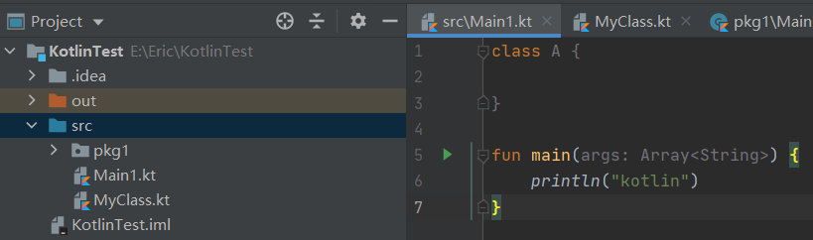

提示：

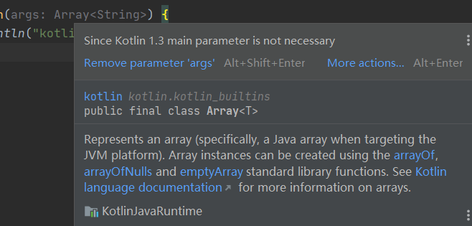

快捷方式生成：

输入main 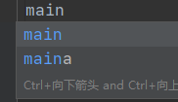-》回车

## 对应java中的静态成员

参考：

1. <https://www.jianshu.com/p/001be8361d81>
2. <https://blog.csdn.net/u011337574/article/details/87473750>

### 使用包级属性和函数

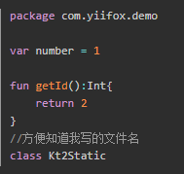

### 伴生对象

### 使用@JvmStatic注解

## 可见性修饰符：Visibility modifiers

<https://www.kotlincn.net/docs/reference/visibility-modifiers.html>

<https://www.cnblogs.com/Jetictors/p/8031291.html>

### 【1】 概述

<https://kotlinlang.org/docs/visibility-modifiers.html>

<https://www.kotlincn.net/docs/reference/visibility-modifiers.html>

Classes, objects, interfaces, constructors, and functions, as well as properties and their setters, can have *visibility modifiers*. Getters always have the same visibility as their properties.

There are four visibility modifiers in Kotlin: private, protected, internal, and public. The default visibility is public. 【即如果没有显式指定修饰符的话，默认可见性是 public。】

On this page, you'll learn how the modifiers apply to different types of declaring scopes.

### 【2】 4个关键字概述

#### 《1》 private

<https://kotlinlang.org/docs/keyword-reference.html#modifier-keywords>

private marks a declaration as [visible in the current class or file](https://kotlinlang.org/docs/visibility-modifiers.html).

#### 《2》 protected

<https://kotlinlang.org/docs/keyword-reference.html#modifier-keywords>

protected marks a declaration as [visible in the current class and its subclasses](https://kotlinlang.org/docs/visibility-modifiers.html).

#### 《3》 internal

<https://kotlinlang.org/docs/keyword-reference.html#modifier-keywords>

internal marks a declaration as [visible in the current module](https://kotlinlang.org/docs/visibility-modifiers.html).

#### 《4》 public

<https://kotlinlang.org/docs/keyword-reference.html#modifier-keywords>

public marks a declaration as [visible anywhere](https://kotlinlang.org/docs/visibility-modifiers.html).

### 【3】 相关概念

#### 《1》 module

<https://kotlinlang.org/spec/packages-and-imports.html>

<https://kotlinlang.org/docs/visibility-modifiers.html#modules>

## 函数：functions

参考：

1. <https://www.cnblogs.com/Jetictors/p/8506941.html>
2. <https://www.jianshu.com/p/3a815c51dcb5>
3. <https://zhuanlan.zhihu.com/p/89413632>
4. <https://kotlinlang.org/docs/functions.html#tail-recursive-functions>
5. <https://kotlinlang.org/docs/functions.html>

### 【1】 函数的声明

<https://www.cnblogs.com/Jetictors/p/8506941.html>

在Kotlin中函数的声明，同JavaScript相似。

#### 《1》 写法

* Kotlin中的函数声明关键字为：fun
* 定义格式为：

|  |
| --- |
| 可见性修饰符 fun 函数名(参数名 ：类型,...) : 返回值{} |

#### 《2》 示例

例：定义一个最基本的函数

|  |
| --- |
| fun basis(){  ...  } |

* 上面的例子中没有可见性修饰符，那是因为Kotlin中默认为public可见性修饰符
* ()圆括号必须存在，即使是没有参数的情况下
* {}大括号必须存在，即使是没有函数体的时候，不过在Kotlin中有一个特例就是，函数具备返回值的时候，如果只用一个表达式就可以完成这个函数，则可以使用**单表达式函数**。在下面会详细的给大家讲解
* 在函数没有返回值时可以省略其返回值

### 【x】 函数的使用

<https://www.cnblogs.com/Jetictors/p/8506941.html>

函数的使用分为两种：

* 普通的使用
* 成员函数的使用

例：

|  |
| --- |
| //1.普通的使用 basis() // 如果函数有返回值 val x = basis()  //2.成员函数的使用：先初始化对象，再根据对象使用`中缀符号(.)`调用其成员函数 Test().foo() // 如果函数有返回值 val x = Test().foo() |

### 【x】 函数的返回值

在Kotlin中，函数的返回值类型可以分为：

* Unit类型：该类型即无返回值的情况，可以省略。
* 其他类型： 显示返回类型的情况

#### Unit类型

##### 1） 和java的void对比

###### Java的void

void是关键字

<https://docs.oracle.com/javase/tutorial/java/nutsandbolts/_keywords.html>

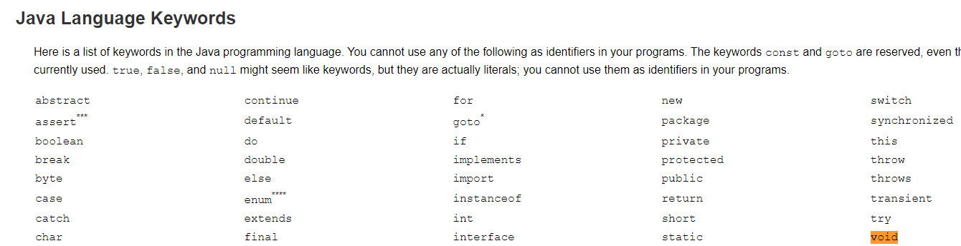

表示 无返回。

###### Kotlin的Unit

Unit是单例类。

|  |
| --- |
| */**  * The type with only one value: the `Unit` object. This type corresponds to the `void` type in Java.  */* public object Unit {  override fun toString() = "kotlin.Unit" } |

Unit也表示 无返回。

使用Unit类是为了明确地告知调用者返回的是什么类型【可使用print打印出来】。

注：补下object关键字

<https://kotlinlang.org/docs/keyword-reference.html#hard-keywords>



<https://kotlinlang.org/docs/object-declarations.html#object-declarations-overview>

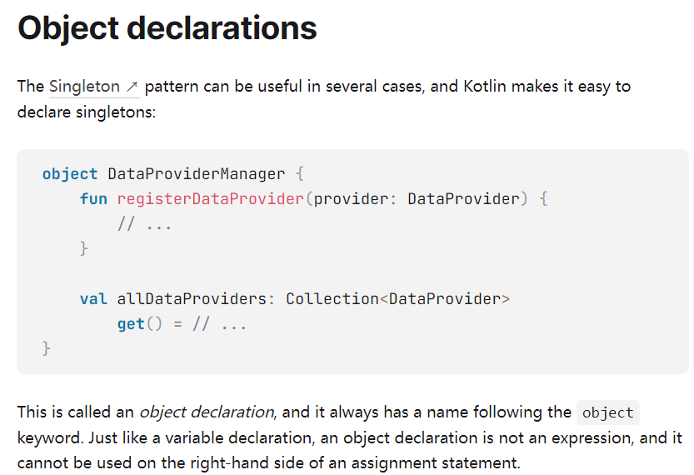

##### 2） 使用

###### 1》 “:Unit”可省略

“:Unit”写和不写意义相同。即“: Unit”不写，默认也有。

|  |
| --- |
| fun main() {  *doWork*()  *doWork1*() }  private fun doWork(): Unit {  return *println*("doWork function") }  private fun doWork1()/*: Unit*/ {  return *println*("doWork1 function") } |

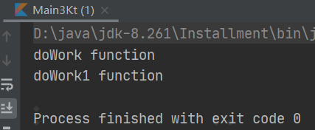

doWork报提示：

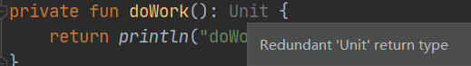

###### 2》 函数体写法

有3种写法：

|  |
| --- |
| fun myFun(): Unit {  *println*("myFun function") // return Unit //写法1 // return //写法2  //写法3：不写return } |

##### 3） 看编译成bytecode后反编译出的java

使用2）1》中代码，得

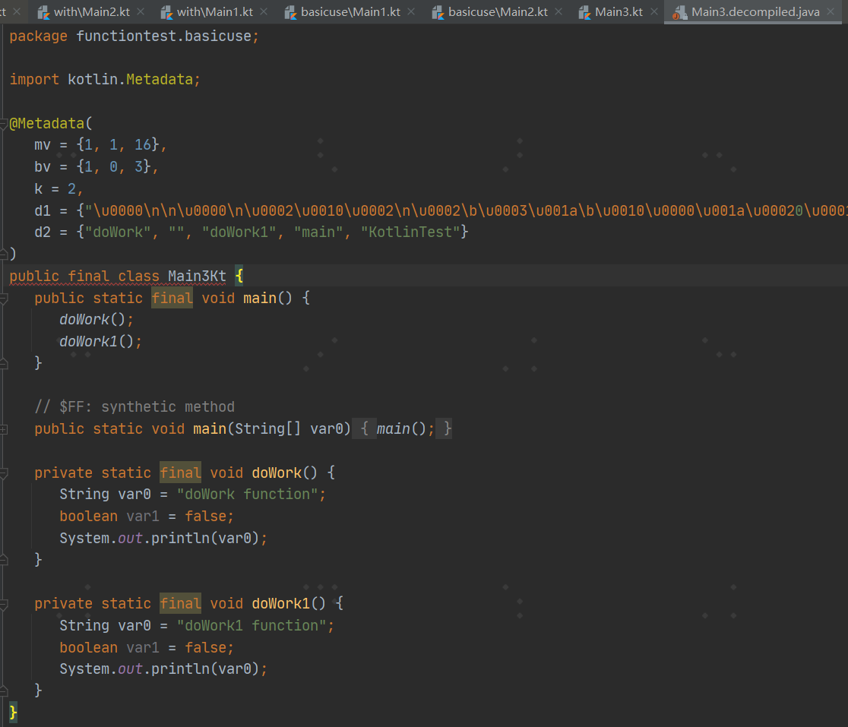

Unit转成了void关键字

#### 其他显示返回类型的返回值

这个类型可以理解为，该函数具有返回值，并且返回值类型不能省略，并且return也不能省略

例： 定义一个返回类型为Int的函数

|  |
| --- |
| fun returnFun() : Int{  return 2  } |

### 【x】 函数的参数

#### 《1》 具有参数的函数定义

定义一个具有参数的函数，使用Pascal表示法定义，其中的参数必须具有显式的参数类型，并且参数与参数之间用逗号(,)隔开。

例：

|  |
| --- |
| fun funArgs(numA : Int, numB : Float){  println("numA = $numA \t numB = $numB")  }  fun main(args: Array<String>) {  funArgs(1,10f)  } |

#### 《2》 默认参数：default arguments

<https://www.cnblogs.com/Jetictors/p/8506941.html>

##### 1） 是什么

指一个函数中的参数具有默认值，这样在使用该函数的时候，可以省略一部分参数，可以减少函数的重载

##### 2） 示例

###### 1》 全部参数无默认值

###### 2》 全部参数有默认值

定义一个具有默认参数的函数

|  |
| --- |
| fun defArgs(numA : Int = 1, numB : Float = 2f, numC : Boolean = false){  *println*("numA = $numA \t numB = $numB \t numC = $numC") }  fun main(args: Array<String>) {   // 默认参数的函数使用  *defArgs*()  *defArgs*(1,10f,true)  *defArgs*(1, 2.3f)  *defArgs*(numB = 3.3f, numC = true) } |

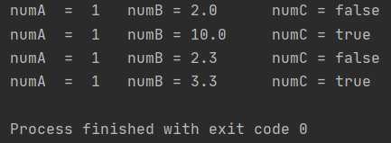

可以看出：当具有默认参数时，可以对有默认值的参数不传递参数值。

若不指定参数名，会从前到后依次赋值。

若指定参数名，会对指定参数赋值。

###### 3》 部分参数有默认值

参考：<https://www.jianshu.com/p/ae2d3e418cad>

##### 3） 注意

不过这里有一点值得注意的是： 当该函数是一个成员函数时,并且该函数时覆写继承类中的方法时，则该成员函数必须从签名中省略该函数的默认值。其实这一点不必过于看重，因为在你覆写方法时，编辑器都默认会帮你实现的.

Xx

#### 《3》 具名参数：named arguments

##### 参1：

<https://www.bilibili.com/video/BV1kT4y1o7nP?p=20&spm_id_from=pageDriver>

有如下代码：

|  |
| --- |
| package com.eric.s1  fun main() {  }  private fun loginAction(username: String, userpwd: String, phonenumber: String, age: Int, usernam: String) {  *println*("username:$username, userpwd:$userpwd, phonenumber:$phonenumber, age:$age") } |

假设一个函数有200个参数，则传统调用方法方式需要一个个去对，眼睛看花了。

因此使用具名参数进行调用，

|  |
| --- |
| package methodtest  fun main() {  *loginAction*(age = 99, userpwd = "123", usernam = "de", username = "Eric", phonenumber = "123") }  private fun loginAction(username: String, userpwd: String, phonenumber: String, age: Int, usernam: String) {  *println*("username:$username, userpwd:$userpwd, phonenumber:$phonenumber, age:$age") } |

可以随意更换形参顺序进行赋值

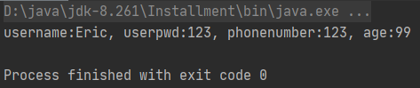

##### 参2：

<https://kotlinlang.org/docs/functions.html#named-arguments>

<https://book.kotlincn.net/text/functions.html>

### 【x】 函数嵌套

<https://kotlinlang.org/docs/returns.html#return-to-labels>

In Kotlin, functions can be nested using function literals, local functions, and object expressions.

### 【4】 不同类型函数

#### 《1》 Function scope：函数作用域

##### 1） 概述

<https://kotlinlang.org/docs/functions.html#function-scope>

Kotlin functions can be declared at the top level in a file, meaning you do not need to create a class to hold a function, which you are required to do in languages such as Java, C#, and Scala. In addition to **top level functions**, Kotlin functions can also be declared locally as **member functions** and **extension functions**.

##### 2） 顶层函数：top level functions

###### 1》 是什么

<https://kotlinlang.org/docs/functions.html#function-scope>

Kotlin functions can be declared at the top level in a file, meaning you do not need to create a class to hold a function, which you are required to do in languages such as Java, C#, and Scala.

###### 2》 使用

<https://zhuanlan.zhihu.com/p/89413632>

a） 正常调

|  |
| --- |
| package functiontest.toplevelfunction  fun joinToString(): Unit {  *println*("top level function") }  fun main() {  *joinToString*() } |

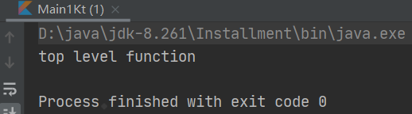

b） 静态函数调

整体结构：

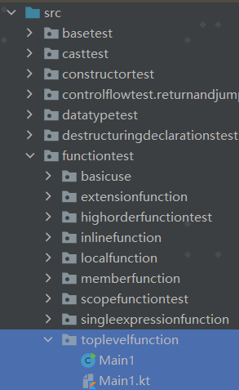

Main1.kt：

|  |
| --- |
| package functiontest.toplevelfunction  fun joinToString(): Unit {  *println*("top level function") } |

Main1.java【Java调kt】：

|  |
| --- |
| package functiontest.toplevelfunction;  public class Main1 {   public static void main(String[] args) {  Main1Kt.*joinToString*();  } } |

结果：

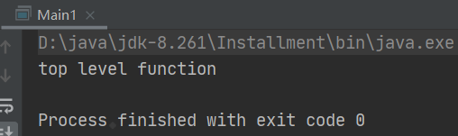

###### 3》 原理

<https://zhuanlan.zhihu.com/p/89413632>

编译后顶层函数会成为文件类下的静态函数，比如在文件名是join.kt下定义的joinToString函数可以通过JoinKt.joinToSting调用，其中JoinKt是编译后的类名。

|  |
| --- |
| // 编译成静态函数  // 文件名 join.kt  package strings  fun joinToString() : String {...}  /* Java */  import strings.JoinKt;  JoinKt.joinToSting(....) |

具体实例见“2》使用-b）静态函数调”

看下上面函数编译后的效果：// 编译成class文件后反编译结果

这里以“2》使用-b）静态函数调”为例：

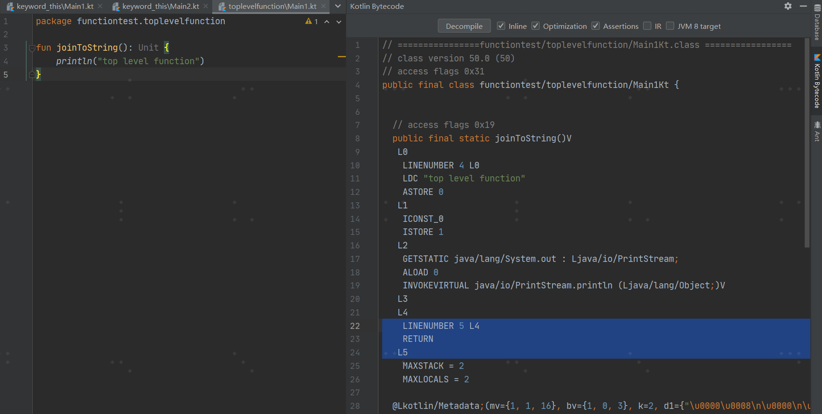

点“Decompile”得到

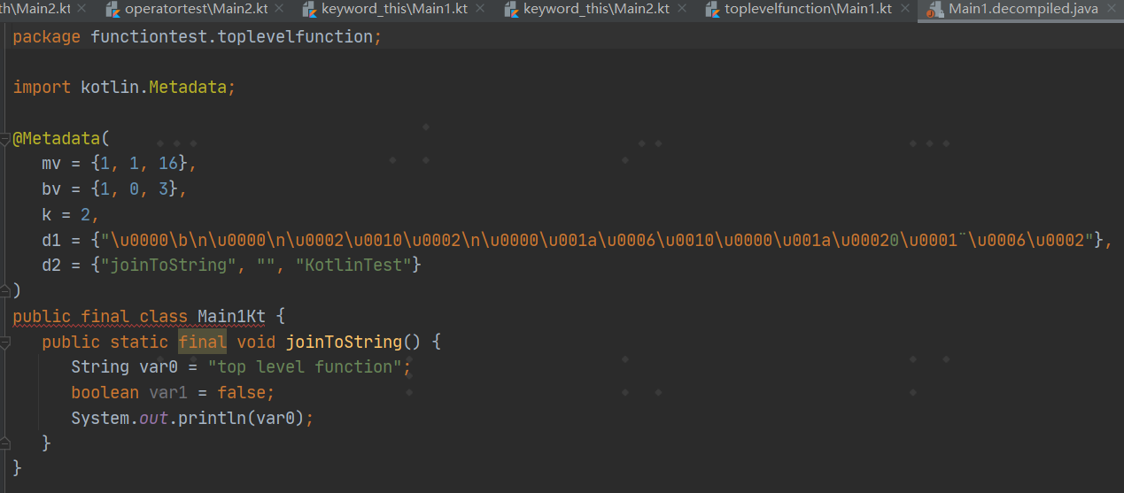

##### 3） 局部函数：local functions

<https://kotlinlang.org/docs/functions.html#local-functions>

Kotlin supports local functions, which are functions inside other functions:

|  |
| --- |
| fun dfs(graph: Graph) {  fun dfs(current: Vertex, visited: MutableSet<Vertex>) {  if (!visited.add(current)) return  for (v in current.neighbors)  dfs(v, visited)  }   dfs(graph.vertices[0], HashSet()) } |

A local function can access local variables of outer functions (the closure). In the case above, visited can be a local variable:

|  |
| --- |
| fun dfs(graph: Graph) {  val visited = HashSet<Vertex>()  fun dfs(current: Vertex) {  if (!visited.add(current)) return  for (v in current.*neighbors*)  dfs(v)  }   dfs(graph.*vertices*[0]) } |

##### 4） 成员函数：member functions

<https://kotlinlang.org/docs/functions.html#member-functions>

A member function is a function that is defined inside a class or object:

|  |
| --- |
| class Sample {  fun foo() { print("Foo") }  } |

Member functions are called with dot notation:

|  |
| --- |
| Sample().foo() // creates instance of class Sample and calls foo |

示例：

|  |
| --- |
| class Sample {  fun foo() { *print*("Foo") } }  fun main() {  Sample().foo() // creates instance of class Sample and calls foo } |

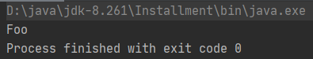

For more information on classes and overriding members see [Classes](https://kotlinlang.org/docs/classes.html) and [Inheritance](https://kotlinlang.org/docs/classes.html#inheritance).

##### 5） 扩展函数：Extension functions

###### 参1：<https://www.jianshu.com/p/3a815c51dcb5>

它使得我们能够动态地为一个类扩展新功能，而无需继承重写。

|  |
| --- |
| fun TextView.handleText(text: String) {  if (text.length > 7) {  var newText = text.substring(0, 7) + "..."  setText(newText)  //注意，这里相当于直接在TextView里哦！  }  } |

上面这个函数，给TextView扩展了一个功能！

|  |
| --- |
| tv_test.handleText("CoorChice为帅而生！") |

当函数写好后，你会发现，TextView已经拥有这个函数了！

一个类的扩展方法可以在编写它的地方使用，出了这个范围就不行了。但如果把扩展方法写在方法文件中，通过**import**导入后，可以导入的文件中使用。

++**注意：在Kotlin中，一个函数就可以作为一个文件！**++ 你不必为了书写一个函数而专门创建一个类。事实上，你可以把公共函数写到一个文件中，而不用专门创建一个类似于**AppUtils**之类的类。

###### 参2：<https://kotlinlang.org/docs/extensions.html#extension-functions>

To declare an extension function, prefix its name with a receiver type, which refers to the type being extended. The following adds a swap function to MutableList<Int>:

|  |
| --- |
| fun MutableList<Int>.swap(index1: Int, index2: Int) {  val tmp = this[index1] // 'this' corresponds to the list  this[index1] = this[index2]  this[index2] = tmp } |

The this keyword inside an extension function corresponds to the receiver object (the one that is passed before the dot). Now, you can call such a function on any MutableList<Int>:

|  |
| --- |
| val *list* = *mutableListOf*(1, 2, 3) list.swap(0, 2) // 'this' inside 'swap()' will hold the value of 'list' |

This function makes sense for any MutableList<T>, and you can make it generic:

|  |
| --- |
| fun <T> MutableList<T>.swap(index1: Int, index2: Int) {  val tmp = this[index1] // 'this' corresponds to the list  this[index1] = this[index2]  this[index2] = tmp } |

You need to declare the generic type parameter before the function name to make it available in the receiver type expression. For more information about generics, see [generic functions](https://kotlinlang.org/docs/generics.html).

#### 《x》 单表达式函数：single-expression functions

##### 1） 是什么

<https://kotlinlang.org/docs/functions.html#single-expression-functions>

When a function returns a single expression, the curly braces:大括号 can be omitted and the body is specified after a = symbol:

|  |
| --- |
| fun double(x: Int): Int = x * 2 |

Explicitly declaring the return type is [optional](https://kotlinlang.org/docs/functions.html#explicit-return-types) when this can be inferred by the compiler:

|  |
| --- |
| fun double(x: Int) = x * 2 |

##### 2） 示例

###### 1》 例1

<https://stackoverflow.com/questions/45875491/what-is-a-receiver-in-kotlin>

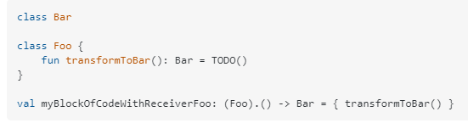

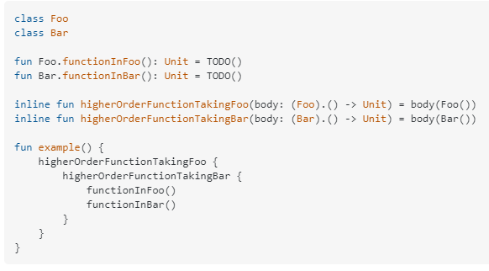

###### 2》 例2

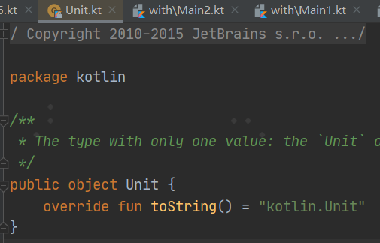

#### 《5》 高阶函数

见“【5】高阶函数和lambdas”

#### 《6》 内联函数

见“【x】内联函数”

#### 《7》 作用域函数

见“【x】作用域函数”

### 【5】 高阶函数和lambdas：High-order functions and lambdas

参考：

* 1. <https://kotlinlang.org/docs/lambdas.html>
  2. <https://www.kotlincn.net/docs/reference/lambdas.html>

#### 概述

##### Kotlin函数是什么：

Kotlin functions are [first-class](https://en.wikipedia.org/wiki/First-class_function), which means they can be stored in variables and data structures, and can be passed as arguments to and returned from other [higher-order functions](https://kotlinlang.org/docs/lambdas.html#higher-order-functions).

##### Kotlin如何操作函数：

You can perform any operations on functions that are possible for other non-function values.

##### Kotlin如何实现函数：

To facilitate this, Kotlin, as a statically typed programming language, uses a family of [function types](https://kotlinlang.org/docs/lambdas.html#function-types) to represent functions, and provides a set of specialized language constructs, such as [lambda expressions](https://kotlinlang.org/docs/lambdas.html#lambda-expressions-and-anonymous-functions).（为了实现这一点，作为一种静态类型编程语言，Kotlin使用一系列函数类型来表示函数，并提供了一组专门的语言结构，比如lambda表达式。）

#### 《2》 Higher-order functions：高阶函数

##### 1） 定义

A higher-order function is a function that takes functions as parameters, or returns a function.

##### 2） 示例：fold函数

###### 1》 fold函数语法

A good example of a higher-order function is the [functional programming idiom fold](https://en.wikipedia.org/wiki/Fold_(higher-order_function)) for collections.

It takes an initial accumulator value and a combining function and builds its return value by consecutively combining the current accumulator value with each collection element, replacing the accumulator value each time:

|  |
| --- |
| **fun** <T, R> Collection<T>.fold(  initial: R,  combine: (acc: R, nextElement: T) -> R  ): R {  **var** accumulator: R = initial  **for** (element: T **in** **this**) {  accumulator = combine(accumulator, element)  }  **return** accumulator  } |

In the code above, the combine parameter has the [function type](https://kotlinlang.org/docs/lambdas.html#function-types) (R, T) -> R, so it accepts a function that takes two arguments of types R and T and returns a value of type R. It is [invoked](https://kotlinlang.org/docs/lambdas.html#invoking-a-function-type-instance) inside the for loop, and the return value is then assigned to accumulator.

###### 2》 调用fold函数

To call fold, you need to pass an [instance of the function type](https://kotlinlang.org/docs/lambdas.html#instantiating-a-function-type) to it as an argument, and lambda expressions ([described in more detail below](https://kotlinlang.org/docs/lambdas.html#lambda-expressions-and-anonymous-functions)) are widely used for this purpose at higher-order function call sites:

|  |
| --- |
| fun main() {  val items = *listOf*(1, 2, 3, 4, 5)   // Lambdas are code blocks enclosed in curly braces.  items.*fold*(0, **{** // When a lambda has parameters, they go first, followed by '->'  acc: Int, i: Int **->** *print*("acc = $acc, i = $i, ")  val result = acc + i  *println*("result = $result")  // The last expression in a lambda is considered the return value:  result  **}**)   // Parameter types in a lambda are optional if they can be inferred:  val joinedToString = items.*fold*("Elements:", **{** acc, i **->** acc + " " + i **}**)   // Function references can also be used for higher-order function calls:  val product = items.*fold*(1, Int::times)   *println*("joinedToString = $joinedToString")  *println*("product = $product") } |

结果：

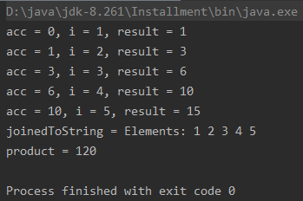

##### 3） 常用高阶函数

###### 1》 forEach（）

A） api

<https://kotlinlang.org/api/latest/jvm/stdlib/kotlin.collections/for-each.html>

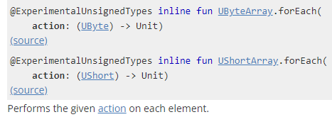

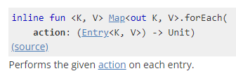

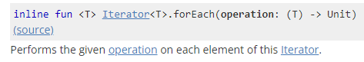

B） 是什么

<https://blog.csdn.net/m290345792/article/details/115656439>

对数据的主要遍历操作。常规的都是使用for循环。在kotlin的[函数式编程](https://so.csdn.net/so/search?q=%E5%87%BD%E6%95%B0%E5%BC%8F%E7%BC%96%E7%A8%8B&spm=1001.2101.3001.7020)中一般都是使用forEach和forEachIndexed。

forEach函数适用于Collection和Map集合，以及数组，函数只有一个函数类型的参数，实参往往使用尾随形式的Lambda表达式。在执行时forEach会把集合或数组中的每一个元素传递给Lambda表达式（或其他的函数引用）以便去执行。

C） 示例

A》 例1

<https://blog.csdn.net/m290345792/article/details/115656439>

|  |
| --- |
| fun main(args: Array<String>) {  val strArray = *arrayOf*("张三", "李四", "王五")  strArray.*forEach* **{** *println*(**it**)  **}** } |

结果：

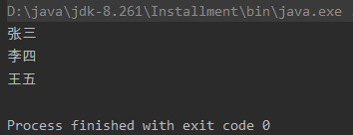

其中forEach源码为：

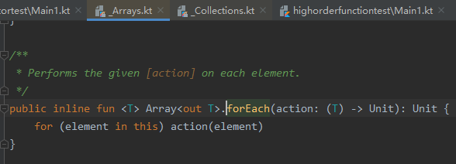

B》 例2

https://blog.csdn.net/wd2014610/article/details/79792262

|  |
| --- |
| fun main(args: Array<String>) {  //定义一个list  val list = *listOf*(1,3,4,5,6,7,43,63)  //再定义一个arrayList  val newList = ArrayList<Int>()   //一个集合的映射  list.*forEach***{** val newElement = **it** * 2 + 3  newList.add(newElement)  **}** newList.*forEach*(::println) } |

结果：

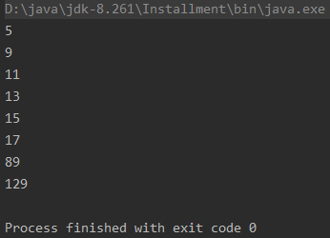

其中forEach源码为：

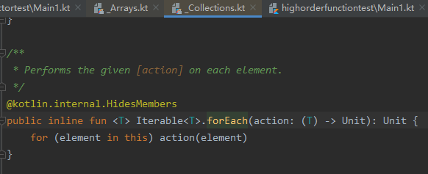

C》 例3

https://blog.csdn.net/weixin_33966365/article/details/88032252

#### 《3》 Function types

##### 1） 是什么

Kotlin uses function types, such as (Int) -> String, for declarations that deal with functions:

|  |
| --- |
| val onClick: () -> Unit = ... |

##### 2） 写法

These types have a special notation that corresponds to the signatures of the functions - their parameters and return values:

###### 1》 第1点：基本语法

* All function types have a parenthesized：加上括弧的 list of parameter types and a return type:

|  |
| --- |
| (A, B) -> C denotes a type that represents functions that take two arguments of types A and B and return a value of type C. |

* The list of parameter types may be empty, as in () -> A.
* The [Unit return type](https://kotlinlang.org/docs/functions.html#unit-returning-functions) cannot be omitted.

###### 2》 第2点：带receiver type的function type

* Function types can optionally have an additional receiver type, which is specified before the dot in the notation: the type A.(B) -> C represents functions that can be called on a receiver object A with a parameter B and return a value C.
* [Function literals with receiver](https://kotlinlang.org/docs/lambdas.html#function-literals-with-receiver) are often used along with these types.

###### 3》 第3点

* [Suspending functions](https://kotlinlang.org/docs/coroutines-basics.html#extract-function-refactoring) belong to a special kind of function type that have a suspend modifier in their notation, such as：

suspend () -> Unit or suspend A.(B) -> C.

###### 4》 第4点

The function type notation can optionally include names for the function parameters: (x: Int, y: Int) -> Point. These names can be used for documenting the meaning of the parameters.

###### 5》 第5点

To specify that a function type is [nullable](https://kotlinlang.org/docs/null-safety.html#nullable-types-and-non-null-types), use parentheses：圆括号 as follows: ((Int, Int) -> Int)?.

###### 6》 第6点

Function types can also be combined using parentheses:

(Int) -> ((Int) -> Unit).

注：The arrow notation is right-associative,

(Int) -> (Int) -> Unit is equivalent to the previous example, but not to ((Int) -> (Int)) -> Unit.

###### 7》 第7点

You can also give a function type an alternative name by using [a type alias](https://kotlinlang.org/docs/type-aliases.html)：类型别名:

**typealias** ClickHandler = (Button, ClickEvent) -> Unit

##### 3） instantiating a function type

There are several ways to obtain an instance of a function type:

###### 1》 方式1：function literal

* Use a code block within a function literal, in one of the following forms:
  + a [lambda expression](https://kotlinlang.org/docs/lambdas.html#lambda-expressions-and-anonymous-functions): { a, b -> a + b },
  + an [anonymous function](https://kotlinlang.org/docs/lambdas.html#anonymous-functions): fun(s: String): Int { return s.toIntOrNull() ?: 0 }
* [Function literals with receiver](https://kotlinlang.org/docs/lambdas.html#function-literals-with-receiver) can be used as values of function types with receiver.

###### 2》 方式2：“::”

* Use a callable reference to an existing declaration:
  + a top-level, local, member, or extension [function](https://kotlinlang.org/docs/reflection.html#function-references): ::isOdd, String::toInt,
  + a top-level, member, or extension [property](https://kotlinlang.org/docs/reflection.html#property-references): List<Int>::size,
  + a [constructor](https://kotlinlang.org/docs/reflection.html#constructor-references): ::Regex

These include [bound callable references](https://kotlinlang.org/docs/reflection.html#bound-function-and-property-references) that point to a member of a particular instance: foo::toString.

###### 3》 方式3：custom class

* Use instances of a custom class that implements a function type as an interface:

|  |
| --- |
| **class** IntTransformer: (Int) -> Int {  **override** **operator** **fun** invoke(x: Int): Int = TODO()  }  **val** intFunction: (Int) -> Int = IntTransformer() |

##### 4） Invoking a function type instance

A value of a function type can be invoked by using its [invoke(...) operator](https://kotlinlang.org/docs/operator-overloading.html#invoke-operator): f.invoke(x) or just f(x).

If the value has a receiver type, the receiver object should be passed as the first argument. Another way to invoke a value of a function type with receiver is to prepend it with the receiver object, as if the value were an [extension function](https://kotlinlang.org/docs/extensions.html): 1.foo(2).

Example:

|  |
| --- |
| fun main() {  val stringPlus: (String, String) -> String = String::plus  val intPlus: Int.(Int) -> Int = Int::plus   *println*(stringPlus.invoke("<-", "->"))  *println*(stringPlus("Hello, ", "world!"))   *println*(intPlus.invoke(1, 1))  *println*(intPlus(1, 2))  *println*(2.intPlus(3)) // extension-like call } |

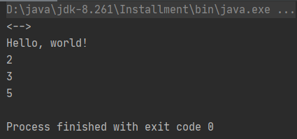

##### 5） Inline functions

Sometimes it is beneficial to use [inline functions](https://kotlinlang.org/docs/inline-functions.html), which provide flexible control flow, for higher-order functions.

#### 《4》 Lambda expressions and anonymous functions

##### 1） 概述

###### Lambda表达式+匿名函数 与 function literals的关系：

Lambda expressions and anonymous functions are **function literals**：函数字面值.

###### function literal定义：

**Function literals** are functions that are not declared but are passed immediately as an expression.

###### function literal示例：

Consider the following example:

|  |
| --- |
| max(strings, **{** a, b **->** a.length < b.length **}**) |

The function max is a higher-order function, as it takes a function value as its second argument.

This second argument is an expression that is itself a function, called a **function literal**, which is equivalent to the following named function：具名函数

|  |
| --- |
| **fun** compare(a: String, b: String): Boolean = a.length < b.length |

##### 2） Lambda expression：lambda表达式

###### 1》 Lambda expression syntax

完整语法：

The full syntactic form of lambda expressions is as follows:

|  |
| --- |
| **val** sum: (Int, Int) -> Int = { x: Int, y: Int -> x + y } |

* A lambda expression is always surrounded by curly braces：大/花括号.
* Parameter declarations in the full syntactic form go inside curly braces and have optional type annotations：类型标注.
* The body goes after the ->.
* If the inferred return type of the lambda is not Unit, the last (or possibly single) expression inside the lambda body is treated as the return value.

去掉所有可选标注后的语法：

If you leave all the optional annotations out, what's left looks like this: 如果你把所有可选的标注都去掉，剩下的看起来像这样：

|  |
| --- |
| **val** sum = { x: Int, y: Int -> x + y } |

###### 2》 Passing trailing lambdas

语法1：

According to Kotlin convention, if the last parameter of a function is a function, then a lambda expression passed as the corresponding argument can be placed outside the parentheses: 如果函数的最后一个参数是函数，那么作为相应实参传入的 lambda 表达式可以放在圆括号之外

|  |
| --- |
| val product = items.fold(1) { acc, e -> acc * e } |

Such syntax is also known as **trailing lambda：**拖尾lambda表达式.

示例：

|  |
| --- |
| package lyh.lambda  fun main() {  val items = *listOf*(1, 2, 3, 4, 5)  var product = items.*fold*(1) **{** acc, e **->** acc * e **}** *println*(product) } |

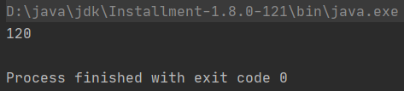

其中fold函数：

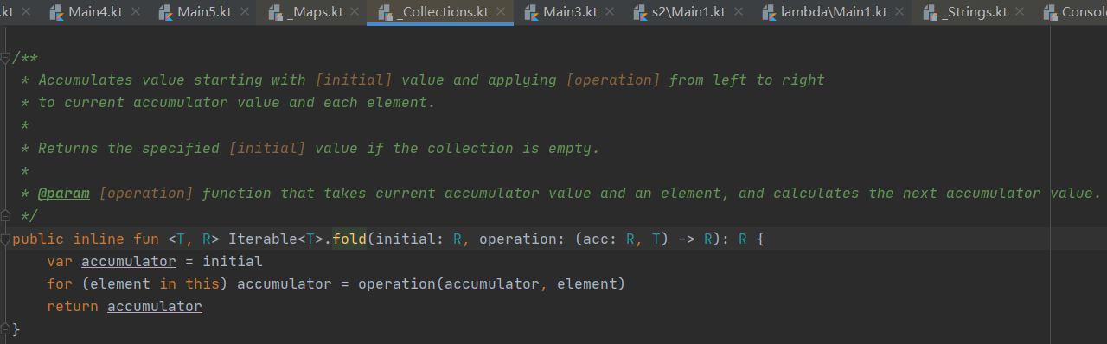

语法2：

If the lambda is the only argument in that call, the parentheses can be omitted entirely: 如果该 lambda 表达式是调用时唯一的参数，那么圆括号可以完全省略

|  |
| --- |
| run { println(**"..."**) } |

示例：

|  |
| --- |
| fun main() {  val items = *listOf*(1, 2, 3)  items.*run* **{** *println*("in run() function") **}** } |

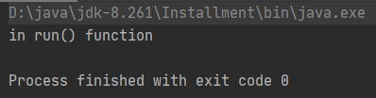

其中run函数：

|  |
| --- |
| */**  * Calls the specified function [block] with `this` value as its receiver and returns its result.  *  * For detailed usage information see the documentation for [scope functions](https://kotlinlang.org/docs/reference/scope-functions.html#run).  */* @kotlin.internal.InlineOnly public inline fun <T, R> T.run(block: T.() -> R): R {  *contract* **{** callsInPlace(block, InvocationKind.EXACTLY_ONCE)  **}** return block() } |

###### 3》 it: implicit name of a single parameter

语法：

It's very common for a lambda expression to have only one parameter.

If the compiler can parse the signature without any parameters, the parameter does not need to be declared and -> can be omitted. The parameter will be implicitly declared under the name it:如果编译器能识别出签名，则可以不用声明唯一的参数 并 可以忽略->。该参数会隐式声明为it。

示例1：单参

|  |
| --- |
| ints.filter { it > 0 } // this literal is of type '(it: Int) -> Boolean' |

运行：

|  |
| --- |
| package lyh.lambda  fun main() {  val ints = *listOf*(1, 2, 3, 4)  val ints1 = ints.*filter* **{ it** > 2 **}** *println*(ints1) } |

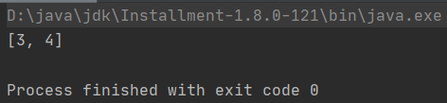

其中filter函数：

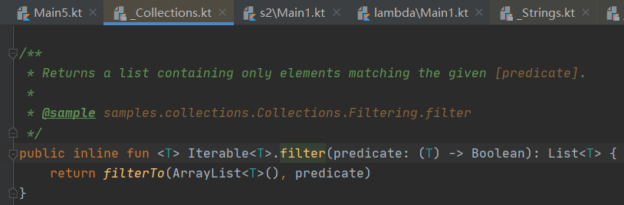

示例2：无参

<https://www.jianshu.com/p/3503a9a7c816>

|  |
| --- |
| package threadtest  import kotlin.concurrent.thread  fun main() {  *thread* **{** for (x in 1..100) {  *println*("message：$x")  Thread.sleep(2000)  }  **}** } |

其中thread函数

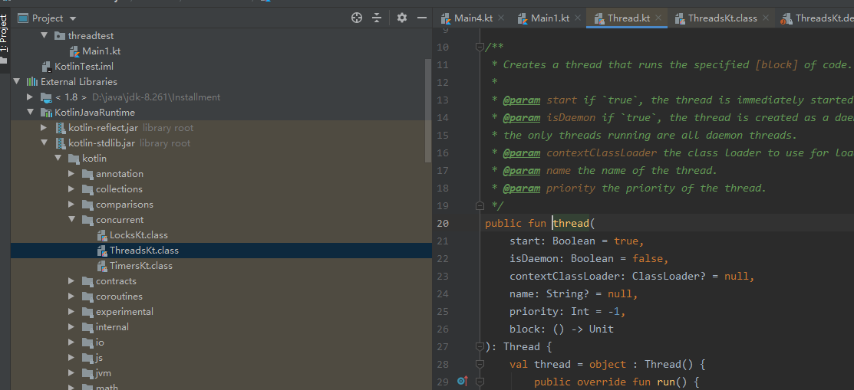

###### 4》 Returning a value from a lambda expression

语法：

You can explicitly return a value from the lambda using the [qualified return](https://kotlinlang.org/docs/returns.html#return-to-labels) syntax. Otherwise, the value of the last expression is implicitly returned.

示例：

Therefore, the two following snippets：代码片段 are equivalent:

|  |
| --- |
| ints.filter {  **val** shouldFilter = it > 0  shouldFilter  }  ints.filter {  **val** shouldFilter = it > 0  **return**@filter shouldFilter  } |

运行：

|  |
| --- |
| package lyh.lambda  fun main() {  val ints = *listOf*(1, 2, 3, 4)   *println*("方式1：" + ints.*filter* **{** val shouldFilter = **it** > 2  shouldFilter  **}**)   *println*("方式2：" + ints.*filter* **{** val shouldFilter = **it** > 2  return@filter shouldFilter  **}**) } |

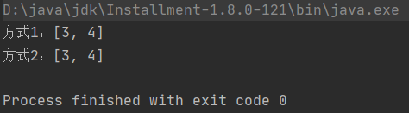

其中filter函数：

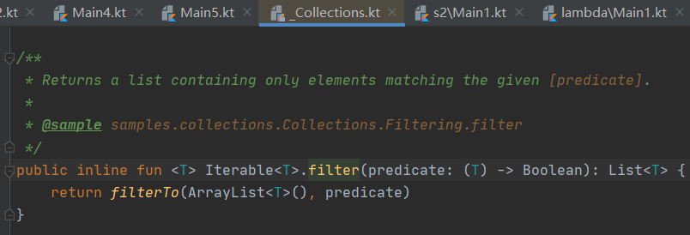

和2》结合：

This convention, along with [passing a lambda expression outside of parentheses](https://kotlinlang.org/docs/lambdas.html#passing-trailing-lambdas), allows for [LINQ-style](https://docs.microsoft.com/en-us/previous-versions/dotnet/articles/bb308959(v=msdn.10)) code:

|  |
| --- |
| strings.filter { it.length == 5 }.sortedBy { it }.map { it.uppercase() } |

运行：

|  |
| --- |
| package lyh.lambda  fun main() {  *m2*() }  fun m2() {  val strings = *listOf*("aaaaaa", "bbbbb", "ccc", "d", "eeeeeeee")  *println*(strings.*filter* **{ it**.length <= 3 **}**.*sortedBy* **{ it }**.*map* **{ it**.*uppercase*() **}**) } |

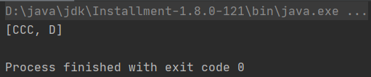

###### 5》 Underscore:下划线 for unused variables

语法：

If the lambda parameter is unused, you can place an underscore instead of its name.

示例：

|  |
| --- |
| map.forEach { _, value -> println(**"$value!"**) } |

运行：

|  |
| --- |
| package lyh.lambda  fun main() {  val map = *mapOf*("one" *to* 1, "two" *to* 2, "three" *to* 3)  map.*forEach* **{** (_, value) **->** *println*("$value!")**}** //_Maps.kt  *println*("=========================")  map.forEach **{** _, value **->** *println*("$value!")**}** //Map.java } |

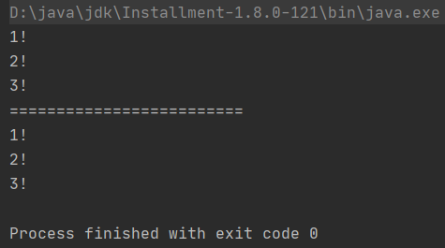

第二个forEach报：

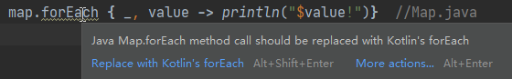

其中第一个forEach函数：

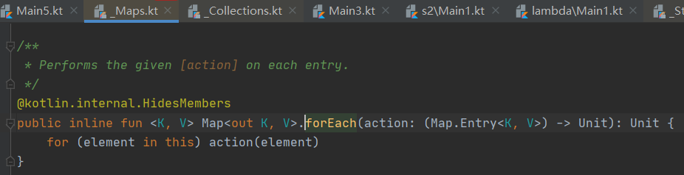

第二个forEach函数：

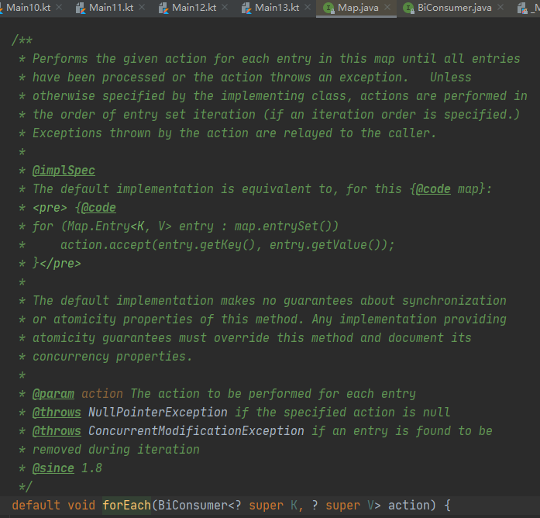

###### 6》 Destructuring in lambdas

Destructuring in lambdas is described as a part of [destructuring declarations](https://kotlinlang.org/docs/destructuring-declarations.html#destructuring-in-lambdas).

##### 3） Anonymous functions：匿名函数

###### 1》 lambda表达式和匿名函数 的区别1

The lambda expression syntax above is missing one thing – the ability to specify the function’s return type. In most cases, this is unnecessary because the return type can be inferred automatically. However, if you do need to specify it explicitly, you can use an alternative syntax: an **anonymous function**.

###### 2》 匿名函数 语法

A） 语法1：匿名函数声明

An anonymous function looks very much like a regular function declaration：常规函数声明, except its name is omitted. Its body can be either an expression：

|  |
| --- |
| **fun**(x: Int, y: Int): Int = x + y |

or a block:

|  |
| --- |
| **fun**(x: Int, y: Int): Int {  **return** x + y  } |

运行：【参考：<https://www.jianshu.com/p/8eb0623f08c6> 】

|  |
| --- |
| package lyh.lambda  fun main() {  *m52*() }  fun m52() {  var anonymousFun = fun(x: Int, y: Int): Int = x + y  *println*(anonymousFun(2, 3))   *println*("=================")  anonymousFun = fun(x: Int, y: Int): Int {  return x + y  }  *println*(anonymousFun(2, 3)) } |

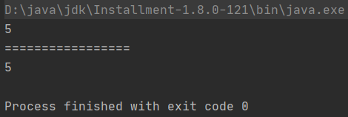

B） 语法2：参数类型推断

The parameters and the return type are specified in the same way as for regular functions, except the parameter types can be omitted if they can be inferred from the context:

|  |
| --- |
| ints.filter(**fun**(item) = item > 0) |

运行：

|  |
| --- |
| fun main() {  val ints = *listOf*(1, 2, 3, 4)  *println*(ints.*filter*(fun(item) = item > 2)) //anonymous functions写法：结果=[3, 4] // println(ints.filter{fun(item) = item > 2}) //anonymous functions用lambda expression写法：编译报错  *println*(ints.*filter***{** item **->** item > 2 **}**) //lambda expression写法1：结果=[3， 4]  *println*(ints.*filter***{ it** > 2 **}**) //lambda expression写法2：结果=[3， 4] } |

其中编译报错为：

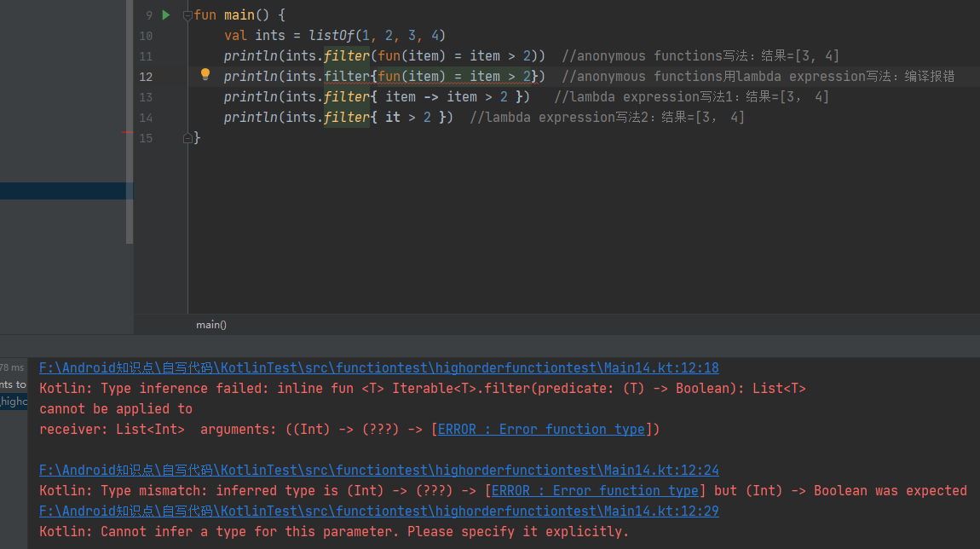

其中filter函数：

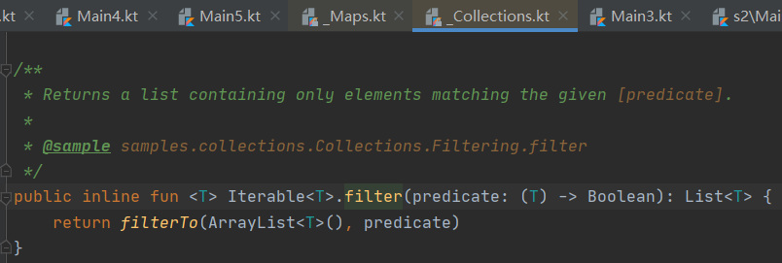

C） 语法3：返回类型推断

The return type inference for anonymous functions works just like for normal functions：正常函数:

* the return type is inferred automatically for anonymous functions with an expression body
* but it has to be specified explicitly (or is assumed to be Unit) for anonymous functions with a block body

示例同B）

###### 3》 lambda表达式和匿名函数 的区别2

When passing anonymous functions as parameters, place them inside the parentheses. The shorthand syntax that allows you to leave the function outside the parentheses works only for lambda expressions.：当传递匿名函数作为参数时，将它们放在圆括号内。允许将函数放在括号外的简写语法只适用于lambda表达式。

###### 4》 lambda表达式和匿名函数 的区别3

Another difference between lambda expressions and anonymous functions is the behavior of [non-local returns](https://kotlinlang.org/docs/inline-functions.html#non-local-returns). A return statement without a label always returns from the function declared with the fun keyword. This means that a return inside a lambda expression will return from the enclosing function, whereas a return inside an anonymous function will return from the anonymous function itself.：lambda表达式和匿名函数之间的另一个区别是非局部返回的行为。不带标签的return语句总是从使用fun关键字声明的函数返回。这意味着，lambda表达式内部的return将从外围函数返回，而匿名函数内部的return将从匿名函数本身返回。

##### 4） Closures：闭包

A lambda expression or anonymous function (as well as a [local function](https://kotlinlang.org/docs/functions.html#local-functions) and an [object expression](https://kotlinlang.org/docs/object-declarations.html#object-expressions)) can access its closure, which includes the variables declared in the outer scope. The variables captured in the closure can be modified in the lambda:

|  |
| --- |
| var sum = 0  ints.filter { it > 0 }.forEach {  sum += it  }  print(sum) |

示例：

|  |
| --- |
| fun main() {  var sum = 0  val ints = *listOf*(-1, -2, 0, 1, 2)  ints.*filter* **{ it** > 0 **}**.*forEach* **{** sum += **it  }** *print*(sum) } |

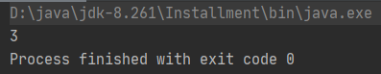

##### 5） Function literals with receiver

### 【x】 内联函数：inline functions

<https://kotlinlang.org/docs/inline-functions.html>

<https://www.kotlincn.net/docs/reference/inline-functions.html>

#### 《1》 概述

##### 参1：<https://www.jianshu.com/p/8a0d5bae9cdf>

##### 参2：<https://kotlinlang.org/docs/inline-functions.html>

#### 《2》 noinline：禁用内联

#### 《3》 Non-local returns：非局部返回

#### 《4》 Reified type parameters：具体化的类型参数

<https://kotlinlang.org/docs/inline-functions.html#reified-type-parameters>

<https://www.jianshu.com/p/24397a9dd428>

<https://kotlinlang.org/docs/keyword-reference.html#special-identifiers>

##### 1） 是什么

###### 参1：<https://kotlinlang.org/docs/keyword-reference.html#special-identifiers>

reified marks a type parameter of an inline function as [accessible at runtime](https://kotlinlang.org/docs/inline-functions.html#reified-type-parameters).

##### 2） 使用场景

<https://www.jianshu.com/p/24397a9dd428>

<https://kotlinlang.org/docs/inline-functions.html#reified-type-parameters>

#### 《5》 Inline properties：内联属性

#### 《6》 Restrictions for public API inline functions

### 【x】 运算符重载：operator overloading

<https://kotlinlang.org/docs/operator-overloading.html>

<https://www.kotlincn.net/docs/reference/operator-overloading.html>

### 【x】 作用域函数：scope functions（版本一：官网）

<https://kotlinlang.org/docs/scope-functions.html>

<https://book.kotlincn.net/text/scope-functions.html>

#### 《1》 概述

##### 什么是scope function：

The Kotlin standard library contains several functions whose sole purpose（唯一目的） is to execute a block of code within the context of an object. When you call such a function on an object with a [lambda expression](https://kotlinlang.org/docs/lambdas.html) provided, it forms a temporary scope（临时作用域）. In this scope, you can access the object without its name. Such functions are called **scope functions**.

There are five of them: let, run, with, apply, and also.

##### 5个函数的异同：

同：Basically, these functions do the same: execute a block of code on an object.

异：What's different is how this object becomes available inside the block and what is the result of the whole expression.

##### 示例：

Here's a typical usage of a scope function:

|  |
| --- |
| data class Person(var name: String, var age: Int, var city: String) {  fun moveTo(newCity: String) { city = newCity }  fun incrementAge() { age++ } }  fun main() {  Person("Alice", 20, "Amsterdam").*let* **{** *println*(**it**)  **it**.moveTo("London")  **it**.incrementAge()  *println*(**it**)  **}** } |

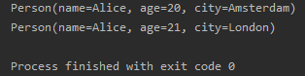

If you write the same without let, you'll have to introduce a new variable and repeat its name whenever you use it.

|  |
| --- |
| data class Person(var name: String, var age: Int, var city: String) {  fun moveTo(newCity: String) { city = newCity }  fun incrementAge() { age++ }  }  fun main() {  val alice = Person("Alice", 20, "Amsterdam")  println(alice)  alice.moveTo("London")  alice.incrementAge()  println(alice)  } |

##### 优点：

The scope functions do not introduce any new technical capabilities, but they can make your code more concise and readable（简明和可读）.

##### 如何选择scope function：

Due to the similar nature of scope functions, choosing the right one for your case can be a bit tricky. The choice mainly depends on your intent and the consistency of use in your project.

 Below we'll provide detailed descriptions of the distinctions between scope functions and the conventions on their usage.

#### 《2》 Function selection

##### 1） 关键不同

To help you choose the right scope function for your purpose, we provide the table of key differences between them.

| **Function** | **Object reference** | **Return value** | **Is extension function** |
| --- | --- | --- | --- |
| let | it | Lambda result | Yes |
| run | this | Lambda result | Yes |
| run | - | Lambda result | No: called without the context object |
| with | this | Lambda result | No: takes the context object as an argument |
| apply | this | Context object | Yes |
| also | it | Context object | Yes |

The detailed information about the differences is provided in the dedicated：专门的 sections below.

##### 2） 选取建议

###### 1》 建议1

Here is a short guide for choosing scope functions depending on the intended purpose:

* Executing a lambda on non-null objects: let
* Introducing an expression as a variable in local scope: let
* Object configuration: apply
* Object configuration and computing the result: run
* Running statements where an expression is required: non-extension run
* Additional effects: also
* Grouping function calls on an object: with

###### 2》 建议2

The use cases（使用情况） of different functions overlap:重叠, so that you can choose the functions based on the specific conventions used in your project or team.

##### 3） 注意点

1. Although the scope functions are a way of making the code more concise:简洁, avoid overusing:过度使用 them: it can decrease your code readability and lead to errors.

2. Avoid nesting scope functions and be careful when chaining them: it's easy to get confused about the current context object and the value of this or it.（很容易混淆当前上下文对象和this或It的值。）

#### 《3》 Distinctions

##### 1） 概述

Because the scope functions are all quite similar in nature, it's important to understand the differences between them.

There are two main differences between each scope function:

* The way to refer to the context object
* The return value.

##### 2) Context object：this or it

###### 1》 概述

Inside the lambda of a scope function, the context object is available by a short reference instead of its actual name.

Each scope function uses one of two ways to access the context object: as a lambda [receiver](https://kotlinlang.org/docs/lambdas.html#function-literals-with-receiver) (this) or as a lambda argument (it ). Both provide the same capabilities, so we'll describe the pros and cons of each for different cases and provide recommendations on their use.（两者提供相同的功能，因此我们将描述它们在不同情况下的优缺点，并提供它们的使用建议。）

|  |
| --- |
| fun main() {  val str = "Hello"  // this  str.*run* **{** *println*("The receiver string length: $length")  //println("The receiver string length: ${this.length}") // does the same  **}** // it  str.*let* **{** *println*("The receiver string's length is ${**it**.length}")  **}** } |

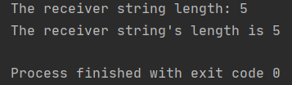

###### 2》 this

* + 1. 是什么：

run, with, and apply refer to the context object as a lambda receiver - by keyword this. run, with, and apply refer to the context object as a lambda receiver - by keyword this.

B) this可省略：

In most cases, you can omit this when accessing the members of the receiver object, making the code shorter.

C) this最好别省略：

On the other hand, if this is omitted, it can be hard to distinguish between the receiver members and external objects or functions. So, having the context object as a receiver (this) is recommended for lambdas that mainly operate on the object members: call its functions or assign properties（因此，对于主要操作对象成员（调用其函数或对属性赋值）的lambdas，建议将上下文对象作为接收器(this)）.

|  |
| --- |
| data class Person(var name: String, var age: Int = 0, var city: String = "")  fun main() {  val adam = Person("Adam").*apply* **{** age = 20 // same as this.age = 20 or adam.age = 20  city = "London"  **}** *println*(adam) } |

###### 3》 it

* + 1. 是什么：

In turn, let and also have the context object as a lambda argument. If the argument name is not specified, the object is accessed by the implicit default name it.

* + 1. 和this比优点：

it is shorter than this and expressions with it are usually easier for reading.

* + 1. 和this比缺点：

However, when calling the object functions or properties you don't have the object available implicitly like this.

* + 1. 使用时机：

1. Hence, having the context object as it is better when the object is mostly used as an argument in function calls.

2. it is also better if you use multiple variables in the code block.

|  |
| --- |
| import kotlin.random.Random  fun writeToLog(message: String) {  *println*("INFO: $message") }  fun main() {  fun getRandomInt(): Int {  return Random.nextInt(100).*also* **{** *writeToLog*("getRandomInt() generated value $**it**")  **}** }   val i = getRandomInt()  *println*(i) } |

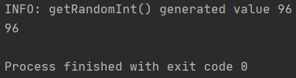

* + 1. 自定义context object名字：

Additionally, when you pass the context object as an argument, you can provide a custom name for the context object inside the scope.

|  |
| --- |
| import kotlin.random.Random  fun writeToLog(message: String) {  *println*("INFO: $message") }  fun main() {  fun getRandomInt(): Int {  return Random.nextInt(100).*also* **{** value **->** *writeToLog*("getRandomInt() generated value $value")  **}** }   val i = getRandomInt()  *println*(i) } |

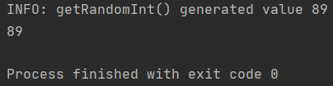

##### 3) Return value

###### 1》 概述

The scope functions differ by the result they return:

* apply and also return the context object.
* let, run, and with return the lambda result.

These two options let you choose the proper function depending on what you do next in your code.

###### 2》 Context object

是什么：

The return value of apply and also is the context object itself.

使用：

* 1. Hence, they can be included into call chains as side steps: you can continue chaining function calls on the same object after them.

|  |
| --- |
| fun main() {  val numberList = *mutableListOf*<Double>()  numberList.*also* **{** *println*("Populating the list") **}** .*apply* **{** add(2.71)  add(3.14)  add(1.0)  **}** .*also* **{** *println*("Sorting the list") **}** .*sort*()  *println*(numberList) } |

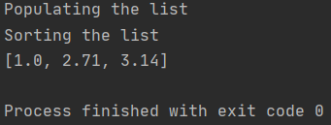

* 1. They also can be used in return statements of functions returning the context object.

|  |
| --- |
| import kotlin.random.Random  fun writeToLog1(message: String) {  *println*("INFO: $message") }  fun main() {  fun getRandomInt(): Int {  return Random.nextInt(100).*also* **{** *writeToLog1*("getRandomInt() generated value $**it**")  **}** }   val i = getRandomInt() } |

###### 3》 Lambda result

是什么：

let, run, and with return the lambda result.

使用：

1. So, you can use them when assigning the result to a variable, chaining operations on the result, and so on.

|  |
| --- |
| fun main() {  val numbers = *mutableListOf*("one", "two", "three")  val countEndsWithE = numbers.*run* **{** add("four")  add("five")  *count* **{ it**.*endsWith*("e") **}  }** *println*("There are $countEndsWithE elements that end with e.") } |

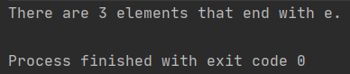

1. Additionally, you can ignore the return value and use a scope function to create a temporary scope for variables.

|  |
| --- |
| fun main() {  val numbers = *mutableListOf*("one", "two", "three")  *with*(numbers) **{** val firstItem = *first*()  val lastItem = *last*()  *println*("First item: $firstItem, last item: $lastItem")  **}** } |

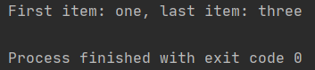

#### 《4》 Functions

To help you choose the right scope function for your case, we'll describe them in detail and provide usage recommendations.

Technically, functions are interchangeable:通用 in many cases, so the examples show the conventions that define the common usage style.

##### 1） let

###### 1》 概述

**The context object** is available as an argument (it). **The return value** is the lambda result.

###### 2》 源码

|  |
| --- |
| */**  * Calls the specified function [block] with `this` value as its argument and returns its result.  *  * For detailed usage information see the documentation for [scope functions](https://kotlinlang.org/docs/reference/scope-functions.html#let).  */* @kotlin.internal.InlineOnly public inline fun <T, R> T.let(block: (T) -> R): R {  *contract* **{** callsInPlace(block, InvocationKind.EXACTLY_ONCE)  **}** return block(this) } |

###### 3》 详述

A） 场景1

let can be used to invoke one or more functions on results of call chains.

A》 原始代码

For example, the following code prints the results of two operations on a collection:

|  |
| --- |
| fun main() {  val numbers = *mutableListOf*("one", "two", "three", "four", "five")  val resultList = numbers.*map* **{ it**.length **}**.*filter* **{ it** > 3 **}** *println*(resultList) } |

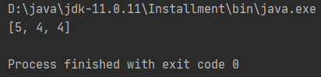

B》 改成let+lambda

With let, you can rewrite it:

|  |
| --- |
| fun main() {  val numbers = *mutableListOf*("one", "two", "three", "four", "five")  numbers.*map* **{ it**.length **}**.*filter* **{ it** > 3 **}**.*let* **{** *println*(**it**)  // and more function calls if needed  **}** } |

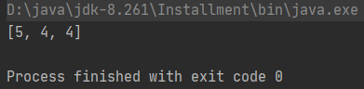

C》 改成let+method reference

If the code block contains a single function with it as an argument:实参, you can use the method reference (::) instead of the lambda:

|  |
| --- |
| fun main() {  val numbers = *mutableListOf*("one", "two", "three", "four", "five")  numbers.*map* **{ it**.length **}**.*filter* **{ it** > 3 **}**.*let*(::println) } |

B） 场景2

let is often used for executing a code block only with non-null values. To perform actions on a non-null object, use the [safe call operator ?.](https://kotlinlang.org/docs/null-safety.html#safe-calls) on it and call let with the actions in its lambda.

|  |
| --- |
| fun processNonNullString(str: String) {}  fun main() {  val str: String? = "Hello"  //processNonNullString(str) // compilation error: str can be null  val length = str?.let {  println("let() called on $it")  processNonNullString(it) // OK: 'it' is not null inside '?.let { }'  it.length  }  } |

运行：

|  |
| --- |
| fun processNonNullString(str: String) {  *println*("processNonNullString function parameter=$str") }  fun main() {  val str: String? = "Hello" // processNonNullString(str) // compilation error: "Type mismatch: inferred type is String? but String was expected"  val length = str?.*let* **{** *println*("let() called on $**it**")  *processNonNullString*(**it**) // OK: 'it' is not null inside '?.let { }'  **it**.length  **}** *println*("length from let function is $length") } |

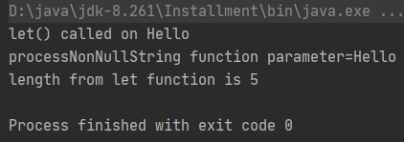

C） 场景3

Another case for using let is introducing local variables with a limited scope for improving code readability. To define a new variable for the context object, provide its name as the lambda argument so that it can be used instead of the default it.

|  |
| --- |
| fun main() {  val numbers = listOf("one", "two", "three", "four")  val modifiedFirstItem = numbers.first().let { firstItem ->  println("The first item of the list is '$firstItem'")  if (firstItem.length >= 5) firstItem else "!" + firstItem + "!"  }.uppercase()  println("First item after modifications: '$modifiedFirstItem'")  } |

运行：

|  |
| --- |
| fun main() {  val numbers = *listOf*("one", "two", "three", "four")  val modifiedFirstItem = numbers.*first*().*let* **{** firstItem **->** *println*("The first item of the list is '$firstItem'")  if (firstItem.length >= 5) firstItem else "!" + firstItem + "!"  **}**.*toUpperCase*()  *println*("First item after modifications: '$modifiedFirstItem'") } |

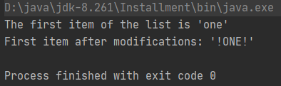

##### 2） with

###### 1》 概述

A non-extension function: **the context object** is passed as an argument, but inside the lambda, it's available as a receiver (this). **The return value** is the lambda result.

###### 2》 源码

|  |
| --- |
| */**  * Calls the specified function [block] with the given [receiver] as its receiver and returns its result.  *  * For detailed usage information see the documentation for [scope functions](https://kotlinlang.org/docs/reference/scope-functions.html#with).  */* @kotlin.internal.InlineOnly public inline fun <T, R> with(receiver: T, block: T.() -> R): R {  *contract* **{** callsInPlace(block, InvocationKind.EXACTLY_ONCE)  **}** return receiver.block() } |

###### 3》 详述

A） 场景1

We recommend with for calling functions on the context object without providing the lambda result. In the code, with can be read as “with this object, do the following.”

|  |
| --- |
| fun main() {  val numbers = *mutableListOf*("one", "two", "three")  *with*(numbers) **{** *println*("'with' is called with argument $this")  *println*("It contains $size elements")  **}** } |

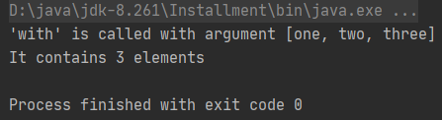

其中“size”为

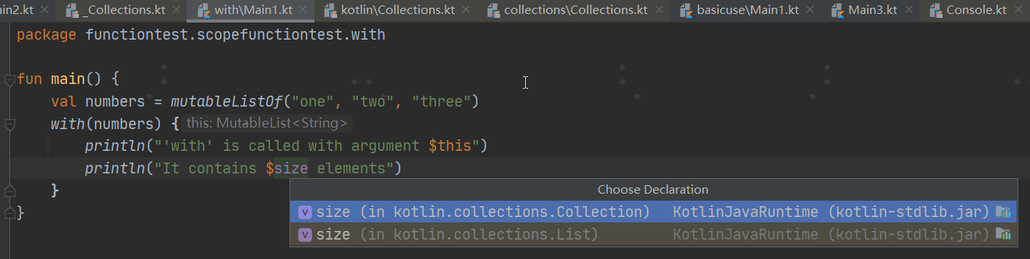

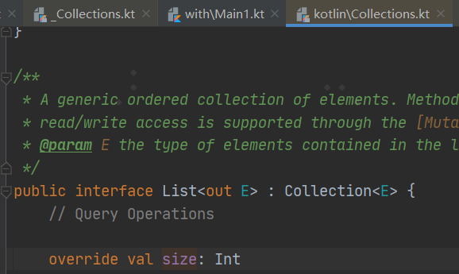

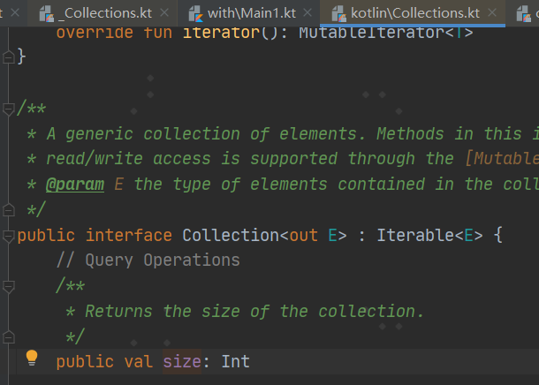

B） 场景2

Another use case for with is introducing a helper object whose properties or functions will be used for calculating a value.

|  |
| --- |
| fun main() {  val numbers = *mutableListOf*("one", "two", "three")  val firstAndLast = *with*(numbers) **{** "The first element is ${*first*()}," +  " the last element is ${*last*()}"  **}** *println*(firstAndLast) } |

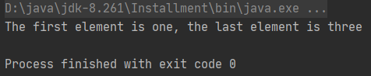

其中：

first（）为：

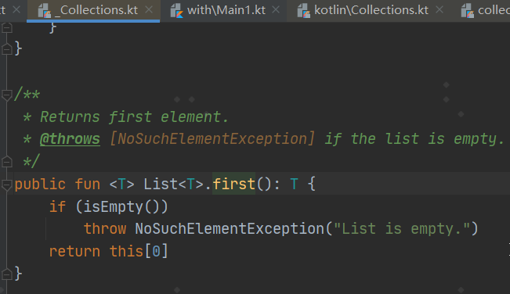

last（）为：

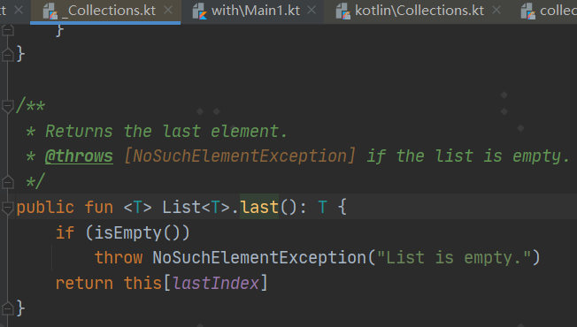

##### 3） run

###### 1》 概述

**The context object** is available as a receiver (this). **The return value** is the lambda result.

###### 2》 扩展函数run

A） 概述

run does the same as with but invokes as let - as an extension function of the context object.

B） 源码

|  |
| --- |
| */**  * Calls the specified function [block] with `this` value as its receiver and returns its result.  *  * For detailed usage information see the documentation for [scope functions](https://kotlinlang.org/docs/reference/scope-functions.html#run).  */* @kotlin.internal.InlineOnly public inline fun <T, R> T.run(block: T.() -> R): R {  *contract* **{** callsInPlace(block, InvocationKind.EXACTLY_ONCE)  **}** return block() } |

C） 场景

run is useful when your lambda contains both the object initialization and the computation of the return value.

|  |
| --- |
| class MultiportService(var url: String, var port: Int) {  fun prepareRequest(): String = "Default request"  fun query(request: String): String = "Result for query '$request'" }  fun main() {  val service = MultiportService("https://example.kotlinlang.org", 80)   val result = service.*run* **{** port = 8080  query(prepareRequest() + " to port $port")  **}** // the same code written with let() function:  val letResult = service.*let* **{  it**.port = 8080  **it**.query(**it**.prepareRequest() + " to port ${**it**.port}")  **}** *println*(result)  *println*(letResult) } |

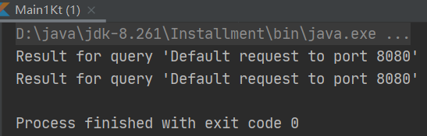

###### 3》 非扩展函数run

A） 概述

Besides calling run on a receiver object, you can use it as a non-extension function.

B） 源码

|  |
| --- |
| */**  * Calls the specified function [block] and returns its result.  *  * For detailed usage information see the documentation for [scope functions](https://kotlinlang.org/docs/reference/scope-functions.html#run).  */* @kotlin.internal.InlineOnly public inline fun <R> run(block: () -> R): R {  *contract* **{** callsInPlace(block, InvocationKind.EXACTLY_ONCE)  **}** return block() } |

C） 场景

Non-extension run lets you execute a block of several statements where an expression is required.

|  |
| --- |
| fun main() {  val hexNumberRegex = *run* **{** val digits = "0-9"  val hexDigits = "A-Fa-f"  val sign = "+-"   Regex("[$sign]?[$digits$hexDigits]+")  **}** for (match in hexNumberRegex.findAll("+123 -FFFF !%*& 88 XYZ")) {  *println*(match.value)  } } |

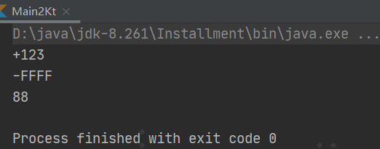

##### 4） apply

###### 1》 概述

**The context object** is available as a receiver (this). **The return value** is the object itself.

###### 2》 源码

|  |
| --- |
| */**  * Calls the specified function [block] with `this` value as its receiver and returns `this` value.  *  * For detailed usage information see the documentation for [scope functions](https://kotlinlang.org/docs/reference/scope-functions.html#apply).  */* @kotlin.internal.InlineOnly public inline fun <T> T.apply(block: T.() -> Unit): T {  *contract* **{** callsInPlace(block, InvocationKind.EXACTLY_ONCE)  **}** block()  return this } |

###### 3》 详述

A） 场景1

Use apply for code blocks that don't return a value and mainly operate on the members of the receiver object.

The common case for apply is the object configuration.

Such calls can be read as “ apply the following assignments to the object.”

|  |
| --- |
| data class Person(var name: String, var age: Int = 0, var city: String = "")  fun main() {  val adam = Person("Adam").*apply* **{** age = 32  city = "London"  **}** *println*(adam) } |

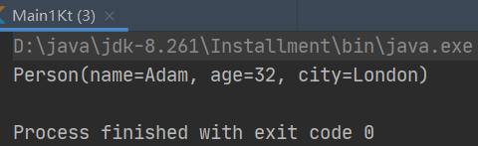

B） 场景2

Having the receiver as the return value, you can easily include apply into call chains for more complex processing.

##### 5） also

###### 1》 概述

**The context object** is available as an argument (it). **The return value** is the object itself.

###### 2》 源码

|  |
| --- |
| */**  * Calls the specified function [block] with `this` value as its argument and returns `this` value.  *  * For detailed usage information see the documentation for [scope functions](https://kotlinlang.org/docs/reference/scope-functions.html#also).  */* @kotlin.internal.InlineOnly @SinceKotlin("1.1") public inline fun <T> T.also(block: (T) -> Unit): T {  *contract* **{** callsInPlace(block, InvocationKind.EXACTLY_ONCE)  **}** block(this)  return this } |

###### 3》 详述

also is good for performing some actions that take the context object as an argument. Use also for actions that need a reference to the object rather than its properties and functions, or when you don't want to shadow the this reference from an outer scope.：also 对于执行一些将上下文对象作为参数的操作很有用。 对于需要引用对象而不是其属性与函数的操作，或者不想屏蔽来自外部作用域的 this 引用时， 请使用 also。

When you see also in the code, you can read it as “and also do the following with the object.”

|  |
| --- |
| fun main() {  val numbers = mutableListOf("one", "two", "three")  numbers  .also { println("The list elements before adding new one: $it") }  .add("four")  } |

运行：

|  |
| --- |
| fun main() {  val numbers = *mutableListOf*("one", "two", "three")  numbers  .*also* **{** *println*("The list elements before adding new one: $**it**") **}** .add("four") // println("The list elements after adding new one: $numbers") //写法1  *println*("The list elements after adding new one: " + numbers) //写法2 } |

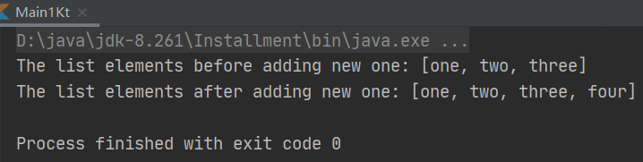

##### 实例：

###### 例1：

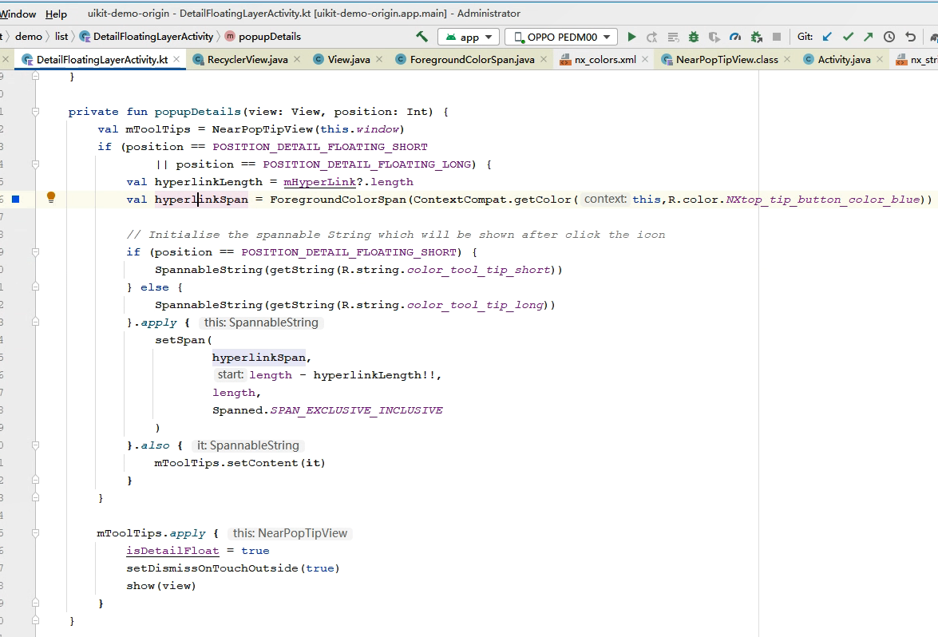

对应：uikitdemo-列表与列表控件-列表控件-详情浮层-短信息/长信息浮层，点击警告圆圈后弹出提示框的逻辑。

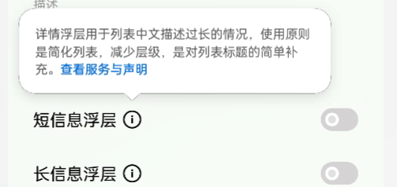

#### 《5》 takeIf and takeUnless

<https://kotlinlang.org/docs/scope-functions.html#takeif-and-takeunless>

##### x） 实例

###### 例1：

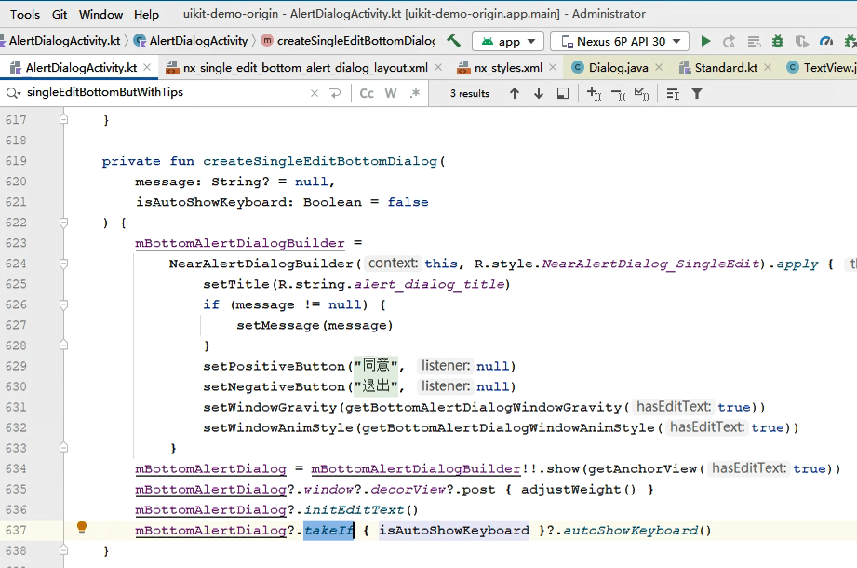

对应：uikitdemo-弹出层-弹窗-底部弹窗-一个输入框带提示

###### 例2：

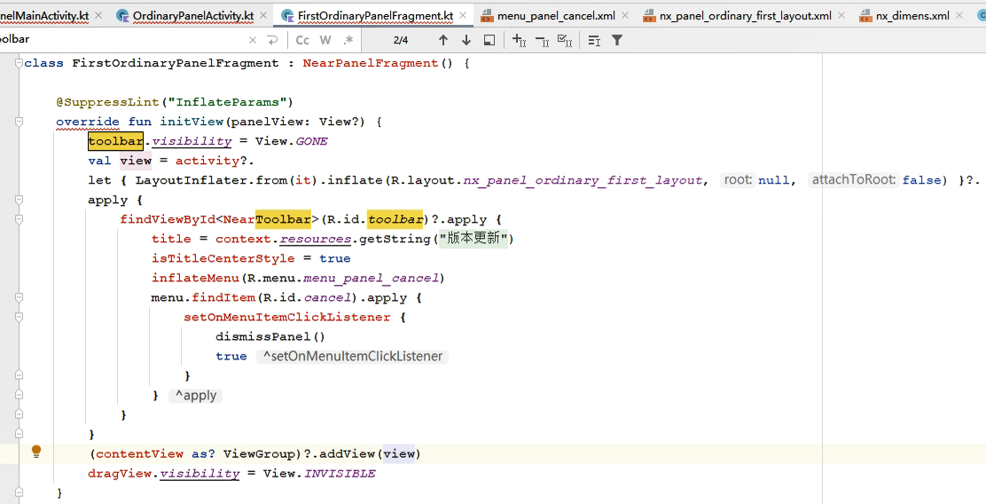

对应：uikitdemo-弹出层-面板-普通-一级

### 【x】 作用域函数：scope functions（版本二：blog）

主：<https://blog.csdn.net/u013064109/article/details/78786646>

辅：<https://www.jianshu.com/p/28ce69d58fea>

<https://www.jianshu.com/p/6e8d4912c576>

<https://zhuanlan.zhihu.com/p/261428175>

<https://www.jianshu.com/p/e3ae07461a21>

<https://blog.csdn.net/zhuhai__yizhi/article/details/82590111>

### 【x】 TODO函数

#### 《1》 源码

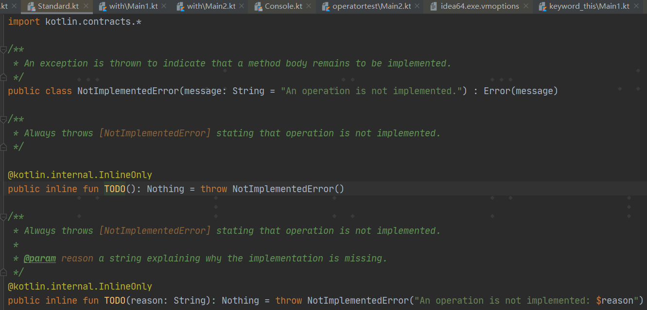

#### 《2》 官方说明

<https://kotlinlang.org/docs/idioms.html#mark-code-as-incomplete-todo>

**Mark code as incomplete (TODO)﻿**

Kotlin's standard library has a TODO() function that will always throw a NotImplementedError. Its return type is Nothing so it can be used regardless of expected type. There's also an overload that accepts a reason parameter:

|  |
| --- |
| fun calcTaxes(): BigDecimal = TODO("Waiting for feedback from accounting") |

IntelliJ IDEA's kotlin plugin understands the semantics:语义 of TODO() and automatically adds a code pointer in the TODO tool window.

## 文件

方法可以直接写在文件里，不用在类里

## object关键字

<https://kotlinlang.org/docs/keyword-reference.html#hard-keywords>

<https://kotlinlang.org/docs/object-declarations.html>

### 是什么

#### 参1：<https://kotlinlang.org/docs/keyword-reference.html#hard-keywords>

* object declares [a class and its instance at the same time](https://kotlinlang.org/docs/object-declarations.html).

#### 参2：<https://kotlinlang.org/docs/object-declarations.html>

Sometimes you need to create an object of a slight modification of some class, without explicitly declaring a new subclass for it. Kotlin handles this case with object expressions and object declarations.

### Object expressions and declarations：对象表达式与对象声明

<https://kotlinlang.org/docs/object-declarations.html>

<https://book.kotlincn.net/text/object-declarations.html>

<https://book.kotlincn.net/text/object-declarations.html>

#### Object expressions

##### 概述

**Object expressions** create objects of **anonymous classes**, that is, classes that aren't explicitly declared with the class declaration. Such classes are useful for one-time use. You can define them from scratch, inherit from existing classes, or implement interfaces. Instances of **anonymous classes** are also called **anonymous objects** because they are defined by an expression, not a name.

##### 2） Creating anonymous objects from scratch

Object expressions start with the object keyword.

If you just need an object that doesn’t have any nontrivial supertypes, write its members in curly braces after object:

|  |
| --- |
| fun main() {  val helloWorld = object {  val hello = "Hello"  val world = "World"  // object expressions extend Any, so `override` is required on `toString()`  override fun toString() = "$hello $world"  }  *print*(helloWorld) } |

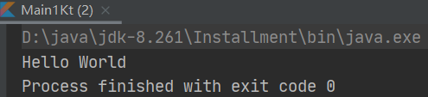

##### 3） Inheriting anonymous objects from supertypes

To create an object of an anonymous class that inherits from some type (or types), specify this type after object and a colon (:). Then implement or override the members of this class as if you were [inheriting](https://kotlinlang.org/docs/inheritance.html) from it:

|  |
| --- |
| window.addMouseListener(object : MouseAdapter() {  override fun mouseClicked(e: MouseEvent) { /*...*/ }  override fun mouseEntered(e: MouseEvent) { /*...*/ }  }) |

运行：

|  |
| --- |
| import java.awt.event.MouseAdapter import java.awt.event.MouseEvent  window.addMouseListener(object : MouseAdapter() {  override fun mouseClicked(e: MouseEvent) { /*...*/ }   override fun mouseEntered(e: MouseEvent) { /*...*/ } }) |

涉及java.awt，暂无法运行。

If a supertype has a constructor, pass appropriate constructor parameters to it. Multiple supertypes can be specified as a comma-delimited list after the colon: 冒号后的逗号分隔列表：

|  |
| --- |
| open class A(x: Int) {  public open val y: Int = x  }  interface B { /*...*/ }  val ab: A = object : A(1), B {  override val y = 15  } |

##### 4） Using anonymous objects as return and value types

###### 1》 语法1

When an anonymous object is used as a type of a local or [private](https://kotlinlang.org/docs/visibility-modifiers.html#packages) but not [inline](https://kotlinlang.org/docs/inline-functions.html) declaration (function or property), all its members are accessible via this function or property:

|  |
| --- |
| class C {  private fun getObject() = object {  val x: String = "x"  }  fun printX() {  println(getObject().x)  }  } |

运行

|  |
| --- |
| class C {  private fun getObject() = object {  val x: String = "x"  }   fun printX() {  *println*(getObject().x)  } }  fun main() {  C().printX() } |

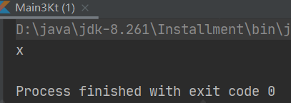

###### 2》 语法2

If this function or property is public or private inline, its actual type is:

* Any if the anonymous object doesn't have a declared supertype
* The declared supertype of the anonymous object, if there is exactly one such type
* The explicitly declared type if there is more than one declared supertype

In all these cases, members added in the anonymous object are not accessible. Overridden members are accessible if they are declared in the actual type of the function or property:

|  |
| --- |
| interface A {  fun funFromA() {}  }  interface B  class C {  // The return type is Any. x is not accessible  fun getObject() = object {  val x: String = "x"  }  // The return type is A; x is not accessible  fun getObjectA() = object: A {  override fun funFromA() {}  val x: String = "x"  }  // The return type is B; funFromA() and x are not accessible  fun getObjectB(): B = object: A, B { // explicit return type is required  override fun funFromA() {}  val x: String = "x"  }  } |

##### 5） Accessing variables from anonymous objects

The code in object expressions can access variables from the enclosing scope:包含它的作用域：

|  |
| --- |
| fun countClicks(window: JComponent) {  var clickCount = 0  var enterCount = 0  window.addMouseListener(object : MouseAdapter() {  override fun mouseClicked(e: MouseEvent) {  clickCount++  }  override fun mouseEntered(e: MouseEvent) {  enterCount++  }  })  // ...  } |

#### Object declarations

##### 概述

###### A） 是什么

The [Singleton](https://en.wikipedia.org/wiki/Singleton_pattern) pattern：单例模式 can be useful in several cases, and Kotlin makes it easy to declare singletons:

|  |
| --- |
| object DataProviderManager {  fun registerDataProvider(provider: DataProvider) {  // ...  }  val allDataProviders: Collection<DataProvider>  get() = // ...  } |

This is called an **object declaration**, and it always has a name following the object keyword.

Just like a variable declaration, an object declaration is not an expression, and it cannot be used on the right-hand side of an assignment statement.

###### B） 初始化

The initialization of an object declaration is thread-safe and done on first access.

###### C） 使用

To refer to the object：引用对象, use its name directly:

|  |
| --- |
| DataProviderManager.registerDataProvider(...) |

运行：

###### D） 存在supertypes

Such objects can have supertypes:

|  |
| --- |
| object DefaultListener : MouseAdapter() {  override fun mouseClicked(e: MouseEvent) { ... }  override fun mouseEntered(e: MouseEvent) { ... }  } |

###### D） 嵌套语法

Object declarations can't be local (that is, they can't be nested directly inside a function), but they can be nested into other object declarations or non-inner classes.

##### Companion objects：伴生对象

参考：

1. 主

<https://kotlinlang.org/docs/object-declarations.html#companion-objects>

<https://book.kotlincn.net/text/object-declarations.html>

1. 辅

<https://zhuanlan.zhihu.com/p/26713535>

<https://blog.csdn.net/sinat_14849739/article/details/80552111>

<https://www.jianshu.com/p/a07cd40a1151>

<https://blog.csdn.net/qq_34676644/article/details/119178392>

<https://www.imooc.com/wiki/kotlinlesson/companionobject.html>【未看，有点问题】

###### 概述

<https://kotlinlang.org/docs/object-declarations.html#companion-objects>

An object declaration inside a class can be marked with the companion keyword:

|  |
| --- |
| class MyClass {  companion object Factory {  fun create(): MyClass = MyClass()  }  } |

运行：

|  |
| --- |
| package keywordtest.keyword_object.objectdeclaration.companionobject  class MyClass {  companion object Factory {  fun create(): MyClass = MyClass()  } } |

Members of the companion object can be called simply by using the class name as the qualifier:

|  |
| --- |
| val instance = MyClass.create() |

运行：

|  |
| --- |
| package keywordtest.keyword_object.objectdeclaration.companionobject  class MyClass {  companion object Factory {  fun create(): MyClass = MyClass()  } }  fun main() {  var instance = MyClass.create()  *println*(instance) } |

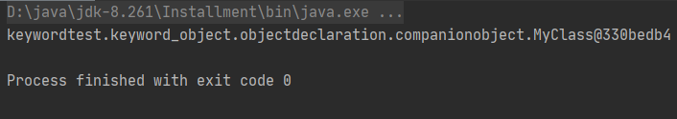

The name of the companion object can be omitted, in which case the name Companion will be used:

|  |
| --- |
| class MyClass {  companion object { }  }  val x = MyClass.Companion |

运行：

|  |
| --- |
| package keywordtest.keyword_object.objectdeclaration.companionobject  class MyClass1 {  companion object {  var v = 100  } }  val *x* = MyClass1.Companion  fun main() {  *println*(*x*.v) } |

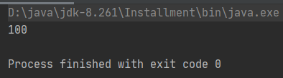

Class members can access the private members of the corresponding companion object.

运行：

|  |
| --- |
| package keywordtest.keyword_object.objectdeclaration.companionobject  class MyClass3 {  companion object Factory {  private fun create() = 2 * 3  private const val str: String = "aaa"  var double: Double = 2.2  internal val d = -1  }   fun m1() {  *println*(create()) //写法1  *println*(Factory.create()) //写法2  *println*(str) //写法1  *println*(MyClass3.Factory.str) //写法2  } }  fun main() {  MyClass3().m1() // MyClass3.create() //Error:Cannot access 'create': it is private in 'Factory' // MyClass3.str //Error:Cannot access 'str': it is private in 'Factory'  *println*(MyClass3.Factory.double)  *println*(MyClass3.d) } |

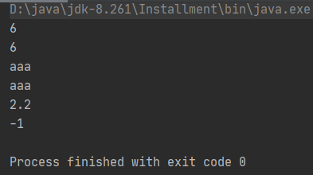

分别有如下提示：

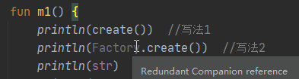

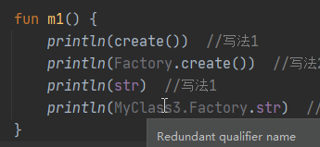

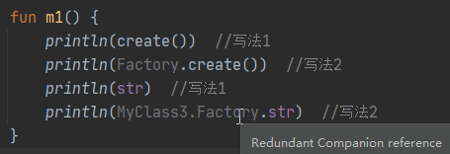

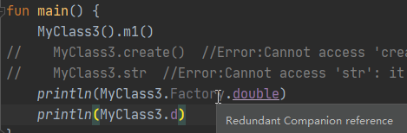

The name of a class used by itself (not as a qualifier to another name) acts as a reference to the companion object of the class (whether named or not):

|  |
| --- |
| class MyClass1 {  companion object Named { }  }  val x = MyClass1  class MyClass2 {  companion object { }  }  val y = MyClass2 |

运行：

|  |
| --- |
| package keywordtest.keyword_object.objectdeclaration.companionobject  class MyClass4 {  companion object Named { } }  val *x1* = MyClass4  class MyClass5 {  companion object { } }  val *y* = MyClass5  fun main() {  *println*(*x1*)  *println*(*y*) } |

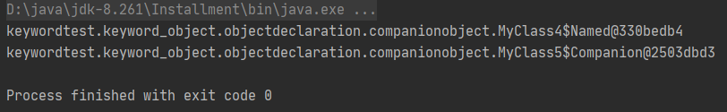

Note that even though the members of companion objects look like static members in other languages, at runtime those are still instance members of real objects, and can, for example, implement interfaces:

|  |
| --- |
| interface Factory<T> {  fun create(): T  }  class MyClass {  companion object : Factory<MyClass> {  override fun create(): MyClass = MyClass()  }  }  val f: Factory<MyClass> = MyClass |

运行：

|  |
| --- |
| package keywordtest.keyword_object.objectdeclaration.companionobject  interface Factory<T> {  fun create(): T }  class MyClass6 {  companion object : Factory<MyClass6> {  override fun create(): MyClass6 = MyClass6()  } }  val *f*: Factory<MyClass6> = MyClass6  fun main() {  *println*(*f*) } |

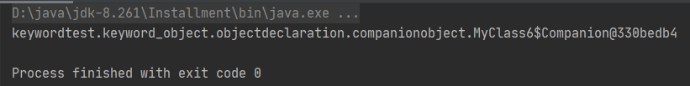

However, on the JVM you can have members of companion objects generated as real static methods and fields if you use the @JvmStatic annotation. See the [Java interoperability](https://kotlinlang.org/docs/java-to-kotlin-interop.html#static-fields) section for more detail.

###### java，kotlin间调用

A） kotlin调kotlin

A》 代码

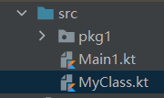 kotlin1.5.10

Main1.kt

|  |
| --- |
| fun main() {  var x = MyClass1.create()  *println*(x)  x = MyClass2.Companion.create()  *print*(x) } |

MyClass.kt

|  |
| --- |
| class MyClass1 {   companion object Factory {  fun create() {  *println*("companion 1");  }  } }  class MyClass2 {   companion object {  fun create() {  *println*("companion 2");  }  } } |

结果：

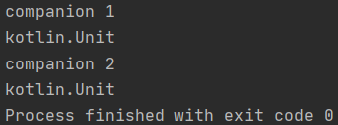

B》 注意

但kotlin编译提示：

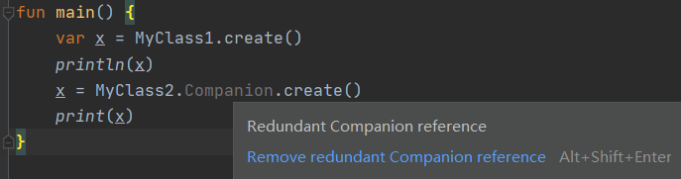

B） java调kotlin

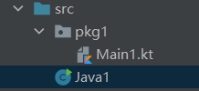

*Java1.java*

|  |
| --- |
| import pkg1.Main1; import pkg1.Main2;  public class Java1 {   public static void main(String[] args) {  Main1.*Obj*.abc();  Main2.*Companion*.abc();  } } |

*Main1.kt*

|  |
| --- |
| package pkg1  class Main1 {   companion object Obj {  fun abc() {  *println*("abc1")  }  } }  class Main2 {   companion object {  fun abc() {  *print*("abc2")  }  } } |

结果：

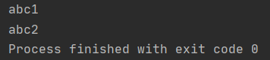

###### 3》 实例

例1：

<https://developer.android.com/guide/components/activities/activity-lifecycle#save-simple,-lightweight-ui-state-using-onsaveinstancestate>

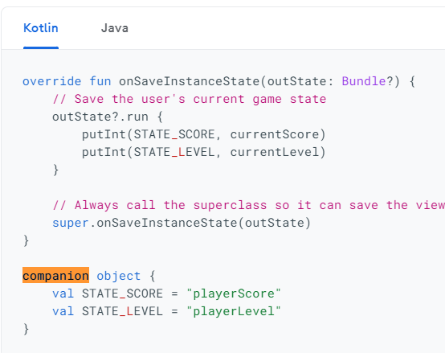

对应

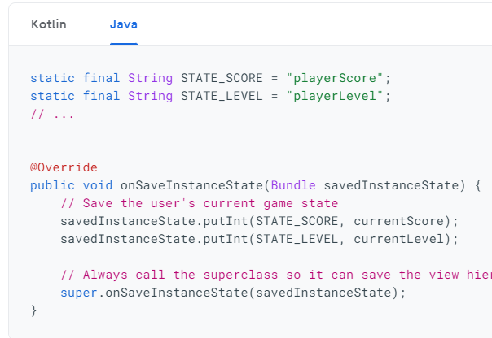

例2：

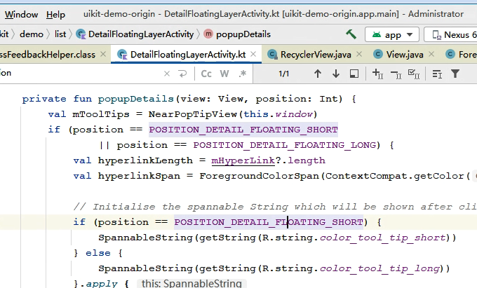

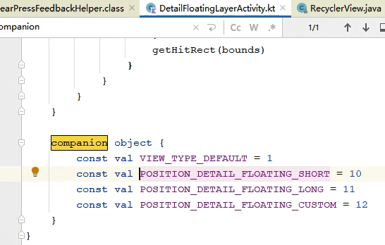

对应：uikitdemo-列表与列表控件-列表控件-详情浮层-点警告圆圈

#### 《3》 Object expressions和Object declarations的初始化时机

<https://kotlinlang.org/docs/object-declarations.html#semantic-difference-between-object-expressions-and-declarations>

There is one important semantic difference between object expressions and object declarations:

* **Object expressions** are executed (and initialized) immediately, where they are used.
* **Object declarations** are initialized lazily, when accessed for the first time.
* A **companion object** is initialized when the corresponding class is loaded (resolved) that matches the semantics of a Java static initializer.

## 输入输出

### 输出

参考：<https://www.yiibai.com/kotlin/kotlin-input-output.html>

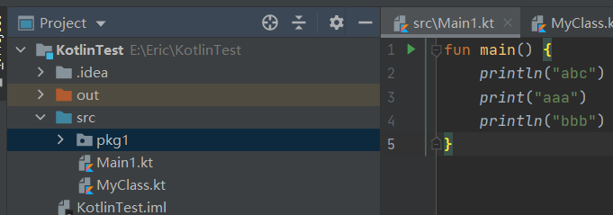

|  |
| --- |
| fun main() {  *println*("abc")  *print*("aaa")  *println*("bbb") } |

结果：

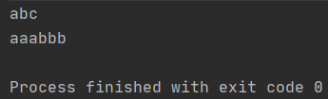

## 数据类型：Types

### 概述

#### 参1：<https://kotlinlang.org/docs/basic-types.html>

In Kotlin, everything is an object in the sense that we can call member functions and properties on any variable. Some types can have a special internal representation - for example, numbers, characters and booleans can be represented as primitive values at runtime - but to the user they look like ordinary classes. In this section we describe the basic types used in Kotlin: [numbers](https://kotlinlang.org/docs/basic-types.html#numbers), [booleans](https://kotlinlang.org/docs/basic-types.html#booleans), [characters](https://kotlinlang.org/docs/basic-types.html#characters), [strings](https://kotlinlang.org/docs/basic-types.html#strings), and [arrays](https://kotlinlang.org/docs/basic-types.html#arrays).：在 Kotlin 中，所有东西都是对象，在这个意义上讲我们可以在任何变量上调用成员函数与属性。一些类型可以有特殊的内部表示——例如，数字、字符以及布尔值可以在运行时表示为原生类型值，但是对于用户来说，它们看起来就像普通的类。 在本节中，我们会描述 Kotlin 中使用的基本类型：数字、字符、布尔值、数组与字符串。

### 分类

#### 《1》 基本类型：Basic types

<https://kotlinlang.org/docs/typecasts.html#is-and-is-operators>

https://www.kotlincn.net/docs/reference/basic-types.html

##### 1） Numbers

###### 1》 2种子类

A） Integer types

A》 是什么

Kotlin provides a set of built-in types that represent numbers.  
For integer numbers, there are four types with different sizes and, hence, value ranges.

| **Type** | **Size (bits)** | **Min value** | **Max value** |
| --- | --- | --- | --- |
| Byte | 8 | -128 | 127 |
| Short | 16 | -32768 | 32767 |
| Int | 32 | -2,147,483,648 (-231) | 2,147,483,647 (231 - 1) |
| Long | 64 | -9,223,372,036,854,775,808 (-263) | 9,223,372,036,854,775,807 (263 - 1) |

B》 赋值

All variables initialized with integer values not exceeding the maximum value of Int have the inferred type Int. If the initial value exceeds this value, then the type is Long. To specify the Long value explicitly, append the suffix L to the value.：所有以未超出 Int 最大值的整型值初始化的变量都会推断为 Int 类型。如果初始值超过了该值，那么推断为 Long 类型。 如需显式指定 Long 型值，请在该值后追加 L 后缀。

|  |
| --- |
| **val** one = 1 // Int  **val** threeBillion = 3000000000 // Long  **val** oneLong = 1L // Long  **val** oneByte: Byte = 1 |

B） Floating-point types

A》 是什么

For real numbers, Kotlin provides floating-point

types Float and Double. According to the [IEEE 754 standard](https://en.wikipedia.org/wiki/IEEE_754), floating point types differ by their decimal place, that is, how many decimal digits they can store. ：对于浮点数，Kotlin 提供了 Float 与 Double 类型。 根据 [IEEE 754 标准](https://zh.wikipedia.org/wiki/IEEE_754)， 两种浮点类型的十进制位数（即可以存储多少位十进制数）不同。 Float 反映了 IEEE 754 单精度，而 Double 提供了双精度。

| **Type** | **Size (bits)** | **Significant bits** | **Exponent bits** | **Decimal digits** |
| --- | --- | --- | --- | --- |
| Float | 32 | 24 | 8 | 6-7 |
| Double | 64 | 53 | 11 | 15-16 |

B》 赋值

You can initialize Double and Float variables with numbers having a fractional part. It's separated from the integer part by a period (.) For variables initialized with fractional numbers, the compiler infers the Double type.

|  |
| --- |
| **val** pi = 3.14 // Double  // val one: Double = 1 // Error: type mismatch  **val** oneDouble = 1.0 // Double |

To explicitly specify the Float type for a value, add the suffix f or F. If such a value contains more than 6-7 decimal digits：十进制数字, it will be rounded.

|  |
| --- |
| **val** e = 2.7182818284 // Double  **val** eFloat = 2.7182818284f // Float, actual value is 2.7182817 |

C》 类型转换

Note that unlike some other languages, there are no implicit widening conversions for numbers in Kotlin.

For example, a function with a Double parameter can be called only on Double values, but not Float, Int, or other numeric values.

|  |
| --- |
| fun main() {  fun printDouble(d: Double) { *print*(d)}   val i = 1  val d = 1.0  val f = 1.0f   printDouble(d) // printDouble(i) //报错：Type mismatch: inferred type is Int but Double was expected // printDouble(f) //报错：Type mismatch: inferred type is Float but Double was expected } |

运行结果：

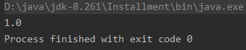

To convert numeric values to different types, use [Explicit conversions](https://kotlinlang.org/docs/basic-types.html#explicit-conversions).

###### 2》 Literal constants

###### 3》 Numbers representation on the JVM

###### 4》 Explicit conversions

###### 5》 Operations

###### 6》 Floating-point numbers comparison

###### 7》 Unsigned integers

##### 2） Characters

###### 1》 是什么

Characters are represented by the type Char.

###### 2》 赋值

A） 通用

Character literals go in single quotes: '1'.：字符字面值用单引号括起来: '1'。

B） 转义序列

Special characters start from an escaping：转义 backslash：反斜杠 \. The

following escape sequences：转义序列 are

supported: \t, \b, \n, \r, \', \", \\ and \$.

To encode any other character, use the Unicode escape sequence syntax: '\uFF00'.

|  |
| --- |
| fun main() {  val aChar: Char = 'a'   *println*(aChar)  *println*('\n') //prints an extra newline character  *println*('\uFF00') } |

运行结果：

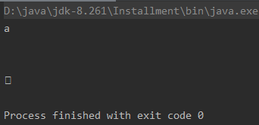

###### 3》 类型转换

If a value of character variable is a digit：数字, you can explicitly convert it to an Int number using the [digitToInt()](https://kotlinlang.org/api/latest/jvm/stdlib/kotlin.text/digit-to-int.html) function.

###### 4》 装箱

**On JVM**: Like [numbers](https://kotlinlang.org/docs/basic-types.html#numbers-representation-on-the-jvm), characters are boxed when a nullable reference is needed. Identity is not preserved by the boxing operation.：当需要可空引用时，像数字、字符会被装箱。装箱操作不会保留同一性。

##### 3） Booleans

###### 1》 是什么

The type Boolean represents boolean objects that can have two values: true and false.

Boolean has a nullable counterpart：可空的对应物 Boolean? that also has the null value.

###### 2》 操作

Built-in operations on booleans include:

* || – disjunction (logical OR)
* && – conjunction (logical AND)
* ! - negation (logical NOT)

|| and && work lazily.

|  |
| --- |
| fun main() {  val myTrue: Boolean = true  val myFalse: Boolean = false  val boolNull: Boolean? = null   *println*(myTrue || myFalse)  *println*(myTrue && myFalse)  *println*(!myTrue) } |

运行结果：

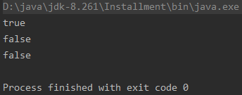

###### 3》 装箱

**On JVM**: nullable references to boolean objects are boxed similarly to [numbers](https://kotlinlang.org/docs/basic-types.html#numbers-representation-on-the-jvm).

##### 4） Strings

###### 1》 是什么

Strings in Kotlin are represented by the type String.

###### 2》 赋值

Generally, a string value is a sequence of characters in double quotes (").

|  |
| --- |
| **val** str = **"abcd 123"** |

###### 3》 操作

A） 访问元素

Elements of a string are characters that you can access via the indexing operation: s[i].

B） 迭代

You can iterate over these characters with a for loop:

|  |
| --- |
| fun main() {  val str = "abcd"  for (c in str) {  *println*(c)  } } |

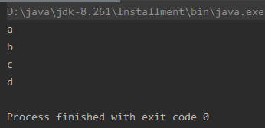

C） 其他

###### 4》 String literals

###### 5》 String templates：字符串模板

<https://kotlinlang.org/docs/basic-types.html#string-templates>

<https://book.kotlincn.net/text/basic-types.html>

A） 是什么

String literals may contain template expressions - pieces of code that are evaluated and whose results are concatenated into the string.

B） 2种基本写法

A template expression starts with a dollar sign ($) and consists of either a name:

|  |
| --- |
| fun main() {  val i = 10  *println*("i = $i") // prints "i = 10" } |

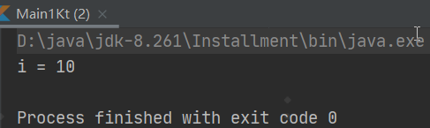

or an expression in curly braces（大括号）:

|  |
| --- |
| fun main() {  val s = "abc"  *println*("$s.length is ${s.length}") // prints "abc.length is 3" } |

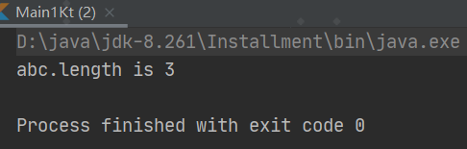

C） 特殊写法

You can use templates both in raw and escaped strings. To insert the $ character in a raw string (which doesn't support backslash escaping：反斜杠转义) before any symbol, which is allowed as a beginning of an [identifier](https://kotlinlang.org/docs/reference/grammar.html#identifiers), use the following syntax:

|  |
| --- |
| val price = """  ${'$'}_9.99  """ |

##### 5） Arrays

<https://kotlinlang.org/docs/basic-types.html#arrays>

###### 1》 是什么

Arrays in Kotlin are represented by the Array class. It has get and set functions that turn into [] by operator overloading conventions, and the size property, along with other useful member functions:

|  |
| --- |
| */**  * Represents an array (specifically, a Java array when targeting the JVM platform).  * Array instances can be created using the [arrayOf], [arrayOfNulls] and [emptyArray]  * standard library functions.  * See [Kotlin language documentation](https://kotlinlang.org/docs/reference/basic-types.html#arrays)  * for more information on arrays.  */* public class Array<T> {  */**  * Creates a new array with the specified [size], where each element is calculated by calling the specified  * [init] function.  *  * The function [init] is called for each array element sequentially starting from the first one.  * It should return the value for an array element given its index.  */* public inline constructor(size: Int, init: (Int) -> T)   */**  * Returns the array element at the specified [index]. This method can be called using the  * index operator.  * ```  * value = arr[index]  * ```  *  * If the [index] is out of bounds of this array, throws an [IndexOutOfBoundsException] except in Kotlin/JS  * where the behavior is unspecified.  */* public operator fun get(index: Int): T   */**  * Sets the array element at the specified [index] to the specified [value]. This method can  * be called using the index operator.  * ```  * arr[index] = value  * ```  *  * If the [index] is out of bounds of this array, throws an [IndexOutOfBoundsException] except in Kotlin/JS  * where the behavior is unspecified.  */* public operator fun set(index: Int, value: T): Unit   */**  * Returns the number of elements in the array.  */* public val size: Int   */**  * Creates an iterator for iterating over the elements of the array.  */* public operator fun iterator(): Iterator<T> } |

###### 2》 操作

###### 3》 Arrays是invariant

###### 4》 Primitive type arrays

###### 5》 实例

例1

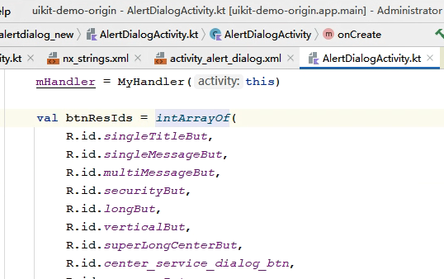

其中intArrayof为

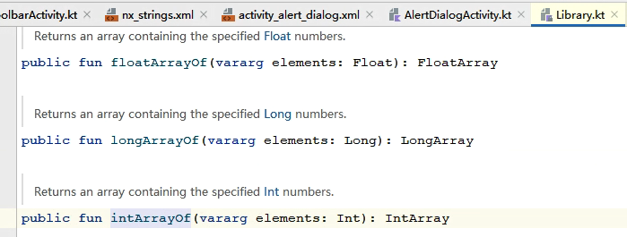

IntArray为

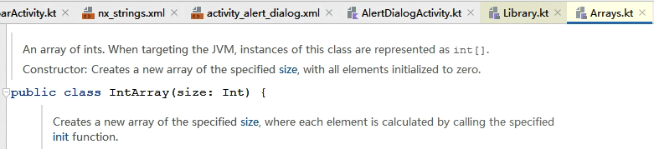

### 【3】 类型检查：Type checks

### 【4】 类型转换：Type casts

参考：<https://kotlinlang.org/docs/typecasts.html>

#### 《1》 Smart casts

#### 《2》 “Unsafe” cast operator

##### 1） 是什么

Usually, the cast operator throws an exception if the cast isn't possible. Thus, it's called unsafe. The unsafe cast in Kotlin is done by the infix operator **as**.

|  |
| --- |
| **val** x: String = y **as** String |

##### 2） 注意点：null

Note that null cannot be cast to String as this type is not [nullable](https://kotlinlang.org/docs/null-safety.html). If y is null, the code above throws an exception.

To make such code correct for null values, use the nullable type on the right hand side of the cast:

|  |
| --- |
| **val** x: String? = y **as** String? |

#### 《3》 “Safe”（nullable） cast operator

##### 1） 是什么

To avoid exceptions, use the safe cast operator as? that returns null on failure.

|  |
| --- |
| **val** x: String? = y **as**? String |

##### 2） 注意点

Note that despite the fact that the right-hand side of as? is a non-null type String, the result of the cast is nullable.

## 空安全：Null safety

参考：<https://kotlinlang.org/docs/null-safety.html>

### 为什么有该机制

Kotlin's type system is aimed at eliminating the danger of null references from code, also known as the [The Billion Dollar Mistake](https://en.wikipedia.org/wiki/Tony_Hoare#Apologies_and_retractions).

One of the most common pitfalls in many programming languages, including Java, is that accessing a member of a null reference will result in a null reference exception. In Java this would be the equivalent of a NullPointerException or NPE for short.

### 【2】 Kotlin可能出现NullPointerException情形

Kotlin's type system is aimed to

eliminate NullPointerException 's from our code. The only possible causes of NPE's may be:

* An explicit call to throw NullPointerException().
* Usage of the !! operator that is described below.
* Some data inconsistency with regard to initialization, such as when:
  + An uninitialized this available in a constructor is passed and used somewhere ("leaking this ").
  + [A superclass constructor calls an open member](https://kotlinlang.org/docs/inheritance.html#derived-class-initialization-order) whose implementation in the derived class uses uninitialized state.
* Java interoperation:
  + Attempts to access a member on a null reference of a [platform type](https://kotlinlang.org/docs/java-interop.html#null-safety-and-platform-types);
  + Generic types used for Java interoperation with incorrect nullability, for example, a piece of Java code might add null into a Kotlin MutableList<String>, meaning that MutableList<String?> should be used for working with it.
  + Other issues caused by external Java code.

### 【3】 是什么：nullable types and non-null types

In Kotlin, the type system distinguishes between references that can hold null (nullable references) and those that cannot (non-null references).

### 【4】 ？的使用

#### 《1》 代码

For example, a regular variable of type String cannot hold null:

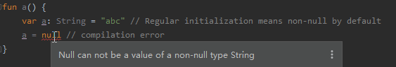

To allow nulls, you can declare a variable as nullable string, written String? :

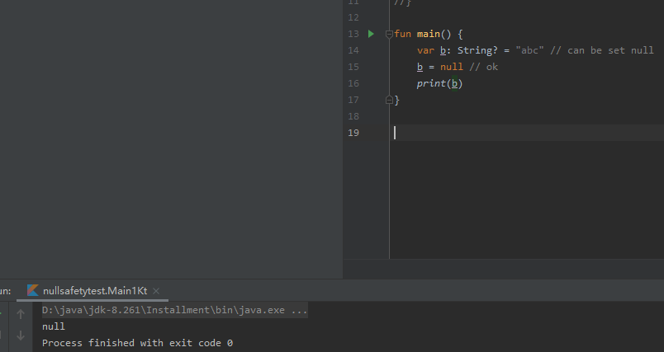

Now, if you call a method or access a property on a, it's guaranteed not to cause an NPE, so you can safely say:

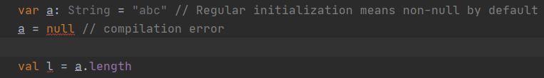

But if you want to access the same property on b, that would not be safe, and the compiler reports an error:

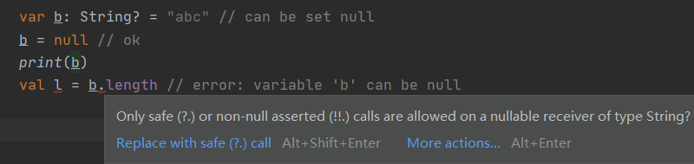

#### 《2》 问题

But you still need to access that property, right? There are a few ways of doing that.

### 【5】 解决实例问题（3种方法）

#### 《1》 checking for null in conditions

##### 1） 是什么

First, you can explicitly check if b is null, and handle the two options separately:

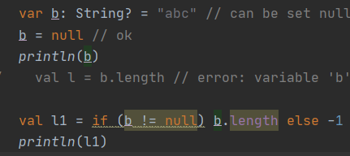正常编译运行

The compiler tracks the information about the check you performed, and allows the call to length inside the if.

##### 2） 复杂用法

More complex conditions are supported as well:

|  |
| --- |
| fun main() {  val b: String? = "Kotlin"  if (b != null && b.length > 0) {  *print*("String of length ${b.length}")  } else {  *print*("Empty string")  } } |

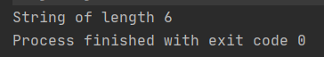

##### 3） 注意点

Note that this only works where b is immutable (that means a local variable which is not modified between the check and the usage or a member val which has a backing field and is not overridable), because otherwise it might happen that b changes to null after the check.

#### 《2》 safe calls（operator）

##### 1） 是什么

Your second option is the safe call operator, written **?.** :

|  |
| --- |
| fun main() {  val a = "Kotlin"  val b: String? = null  *println*(b?.length)  *println*(a?.length) // Unnecessary safe call } |

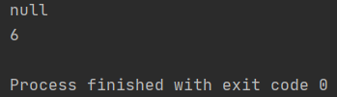

This returns b.length if b is not null, and null otherwise.

The type of this expression（b?.length） is **Int?**.

##### 2） 使用1：链式调用

Safe calls are useful in chains.

例子：

For example, if Bob, an Employee, may be assigned to a Department (or not), that in turn may have another Employee as a department head, then to obtain the name of Bob's department head (if any), you write the following（Bob被分配到某个部门，要获取Bob所在部门的leader的名字，要这么写）:

|  |
| --- |
| bob?.department?.head?.name |

Such a chain returns null if any of the properties in it is null.

##### 3） 使用2：对non-null values操作

To perform a certain operation only for non-null values, you can use the safe call operator together with [let](https://kotlinlang.org/api/latest/jvm/stdlib/kotlin/let.html):

|  |
| --- |
| fun main() {  val listWithNulls: List<String?> = *listOf*("Kotlin", null)  for (item in listWithNulls) {  item?.*let* **{** *println*(**it**) **}** // prints Kotlin and ignores null  } } |

结果：

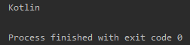

##### 4） 使用3：赋值

A safe call can also be placed on the left side of an assignment. Then, if one of the receivers in the safe calls chain is null, the assignment is skipped, and the expression on the right is not evaluated at all（safe call也可以放在赋值的左侧。然后，如果安全调用链中的接收者之一为空，则跳过赋值，并且根本不计算右侧的表达式：）:

|  |
| --- |
| // If either `person` or `person.department` is null, the function is not called:  person?.department?.head = managersPool.getManager() |

#### 《3》 The !! operator

##### 1） 是什么

The third option is for NPE-lovers: the not-null assertion operator (!!) converts any value to a non-null type and throws an exception if the value is null.

##### 2） 使用

You can write b!!, and this will return a non-null value of b (for example, a String in our example) or throw an NPE if b is null:

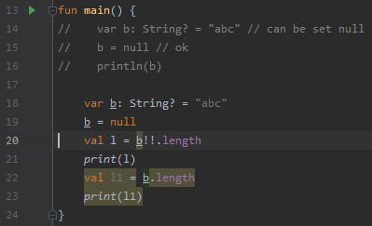

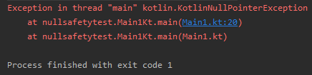

##### 3） 场景

Thus, if you want an NPE, you can have it, but you have to ask for it explicitly, and it does not appear out of the blue（若你想有NPE，能使用这种方式。但你必须显式地运用该运算符，否则NPE是不会凭空出现的）.

### 【6】 Elvis operator

#### 《1》 是什么

##### 参1：<https://kotlinlang.org/docs/keyword-reference.html#special-identifiers>

* ?: takes the right-hand value if the left-hand value is null (the [elvis operator](https://kotlinlang.org/docs/null-safety.html#elvis-operator)).

##### 参2：<https://kotlinlang.org/docs/null-safety.html#elvis-operator>

When you have a nullable reference b, you can say "if b is not null, use it, otherwise use some non-null value":

|  |
| --- |
| val b: String? = null val l: Int = if (b != null) b.length else -1 |

Along with the complete if -expression, this can be expressed with the Elvis operator, written **?:**:

|  |
| --- |
| val b: String? = null val l: Int = b?.length ?: -1 |

If the expression to the left of ?: is not null, the elvis operator returns it, otherwise it returns the expression to the right.

Note that the right-hand side expression is evaluated only if the left-hand side is null.

#### 《2》 throw+return 和 ?: 结合使用

##### 1） 是什么

<https://kotlinlang.org/docs/null-safety.html#elvis-operator>

Since throw and return are expressions in Kotlin, they can also be used on the right hand side of the elvis operator.

This can be very handy, for example, for checking function arguments:

|  |
| --- |
| **fun** foo(node: Node): String? {  **val** parent = node.getParent() ?: **return** **null**  **val** name = node.getName() ?: **throw** IllegalArgumentException(**"name expected"**)  // ...  } |

##### 2） 实例

<https://kotlinlang.org/docs/properties.html#backing-properties>

|  |
| --- |
| private var _table: Map<String, Int>? = null  public val table: Map<String, Int>  get() {  if (_table == null) {  _table = HashMap() // Type parameters are inferred  }  return _table ?: throw AssertionError("Set to null by another thread")  } |

### 【7】 Safe casts

Regular casts may result into a ClassCastException if the object is not of the target type.

Another option is to use safe casts that return null if the attempt was not successful:

|  |
| --- |
| **val** aInt: Int? = a **as**? Int |

### 【8】 Collections of a nullable type

If you have a collection of elements of a nullable type and want to filter non-null elements, you can do so by using filterNotNull:

|  |
| --- |
| val nullableList: List<Int?> = *listOf*(1, 2, null, 4) val intList: List<Int> = nullableList.*filterNotNull*() |

### 【9】 实例

#### 例1：

Uikitdemo-弹出层-弹窗-底部弹窗-多选项

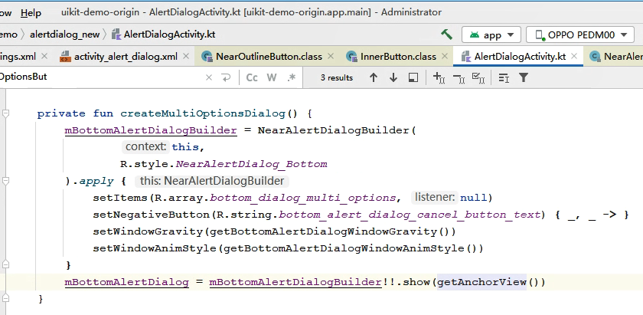

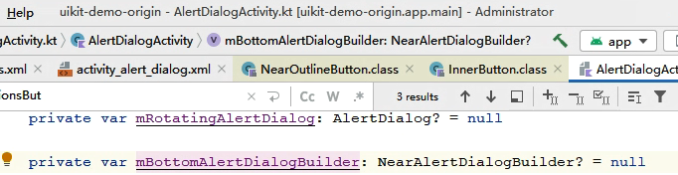

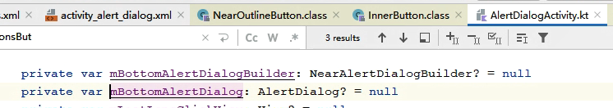

## （13） Destructuring declarations：解构声明

<https://kotlinlang.org/docs/destructuring-declarations.html>

<https://book.kotlincn.net/text/destructuring-declarations.html>

### 【1】 概述

<https://kotlinlang.org/docs/destructuring-declarations.html>

#### 定义：

Sometimes it is convenient to destructure an object into a number of variables, for example:

|  |
| --- |
| val (name, age) = person |

This syntax is called a **destructuring declaration**. A destructuring declaration creates multiple variables at once. You have declared two new variables: name and age, and can use them independently:

|  |
| --- |
| println(name)  println(age) |

示例：

|  |
| --- |
| package destructuringdeclarationstest  data class Person(val name: String, val age: Int, var sex: String = "female")  fun main() {  val person = Person("Eric", 12)  val (name, age) = person  *println*(name)  *println*(age) } |

#### 编译后：

A destructuring declaration is compiled down to the following code:

|  |
| --- |
| val name = person.component1()  val age = person.component2() |

The component1() and component2() functions are another example of the principle of conventions widely used in Kotlin (see operators like + and *, for-loops as an example). Anything can be on the right-hand side of a destructuring declaration, as long as the required number of component functions can be called on it. And, of course, there can be component3() and component4() and so on.

Note：The componentN() functions need to be marked with the operator keyword to allow using them in a destructuring declaration.

#### 在for-loops中使用：

Destructuring declarations also work in for-loops:

|  |
| --- |
| for ((a, b) in collection) { ... } |

Variables a and b get the values returned

by component1() and component2() called on elements of the collection.

### 【2】 Example：returning two values from a function

### 【3】 Example：destructuring declarations and maps

### 【4】 Underscore:下划线 for unused variables

### 【5】 Destructuring in lambdas

## （14） Nothing类

### 【1】 是什么

#### 参1：源码

|  |
| --- |
| */**  * Nothing has no instances. You can use Nothing to represent "a value that never exists": for example,  * if a function has the return type of Nothing, it means that it never returns (always throws an exception).  */* public class Nothing private constructor() |

#### 参2：<https://kotlinlang.org/docs/exceptions.html#the-nothing-type>

### 【2】 实例

#### 《1》 TODO函数

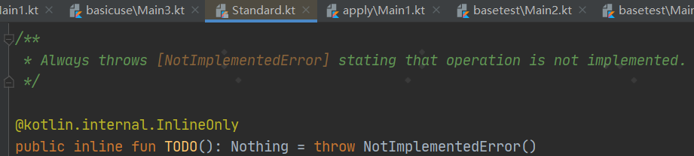

## （15） kt中的label

<https://kotlinlang.org/docs/returns.html#break-and-continue-labels>

Any expression in Kotlin may be marked with a label. Labels have the form of an identifier followed by the @ sign, such as abc@ or fooBar@. To label an expression, just add a label in front of it.

|  |
| --- |
| loop@ for (i in 1..100) {  // ...  } |

# Kotlin关键字和特殊符号

## 关键字：keywords

### Hard keywords

#### 是什么

<https://kotlinlang.org/docs/keyword-reference.html>

The following tokens are always interpreted as keywords and cannot be used as identifiers.

#### 具体

##### this

<https://kotlinlang.org/docs/keyword-reference.html#hard-keywords>

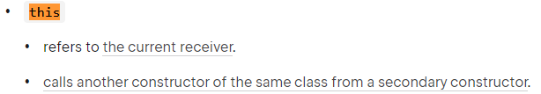

###### refers to the current receiver

<https://kotlinlang.org/docs/this-expressions.html>

<https://book.kotlincn.net/text/this-expressions.html>

a） 概述

定义：

To denote the current receiver, you use this expressions:

* In a member of a [class](https://kotlinlang.org/docs/classes.html#inheritance), this refers to the current object of that class.
* In an [extension function](https://kotlinlang.org/docs/extensions.html) or a [function literal with receiver](https://kotlinlang.org/docs/lambdas.html#function-literals-with-receiver) this denotes the receiver parameter that is passed on the left-hand side of a dot.

作用域：

If this has no qualifiers, it refers to the innermost enclosing scope: 最内层的包含它的作用域. To refer to this in other scopes:其他作用域中的 this, label qualifiers are used.

b） Qualified this

To access this from an outer scope (a [class](https://kotlinlang.org/docs/classes.html), [extension function](https://kotlinlang.org/docs/extensions.html), or labeled [function literal with receiver](https://kotlinlang.org/docs/lambdas.html#function-literals-with-receiver)) you write this@label, where @label is a [label](https://kotlinlang.org/docs/returns.html) on the scope this is meant to be from:

|  |
| --- |
| class A { // implicit label @A  inner class B { // implicit label @B  fun Int.foo() { // implicit label @foo  val a = this@A // A's this  val b = this@B // B's this  val c = this // foo()'s receiver, an Int  val c1 = this@foo // foo()'s receiver, an Int  val funLit = lambda@ fun String.() {  val d = this // funLit's receiver, a String  }  val funLit2 = { s: String ->  // foo()'s receiver, since enclosing lambda expression  // doesn't have any receiver  val d1 = this  }  }  }  } |

运行：

|  |
| --- |
| class A { // implicit label @A  inner class B { // implicit label @B  fun Int.foo() { // implicit label @foo  val a = this@A // A's this  *println*("a=$a")  val b = this@B // B's this  *println*("b=$b")   val c = this // foo()'s receiver, an Int  *println*("c=$c")  val c1 = this@foo // foo()'s receiver, an Int  *println*("c1=$c1")   val funLit = lambda@ fun String.() {  val d = this // funLit's receiver, a String  *println*("d=$d")  }   val funLit2 = **{** s: String **->** // foo()'s receiver, since enclosing lambda expression  // doesn't have any receiver  val d1 = this  *println*("d1=$d1")  **}** }  } }  fun main() {  *TODO*("待调上面的Int.foo()函数") } |

c） Implicit this

When you call a member function on this, you can skip the this. part. If you have a non-member function with the same name, use this with caution because in some cases it can be called instead: 当对 this 调用成员函数时，可以省略 this. 部分。 但是如果有一个同名的非成员函数时，请谨慎使用，因为在某些情况下会调用同名的非成员：

|  |
| --- |
| fun main() {  fun printLine() { *println*("Top-level function") }   class A {  fun printLine() { *println*("Member function") }   fun invokePrintLine(omitThis: Boolean = false) {  if (omitThis) printLine()  else this.printLine()  }  }   A().invokePrintLine() // Member function  A().invokePrintLine(omitThis = true) // Top-level function } |

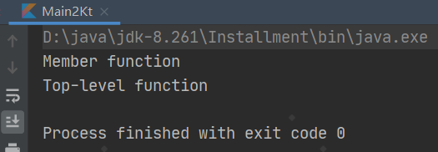

###### 2》 [calls another constructor of the same class from a secondary constructor](https://kotlinlang.org/docs/classes.html#constructors)

##### val和var

见 本文档“声明变量【包含属性】”

##### 3） object

见 本文档“6.Kotlin语法【未具体分类】-object关键字”

### Soft keywords

#### 是什么

The following tokens act as keywords in the context in which they are applicable：适用的, and they can be used as identifiers in other contexts.

#### 具体

### Modifier keywords

#### 是什么

The following tokens act as keywords in modifier lists of declarations, and they can be used as identifiers in other contexts.

#### 具体

##### override

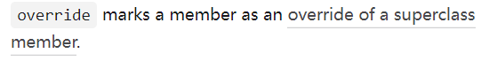

##### operator

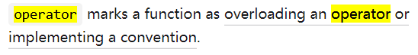

见“本文档-5（4）【9】运算符重载”

##### open

###### 参1：<https://kotlinlang.org/docs/keyword-reference.html#modifier-keywords>

* open allows [subclassing a class or overriding a member](https://kotlinlang.org/docs/classes.html#inheritance).

###### 参2：<https://blog.csdn.net/Sino_Crazy_Snail/article/details/79418510>

在Kotlin中，所有的类默认都是final的。如果你需要允许它可以被继承，那么你需要使用open声明：

|  |
| --- |
| //这个类具有`open`属性，可以被其他类继承  open class People: Speakable{  //`open`的方法被实现和覆写，该方法也是`open`的  override fun say() {}  //`final`属性的方法，不可被覆写  fun sayHello() {}  //`open`属性的方法，可以被继承和覆写  open fun sayName() {}  } |

当然，你也可以阻止某些方法被覆写：

|  |
| --- |
| open class People: Speakable{  //`final`修饰一个原本具有`open`属性的方法，使其变得不可再被覆写  final override fun say() {}  } |

在kotlin中，abstract的用法几乎和Java一致，我就不再啰嗦，值得一提的是，当你使用abstract修饰符的时候，可以忽略open修饰符，因为被abstract修饰的类默认具有open属性。

| **修饰符** | **相应类的成员** | **注解** |
| --- | --- | --- |
| final | 不能被覆写 | 在kotlin中默认所有的方法和类都是final属性 |
| open | 可以被覆写 | 需要被明确指出 |
| abstract | 必须要覆写 | 不能被实例化，默认具有open属性。 |
| override | 覆写超类的方法 | 如果没有被指定为final，则默认具有open属性 |

上述表格仅适用于基类，对于接口类来说，你基本用不上fianl、open、abstract，因为接口类默认是open，且不能被声明为final，如果接口类的方法没有函数体，那么其为abstract，但是不需要你明确指出他是abstract的。

###### 参3：<https://juejin.cn/post/6844903870586437645>

在java中允许创建任意的子类并重写任意的方法，除非显式地使用了final关键字进行标注。

而在kotlin的世界里面则不是这样，在kotlin中它所有的类默认都是final的，那么就意味着不能被继承，而且在类中所有的方法也是默认是final的，那么就是kotlin的方法默认也不能被重写。**那么想在kotlin中继承父类应该怎么做呢？**

* 为类增加open，class就可以被继承了

|  |
| --- |
| open class Person{    } |

* 为方法增加open，那么方法就可以被重写了

|  |
| --- |
| open class Person{  open fun eat(food: String) {   } }  open class Man:Person(){  override fun eat(food: String) {  super.eat(food)  } } |

##### 4） final

###### 参1：<https://kotlinlang.org/docs/keyword-reference.html#modifier-keywords>

* final forbids [overriding a member](https://kotlinlang.org/docs/inheritance.html#overriding-methods).

###### 参2：<https://www.cnblogs.com/nicolas2019/p/10937956.html>

1》 概念

final用于修饰类、属性和方法，代表类、属性和方法是不可被继承的，kotlin类、属性、方法如果不添加修饰符（final/open修饰符）默认使用final修饰。

​ open是final的反义词，用于对类、属性和方法开放继承权限。

|  |
| --- |
| */**  * 默认final修饰的类  */* class FinalClass //class sub1 : FinalClass()//子类不能继承final类  */**  * open修饰的类  */* open class OpenClass class sub2 : OpenClass()//子类可以继承open类 |

2》 注意点

 final和open不可用于修饰局部变量。

## （2） Special identifiers

<https://kotlinlang.org/docs/keyword-reference.html#special-identifiers>

## （3） 特殊符号：special symbols

### 【1】 ？

参考：

* 1. <https://blog.csdn.net/Sindyue/article/details/99625012>
  2. <https://blog.csdn.net/u010410408/article/details/72637408>
  3. <https://www.jianshu.com/p/0917e0510a56>

#### 定义变量

定义变量时，可在类型后面加一个问号?，表示该变量是Nullable，不加表示该变量不可为null。如下：

|  |
| --- |
| 1. var s:String? = null 2. var s2:String = "xxx" *//如果该变量被赋值为null，则编译不通过* |

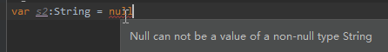

#### 使用变量

1. ？加在变量名后表示当对象为空时，不会执行后面的代码，即运行不会报空指针异常。
2. 对于可以为null的变量，在使用该变量的时候，必须用变量名+?(如上面的s?)的形式进行调用，表示如果该变量为null，则不执行该变量调用的方法。

验证：

|  |
| --- |
| s = "yyy"//赋值时不需要使用s?形式  var l= s?.length//如果s为null，则不执行length方法 |

 当s为null时，不会执行length方法，从而避免了java中频繁的空指针异常。

#### 和!!关系

# Kotlin变量：variables

## 参1：<https://kotlinlang.org/docs/properties.html#declaring- properties>

Properties in Kotlin classes can be declared either as mutable（可变的） using the **var** keyword, or as read-only using the **val** keyword.

|  |
| --- |
| **class** Address {  **var** name: String = **"Holmes, Sherlock"**  **var** street: String = **"Baker"**  **var** city: String = **"London"**  **var** state: String? = **null**  **var** zip: String = **"123456"**  } |

## 参2：<https://developer.android.com/kotlin/learn>

**1） 是什么：**

Kotlin uses two different keywords to declare variables: val and var.

* Use val for a variable whose value never changes. You can't reassign a value to a variable that was declared using val.
* Use var for a variable whose value can change.

## 参3：<https://kotlinlang.org/docs/basic-syntax.html#variables>

Read-only local variables are defined using the keyword val. They can be assigned a value only once.：只读局部变量使用关键字val定义，它们只能被赋值一次。

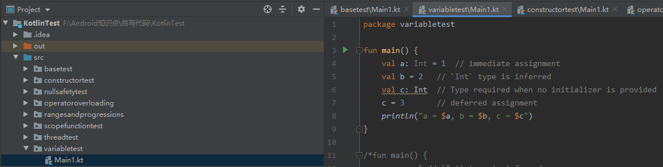

|  |
| --- |
| package variabletest  fun main() {  val a: Int = 1 // immediate assignment  val b = 2 // `Int` type is inferred  val c: Int // Type required when no initializer is provided  c = 3 // deferred assignment  *println*("a = $a, b = $b, c = $c") } |

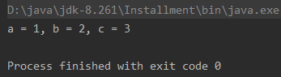

Variables that can be reassigned use the var keyword.

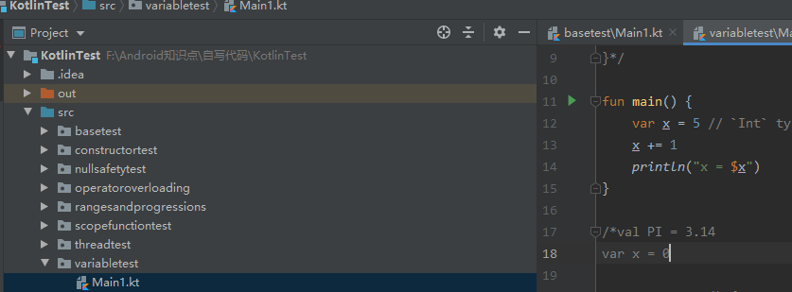

|  |
| --- |
| package variabletest  fun main() {  var x = 5 // `Int` type is inferred  x += 1  *println*("x = $x") } |

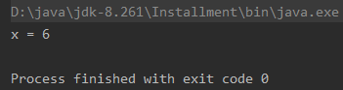

You can declare variables at the top level.

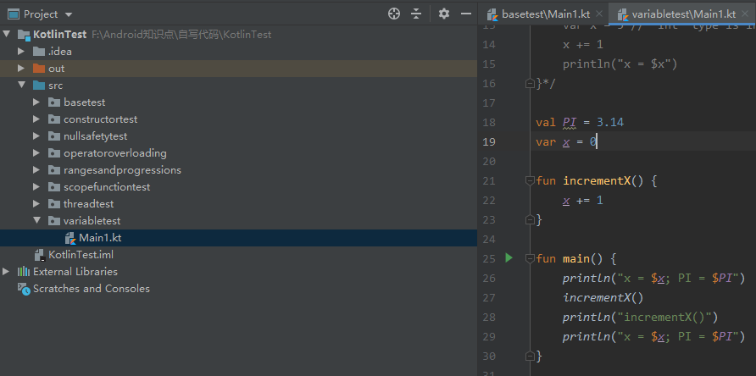

|  |
| --- |
| package variabletest  val *PI* = 3.14 var *x* = 0  fun incrementX() {  *x* += 1 }  fun main() {  *println*("x = $*x*; PI = $*PI*")  *incrementX*()  *println*("incrementX()")  *println*("x = $*x*; PI = $*PI*") } |

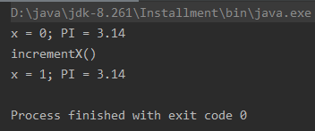

## 参4：

<https://kotlinlang.org/docs/keyword-reference.html#soft-keywords>

* val declares a read-only [property](https://kotlinlang.org/docs/properties.html) or [local variable](https://kotlinlang.org/docs/basic-syntax.html#variables).
* var declares a mutable [property](https://kotlinlang.org/docs/properties.html) or [local variable](https://kotlinlang.org/docs/basic-syntax.html#variables).

## 归纳：

1） kt中属性指类中的变量，变量的范围更广

2） kt中变量只能用val或var关键字修饰

1》 val：表示该变量是 只读的，不可变的。即只能进行一次赋值。

2》 var：表示该变量是 可读可改的，可变的。即可以多次赋值。

3） kt中变量的声明位置：顶层：top-level，函数中，类内【称为属性】

4） kt中的var对应java中的变量，kt中的val对应java中的final常量，kt中的const val对应java中的static final常量

# Kotlin操作符/运算符：operator

### 【x】 算术运算符:mathematical operator

### 【x】 赋值运算符:assignment operator

#### 《1》 用法

同java

#### 《2》 注意：kt的赋值运算符无返回值/返回值为Unit

##### 1） 和java对比

###### Kt code：

|  |
| --- |
| fun main() {  var a = 2  println(a = 3) //编译报错1  println(a += 2) //编译报错2 } |

其中编译报错1：

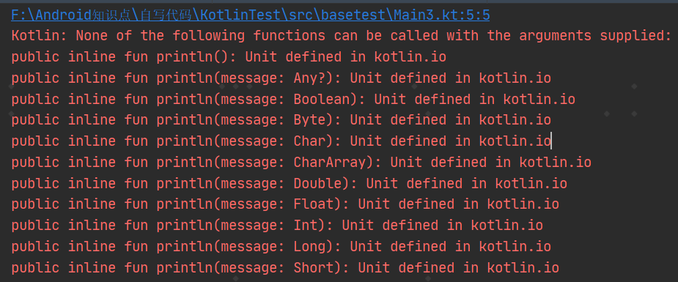

编译报错2：



###### 对应的java code：

|  |
| --- |
| public class Main2 {   public static void main(String[] args) {  int a = 2;  System.*out*.println(a = 3);  System.*out*.println(a += 2);  } } |

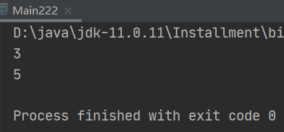

##### 2） 实例

###### 例1：

<https://kotlinlang.org/docs/scope-functions.html#apply>

|  |
| --- |
| data class Person(var name: String, var age: Int = 0, var city: String = "")  fun main() {  val adam = Person("Adam").apply {  age = 32  city = "London"  }  println(adam)  } |

其中apply

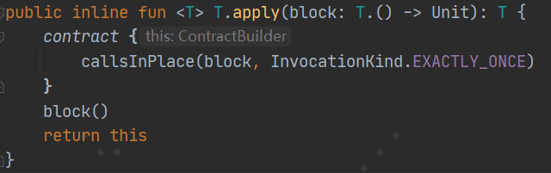

### 【x】 位运算符:bitwise operator

参考：<https://kotlinlang.org/docs/basic-types.html#bitwise-operations>

1. 是什么

Kotlin provides a set of bitwise operations on integer numbers.

They operate on the binary level directly with bits of the numbers' representation.（直接在二进制层面操作）

1. 限制

Bitwise operations are represented by functions that can be called in infix form（按位操作由可以以中缀形式调用的函数表示。）. They can be applied only to Int and Long.

|  |
| --- |
| **val** x = (1 shl 2) and 0x000FF000 |

1. 位运算符列表

Here is the complete list of bitwise operations:

* shl(bits)– signed shift left
* shr(bits)– signed shift right
* ushr(bits)– unsigned shift right
* and(bits)– bitwise **and**
* or(bits)– bitwise **or**
* xor(bits)– bitwise **xor**
* inv()– bitwise inversion

### 【x】 Elvis operator ?:

见本文档“空安全：Null safety-【6】Elvis operator”

### 【x】 逻辑运算符



### 【x】 相等性判断

<https://kotlinlang.org/docs/keyword-reference.html#operators-and-special-symbols>

<https://kotlinlang.org/docs/equality.html>

<https://www.kotlincn.net/docs/reference/equality.html>

<https://kotlinlang.org/docs/operator-overloading.html#equality-and-inequality-operators>

<https://juejin.cn/post/6859514232526864392>

#### 《1》 概述

In Kotlin there are two types of equality:

* Structural equality (== - a check for equals())：结构相等==（用equals（）检测）
* Referential equality (=== - two references point to the same object)：引用相等===（两个引用指向同一对象）

#### 《2》 2种相等详解

##### 1） ==/equals 和 !=

###### 1》 是什么

参1：<https://kotlinlang.org/docs/operator-overloading.html#equality-and-inequality-operators>

https://www.kotlincn.net/docs/reference/operator-overloading.html#equals

| **Expression** | **Translated to** |
| --- | --- |
| a == b | a?.equals(b) ?: (b === null) |
| a != b | !(a?.equals(b) ?: (b === null)) |

These operators only work with the function [equals(other: Any?): Boolean](https://kotlinlang.org/api/latest/jvm/stdlib/kotlin/-any/equals.html), which can be overridden to provide custom equality check implementation. Any other function with the same name (like equals(other: Foo)) will not be called.：这些操作符只使用函数 [equals(other: Any?): Boolean](https://kotlinlang.org/api/latest/jvm/stdlib/kotlin/-any/equals.html)，可以覆盖它来提供自定义的相等性检测实现。不会调用任何其他同名函数（如 equals(other: Foo)）。

|  |
| --- |
| 注：=== and !== (identity checks) are not overloadable, so no conventions exist for them. |

参2：<https://kotlinlang.org/docs/equality.html#structural-equality>

<https://www.kotlincn.net/docs/reference/equality.html>

Structural equality is checked by the == operation and its negated counterpart !=. By convention, an expression like a == b is translated to:

|  |
| --- |
| a?.equals(b) ?: (b === **null**) |

If a is not null, it calls the equals(Any?) function, otherwise (a is null) it checks that b is referentially equal to null.：也就是说如果 a 不是 null 则调用 equals(Any?) 函数，否则（即 a 是 null）检测 b 是否与 null 引用相等。

###### 2》 equals（）

<https://kotlinlang.org/api/latest/jvm/stdlib/kotlin/-any/equals.html>

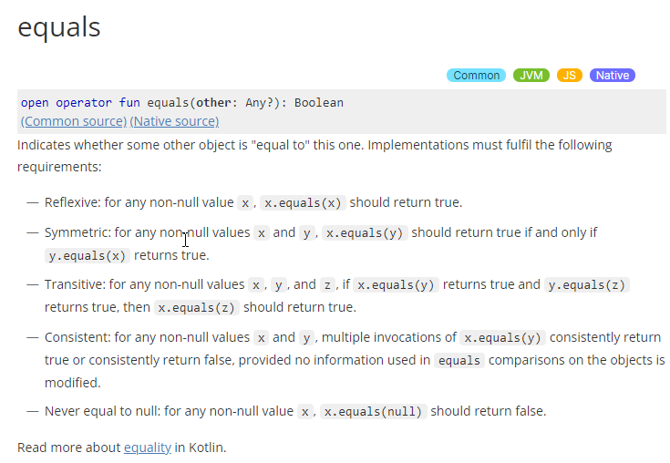

###### x》 ==和equals（）

https://kotlinlang.org/docs/equality.html#structural-equality

To provide a custom equals check implementation, override the [equals(other: Any?): Boolean](https://kotlinlang.org/api/latest/jvm/stdlib/kotlin/-any/equals.html) function. Functions with the same name and other signatures, like equals(other: Foo), don't affect equality checks with the operators == and !=.

Structural equality has nothing to do with comparison defined by the Comparable<...> interface, so only a custom equals(Any?) implementation may affect the behavior of the operator.

###### x》 关于null

<https://kotlinlang.org/docs/operator-overloading.html#equality-and-inequality-operators>

<https://www.kotlincn.net/docs/reference/operator-overloading.html#equals>

The == operation is special: it is translated to a complex expression that screens for null's. null == null is always true, and x == null for a non-null x is always false and won't invoke x.equals().：这个 == 操作符有些特殊：它被翻译成一个复杂的表达式，用于筛选 null 值。 null == null 总是 true，对于非空的 x，x == null 总是 false 而不会调用 x.equals()。

https://kotlinlang.org/docs/equality.html#structural-equality

Note that there's no point in optimizing your code when comparing to null explicitly: a == null will be automatically translated to a === null.

###### x》 示例

##### 2） === 和 !==

###### 1》 是什么

<https://kotlinlang.org/docs/equality.html#referential-equality>

<https://www.kotlincn.net/docs/reference/equality.html>

Referential equality is checked by the === operation and its negated counterpart !==. a === b evaluates to true if and only if a and b point to the same object.

For values represented by primitive types at runtime (for example, Int), the === equality check is equivalent to the == check.：引用相等由 ===（以及其否定形式 !==）操作判断。a === b 当且仅当 a 与 b 指向同一个对象时求值为 true。对于运行时表示为原始类型的值 （例如 Int），=== 相等检测等价于 == 检测。

###### 2》 示例

#### 《3》 其他

##### 1） Floating-point numbers equality

<https://kotlinlang.org/docs/equality.html#floating-point-numbers-equality>

### 运算符优先级：operator precedence

<https://kotlinlang.org/docs/reference/grammar.html#expressions>

| **Precedence** | **Title** | **Symbols** |
| --- | --- | --- |
| Highest | Postfix | ++, --, ., ?., ? |
|  | Prefix | -, +, ++, --, !, [label](https://kotlinlang.org/docs/reference/grammar.html#label) |
|  | Type RHS | :, as, as? |
|  | Multiplicative | *, /, % |
|  | Additive | +, - |
|  | Range | .. |
|  | Infix function | [simpleIdentifier](https://kotlinlang.org/docs/reference/grammar.html#simpleIdentifier) |
|  | Elvis | ?: |
|  | Named checks | in, !in, is, !is |
|  | Comparison | <, >, <=, >= |
|  | Equality | ==, !=, ===, !== |
|  | Conjunction | && |
|  | Disjunction | || |
|  | Spread operator | * |
| Lowest | Assignment | =, +=, -=, *=, /=, %= |

# Kotlin控制流：control flow

参考：

1. <https://kotlinlang.org/docs/control-flow.html>

## 条件：Conditions

### if expression

<https://kotlinlang.org/docs/control-flow.html#if-expression>

#### 《1》 是什么

In Kotlin, if is an expression: it returns a value.

Therefore, there is no ternary operator:三元运算符 (condition ? then : else) because ordinary if works fine in this role.

|  |
| --- |
| **var** max = a  **if** (a < b) max = b  // With else  **var** max: Int  **if** (a > b) {  max = a  } **else** {  max = b  }  // As expression  **val** max = **if** (a > b) a **else** b |

#### 《2》 分支语句可以是blocks

|  |
| --- |
| fun main() {  val a = 1  val b = 2   val max = if (a > b) {  *print*("Choose a")  a  } else {  *println*("Choose b")  b  }  *print*(max) } |

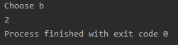

#### 《3》 作为expression注意点

If you're using if as an expression, for example, for returning its value or assigning it to a variable, the else branch is mandatory:强制的.

### when expression

<https://kotlinlang.org/docs/control-flow.html#when-expression>

#### 定义

when defines a conditional expression with multiple branches. It is similar to the switch statement in C-like languages.

#### 示例

Its simple form looks like this.

|  |
| --- |
| **when** (x) {  1 -> print(**"x == 1"**)  2 -> print(**"x == 2"**)  **else** -> { // Note the block  print(**"x is neither 1 nor 2"**)  }  } |

when matches its argument against all branches sequentially（顺序地） until some branch condition is satisfied.

#### 作为expression和statement

when can be used either as an expression or as a statement. If it is used as an expression, the value of the first matching branch becomes the value of the overall expression. If it is used as a statement, the values of individual branches are ignored. Just like with if, each branch can be a block, and its value is the value of the last expression in the block.

#### else branch

**是什么：**

The else branch is evaluated if none of the other branch conditions are satisfied.

限制：

If when is used as an expression, the else branch is mandatory, unless the compiler can prove that all possible cases are covered with branch conditions, for example, with [enum class](https://kotlinlang.org/docs/enum-classes.html) entries and [sealed class](https://kotlinlang.org/docs/sealed-classes.html) subtypes).

#### 为多case定义共同处理

To define a common behavior for multiple cases, combine their conditions in a single line with a comma:

|  |
| --- |
| **when** (x) {  0, 1 -> print(**"x == 0 or x == 1"**)  **else** -> print(**"otherwise"**)  } |

#### 使用expression作为branch conditions

You can use arbitrary expressions (not only constants) as branch conditions

|  |
| --- |
| **when** (x) {  parseInt(s) -> print(**"s encodes x"**)  **else** -> print(**"s does not encode x"**)  } |

#### branch conditions中包含范围

You can also check a value for being in or !in a [range](https://kotlinlang.org/docs/ranges.html) or a collection:

|  |
| --- |
| **when** (x) {  **in** 1..10 -> print(**"x is in the range"**)  **in** validNumbers -> print(**"x is valid"**)  !**in** 10..20 -> print(**"x is outside the range"**)  **else** -> print(**"none of the above"**)  } |

#### 《8》 使用is和！is进行类型检查

Another option is checking that a value is or !is of a particular type. Note that, due to [smart casts](https://kotlinlang.org/docs/typecasts.html#smart-casts), you can access the methods and properties of the type without any extra checks.

|  |
| --- |
| **fun** hasPrefix(x: Any) = **when**(x) {  **is** String -> x.startsWith(**"prefix"**)  **else** -> false  } |

#### 《9》 替代if-else if

when can also be used as a replacement for an if- else if chain. If no argument is supplied, the branch conditions are simply boolean expressions, and a branch is executed when its condition is true:

|  |
| --- |
| **when** {  x.isOdd() -> print(**"x is odd"**)  y.isEven() -> print(**"y is even"**)  **else** -> print(**"x+y is odd"**)  } |

#### 《10》 获取*when*值

You can capture when subject in a variable using following syntax:

|  |
| --- |
| **fun** Request.getBody() =  **when** (**val** response = executeRequest()) {  **is** Success -> response.body  **is** HttpError -> **throw** HttpException(response.status)  } |

#### 《11》 *when*的作用域

The scope of variable introduced in when subject is restricted to the body of this when.

#### 《12》 实例

1）

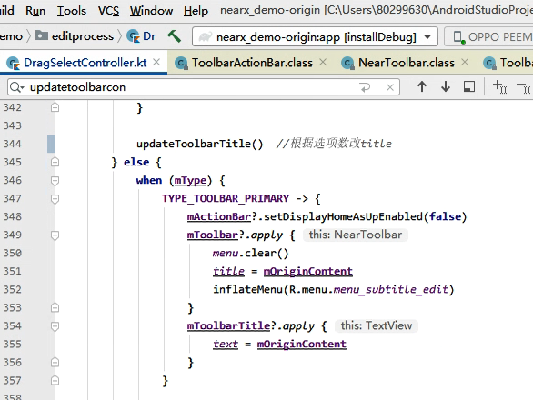

2）

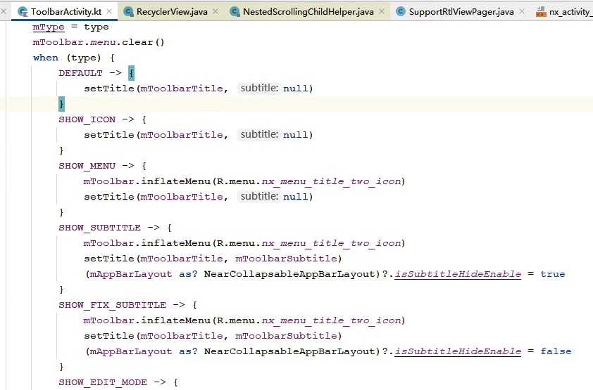

## 循环：loops

### for loops

参考：https://kotlinlang.org/docs/control-flow.html#for-loops

### while loops

## returns and jumps

<https://kotlinlang.org/docs/returns.html>

### 概述

#### 定义：

Kotlin has three structural jump expressions:

* return by default returns from the nearest enclosing function or [anonymous function](https://kotlinlang.org/docs/lambdas.html#anonymous-functions).
* break terminates the nearest enclosing loop.
* continue proceeds to the next step of the nearest enclosing loop.

#### 嵌套使用：

All of these expressions can be used as part of larger expressions:

|  |
| --- |
| val s = person.name ?: return |

#### 类型：

The type of these expressions is the [Nothing type](https://kotlinlang.org/docs/exceptions.html#the-nothing-type).

### break and continue labels

#### 语法：

Any expression in Kotlin may be marked with a label. Labels have the form of an identifier followed by the @ sign, such as abc@ or fooBar@. To label an expression, just add a label in front of it.

|  |
| --- |
| loop@ for (i in 1..100) {  // ...  } |

Now, we can qualify a break or a continue with a label:

|  |
| --- |
| loop@ for (i in 1..100) {  for (j in 1..100) {  if (...) break@loop  }  } |

A break qualified with a label jumps to the execution point right after the loop marked with that label. A continue proceeds to the next iteration of that loop.

#### 示例：

* break

|  |
| --- |
| fun main() {  *println*("last statement before for loop")  loop@ for (i in 1..100) {  for (j in 1..100) {  *println*("i=$i,j=$j")  if (j == 2) break@loop  }  }  *println*("first statement after for loop") } |

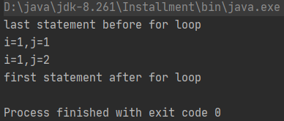

* continue

|  |
| --- |
| fun main() {  *println*("last statement before for loop")  loop@ for (i in 1..10) {  for (j in 1..10) {  if (j % 2 == 0) continue@loop  *println*("i=$i,j=$j")  }  }  *println*("first statement after for loop") } |

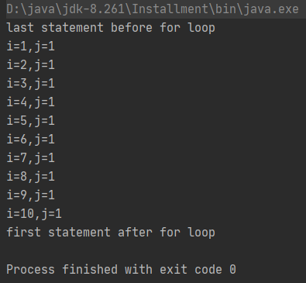

### return to labels

<https://kotlinlang.org/docs/returns.html#return-to-labels>

In Kotlin, functions can be nested using function literals, local functions, and object expressions. Qualified returns allow us to return from an outer function. The most important use case is returning from a lambda expression. Recall that when we write the following, the return-expression returns from the nearest enclosing function - foo:

|  |
| --- |
| fun foo() {  *listOf*(1, 2, 3, 4, 5).*forEach* **{** if (**it** == 3) return // non-local return directly to the caller of foo()  *print*(**it**)  **}** *println*("this point is unreachable") }  fun main() {  *foo*() } |

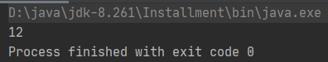

Note that such non-local returns are supported only for lambda expressions passed to [inline functions](https://kotlinlang.org/docs/inline-functions.html). To return from a lambda expression, label it and qualify the return:

|  |
| --- |
| fun foo1() {  *listOf*(1, 2, 3, 4, 5).*forEach* lit@**{** if (**it** == 3) return@lit // local return to the caller of the lambda - the forEach loop  *print*(**it**)  **}** *print*(" done with explicit label") }  fun main() {  *foo1*() } |

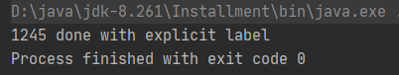

Now, it returns only from the lambda expression. Often it is more convenient to use implicit labels, because such a label has the same name as the function to which the lambda is passed.

|  |
| --- |
| fun foo2() {  *listOf*(1, 2, 3, 4, 5).*forEach* **{** if (**it** == 3) return@forEach // local return to the caller of the lambda - the forEach loop  *print*(**it**)  **}** *print*(" done with implicit label") }  fun main() {  *foo2*() } |

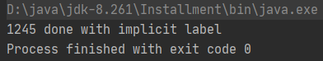

Alternatively, you can replace the lambda expression with an [anonymous function](https://kotlinlang.org/docs/lambdas.html#anonymous-functions). A return statement in an anonymous function will return from the anonymous function itself.

|  |
| --- |
| fun foo3() {  *listOf*(1, 2, 3, 4, 5).*forEach*(fun(value: Int) {  if (value == 3) return // local return to the caller of the anonymous function - the forEach loop  *print*(value)  })  *print*(" done with anonymous function") }  fun main() {  *foo3*() } |

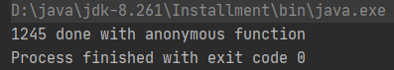

Note that the use of local returns in the previous three examples is similar to the use of continue in regular loops.

There is no direct equivalent for break, but it can be simulated by adding another nesting lambda and non-locally returning from it:

|  |
| --- |
| fun foo4() {  *run* loop@**{** *listOf*(1, 2, 3, 4, 5).*forEach* **{** if (**it** == 3) return@loop // non-local return from the lambda passed to run  *print*(**it**)  **}  }** *print*(" done with nested loop") }  fun main() {  *foo4*() } |

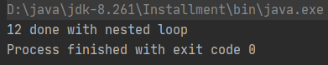

When returning a value, the parser gives preference to the qualified return:

|  |
| --- |
| return@a 1 |

This means "return 1 at label @a" rather than "return a labeled expression (@a 1)".

## 异常：exceptions

<https://kotlinlang.org/docs/exceptions.html>

# Kotlin类与对象：Classes and objects

[https://www.cnblogs.com/Jetictors/p/7758828.html#](https://www.cnblogs.com/Jetictors/p/7758828.html)

## 类基础

参考：<https://kotlinlang.org/docs/classes.html>

### 类声明

Classes in Kotlin are declared using the keyword class:

|  |
| --- |
| **class** Person { /*...*/ } |

包含组成：

The class declaration consists of the class name, the class header (specifying its type parameters, the primary constructor, and some other things), and the class body surrounded by curly braces（大括号）.

Both the header and the body are optional; if the class has no body, the curly braces can be omitted.

|  |
| --- |
| **class** Empty |

### 创建实例：Creating instances of classes

<https://kotlinlang.org/docs/classes.html#creating-instances-of-classes>

To create an instance of a class, call the constructor as if it were a regular：普通的 function:

|  |
| --- |
| **val** invoice = Invoice()  **val** customer = Customer(**"Joe Smith"**) |



The process of creating instances of nested, inner, and anonymous inner classes is described in [Nested classes](https://kotlinlang.org/docs/nested-classes.html).

## 类成员：Class members

参考：<https://kotlinlang.org/docs/classes.html#class-members>

### Constructors and initializer blocks

<https://kotlinlang.org/docs/classes.html#constructors>

<https://blog.csdn.net/xlh1191860939/article/details/79412319>

#### 《1》 是什么

A class in Kotlin can have a primary constructor and one or more secondary constructors.

#### 《2》 primary constructor：主构造器

##### 1） 是什么

The primary constructor is a part of the class header, and it goes after the class name and optional type parameters.

|  |
| --- |
| **class** Person **constructor**(firstName: String) { /*...*/ } |

##### 2） 省略constructor关键字

If the primary constructor does not have any annotations or visibility modifiers, the constructor keyword can be omitted:

|  |
| --- |
| **class** Person(firstName: String) { /*...*/ } |

If the constructor has annotations or visibility modifiers, the constructor keyword is required and the annotation or modifiers go before it:

|  |
| --- |
| **class** Customer **public** **@Inject** **constructor**(name: String) { /*...*/ } |

Learn more about [visibility modifiers](https://kotlinlang.org/docs/visibility-modifiers.html#constructors).

##### 3） primary constructor parameters的使用方式

Primary constructor parameters can be used in the initializer blocks. They can also be used in property initializers declared in the class body:

|  |
| --- |
| **class** Customer(name: String) {  **val** customerKey = name.uppercase()  } |

##### 4） 在primary constructor中声明属性

###### 1》 是什么：

Kotlin has a concise syntax for declaring properties and initializing them from the primary constructor:

|  |
| --- |
| **class** Person(**val** firstName: String, **val** lastName: String, **var** age: Int) |

示例：

|  |
| --- |
| class Person1(private val username: String, private var age: Int) {   fun test1() {  *println*("username=$username,age=$age")  } }  fun main() {  Person1("Eric", 20).test1() } |

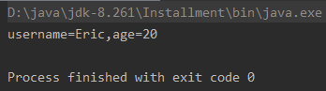

###### 2》 默认值：

Such declarations can also include default values of the class properties:

|  |
| --- |
| **class** Person(**val** firstName: String, **val** lastName: String, **var** isEmployed: Boolean = true) |

###### 3》 使用trailing comma：

You can use a [trailing comma](https://kotlinlang.org/docs/coding-conventions.html#trailing-commas) when you declare class properties:

|  |
| --- |
| **class** Person(  **val** firstName: String,  **val** lastName: String,  **var** age: Int, // trailing comma  ) { /*...*/ } |

###### 4》 使用var和val：

Much like regular properties, properties declared in the primary constructor can be mutable (var) or read-only (val).

#### 《3》 initializer block：初始化代码块

##### 1） 是什么

The primary constructor cannot contain any code. Initialization code can be placed in initializer blocks prefixed with the init keyword.

##### 2） 使用

During the initialization of an instance, the initializer blocks are executed in the same order as they appear in the class body, interleaved：交错 with the property initializers:

|  |
| --- |
| class InitOrderDemo(name: String) {  val firstProperty = "First property: $name".*also*(::println)   init {  *println*("First initializer block that prints ${name}")  }   val secondProperty = "Second property: ${name.length}".*also*(::println)   init {  *println*("Second initializer block that prints ${name.length}")  } }  fun main() {  InitOrderDemo("hello") } |

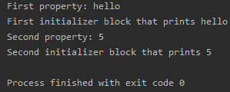

##### 3） 与primary constructor结合

Primary constructor parameters can be used in the initializer blocks. They can also be used in property initializers declared in the class body:

|  |
| --- |
| class Customer(name: String) {   init {  *println*("Second initializer block that prints ${name.length}")  *println*("Second initializer block that prints $name")  }   val customerKey = name.*toUpperCase*()  }  fun main() {  Customer("hello") } |

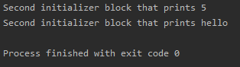

#### 《4》 secondary constructor：次级构造器

### 函数：Functions

见“本文档-5.Kotlin语法-（4）函数”

### 属性：Properties

#### 声明属性

##### 参1：<https://kotlinlang.org/docs/properties.html#declaring-properties>

Properties in Kotlin classes can be declared either as mutable, using the var keyword, or as read-only, using the val keyword.

|  |
| --- |
| class Address {  var name: String = "Holmes, Sherlock"  var street: String = "Baker"  var city: String = "London"  var state: String? = null  var zip: String = "123456"  } |

##### 参2：见“《5》Getters and setters”

##### <https://kotlinlang.org/docs/properties.html#getters-and-setters>

The full syntax for declaring a property is as follows:

|  |
| --- |
| var <propertyName>[: <PropertyType>] [= <property_initializer>]  [<getter>]  [<setter>] |

The **initializer**, **getter**, and **setter** are optional. The **property type** is optional if it can be inferred from the initializer or the getter’s return type, as shown below:

|  |
| --- |
| var initialized = 1 // has type Int, default getter and setter  // var allByDefault // ERROR: explicit initializer required, default getter and setter implied |

#### 类型推断：Type inference

<https://developer.android.com/kotlin/learn#inference>

#### 《3》 使用属性

<https://kotlinlang.org/docs/properties.html#declaring-properties>

To use a property, simply refer to it by its name:

|  |
| --- |
| **fun** copyAddress(address: Address): Address {  **val** result = Address() // there's no 'new' keyword in Kotlin  result.name = address.name // accessors are called  result.street = address.street  // ...  **return** result  } |

#### 《4》 初始化

参考1：<https://rengwuxian.com/kotlin-basic-1/>

参考2：<https://kotlinlang.org/docs/properties.html#late-initialized-properties-and-variables>

参考3：<https://kotlinlang.org/docs/properties.html#getters-and-setters>

##### 置null

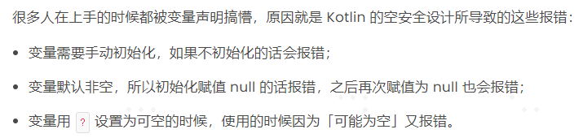

##### lateinit：延迟初始化

具体是这么写的：

|  |
| --- |
| lateinit var view: View |

这个 lateinit 的意思是：告诉编译器我没法第一时间就初始化，但我肯定会在使用它之前完成初始化的。

它的作用就是让 IDE 不要对这个变量检查初始化和报错。换句话说，加了这个 lateinit 关键字，这个变量的初始化就全靠你自己了，编译器不帮你检查了。

##### by lazy：延迟初始化

###### 1》 是什么

<https://www.jianshu.com/p/e2cb4c65d4ff>

<https://blog.csdn.net/guyue35/article/details/93601139>

<https://www.kotlincn.net/docs/reference/delegated-properties.html>

<https://juejin.cn/post/6844903607817469966>

<https://kotlinlang.org/docs/properties.html#delegated-properties>

###### 2》 实例

例1：

Uikitdemo-栏-标题栏-一级

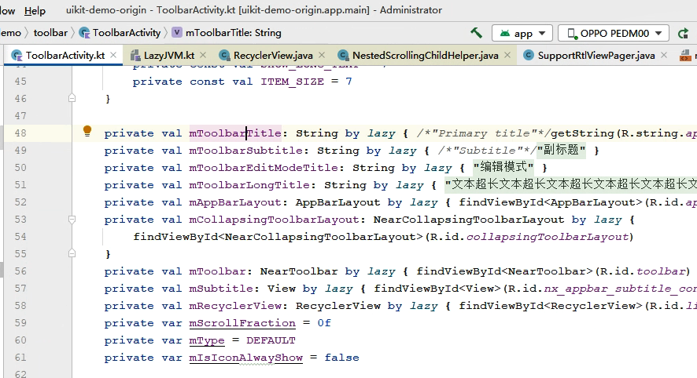

例2：

Uikitdemo-栏-标题栏-次级

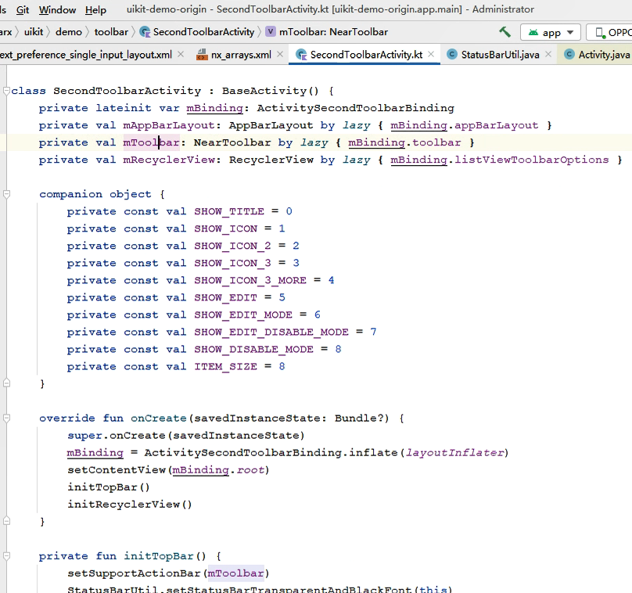

##### 其他初始化方式

#### 《5》 Getters and setters【统称accessors】

参考：

1】 主：

<https://kotlinlang.org/docs/properties.html#getters-and-setters>

<https://book.kotlincn.net/text/properties.html>

2】 辅：

<https://blog.csdn.net/mjb00000/article/details/79174831>

<https://www.delftstack.com/zh/howto/kotlin/kotlin-set/>

<https://blog.csdn.net/arinasiyyj/article/details/113767299>

<https://blog.csdn.net/wmd1732141816/article/details/113794437>

<https://blog.csdn.net/m0_37796683/article/details/107759662>

##### 是什么

###### 参1：<https://www.delftstack.com/zh/howto/kotlin/kotlin-set/>

在一般编程中，getter 帮助获取属性的值。同样，设置属性的值是使用 setter 完成的。

Kotlin 的 getter 和 setter 是自动生成的。因此，我们不需要为我们的程序单独创建它们。

所以，如果我们写，

|  |
| --- |
| class Student {  var Name: String = "John Doe"  } |

上面的代码等价于下面的 Kotlin 程序。

|  |
| --- |
| class Student {  var Name: String = "John Doe"  get() = field  set(value) {  field = value  }  } |

###### 参2：<https://blog.csdn.net/wmd1732141816/article/details/113794437>

Java中getter和setter方法：

在Java中,无论是数据模型类([JavaBean](https://so.csdn.net/so/search?q=JavaBean&spm=1001.2101.3001.7020)),还是自己定义的某个对象中的属性,都需要自己手动定义getter和setter方法,下面以Bird对象为例,定义的getter和setter方法如下:

Kotlin中getter和setter方法：

在Kotlin中,定义对象属性中的getter和setter方法默认是隐藏的,此外,所谓的getter和setter方法是以get(){xxx}和set(value){xxx}方法存在于Kotlin中,与Java中的案例一样,表现与上面Java中相一致的逻辑代码如下:

|  |
| --- |
| class Bird(var color:String,var age:Int,var sex:String) |

或者

|  |
| --- |
| class Bird{  var color:String=""  var age:Int=-1  var sex:String=""  } |

##### 性质

###### 1》 声明属性的完整语法

<https://kotlinlang.org/docs/properties.html#getters-and-setters>

The full syntax for declaring a property is as follows:

|  |
| --- |
| **var** <propertyName>[: <PropertyType>] [= <property_initializer>]  [<getter>]  [<setter>] |

###### 2》 accessor是可省略的/默认生成的

参1：<https://kotlinlang.org/docs/properties.html#getters-and-setters>

The initializer, getter, and setter are optional.

参2：<https://blog.csdn.net/wmd1732141816/article/details/113794437>

对于Kotlin代码：

|  |
| --- |
| class Bird{  var color:String=""  var age:Int=-1  var sex:String="" } |

默认隐藏get(){xxx}和set(value){xxx}方法，这两个默认方法表现形式如下:

|  |
| --- |
| class Bird {  var color: String = ""  get() {  return **field** }  set(value) {  **field** = value  }  var age: Int = -1  get() {  return **field** }  set(value) {  **field** = value  }  var sex: String = ""  get() {  return **field** }  set(value) {  **field** = value  } } |

补充1：<https://blog.csdn.net/mjb00000/article/details/79174831>

上面的隐藏形式不推荐在代码中自己手动去写。如果手动写会报：

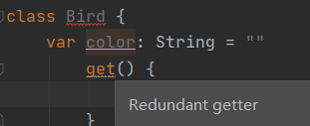

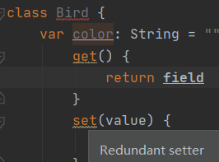

补充2：field关键字见“Backing fields”

###### 3》 property type和getter

<https://kotlinlang.org/docs/properties.html#getters-and-setters>

The property type is optional if it can be inferred from the initializer or the getter’s return type

示例1：从initializer推断

|  |
| --- |
| var *initialized* = 1 // has type Int, default getter and setter // var allByDefault // ERROR: explicit initializer required, default getter and setter implied |

示例2：从getter推断【见“自定义getter-B)示例1+2”】

###### 4》 val+var和setter

<https://kotlinlang.org/docs/properties.html#getters-and-setters>

The full syntax of a read-only property declaration differs from a mutable one in two ways: it starts with val instead of var and does not allow a setter:

|  |
| --- |
| val simple: Int? // has type Int, default getter, must be initialized in constructor val *inferredType* = 1 // has type Int and a default getter |

##### 3） 自定义accessor

###### 1》 自定义getter

A） 作用

<https://kotlinlang.org/docs/properties.html#getters-and-setters>

If you define a custom getter, it will be called every time you access the property (this way you can implement a computed property).

B） 示例

例1：<https://www.kotlincn.net/docs/reference/properties.html>

以下是一个自定义 getter 的示例：

|  |
| --- |
| class Main2 {   val size = 1   val isEmpty: Boolean  get() = this.size == 0  }  fun main() {  *println*(Main2().isEmpty) } |

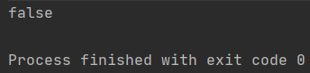

自 Kotlin 1.1 起，如果可以从 getter 推断出属性类型，则可以省略它：

|  |
| --- |
| val isEmpty get() = this.size == 0 // 具有类型 Boolean |

例2：<https://kotlinlang.org/docs/properties.html#getters-and-setters>

Here's an example of a custom getter:

|  |
| --- |
| class Rectangle(val width: Int, val height: Int) {  val area: Int // property type is optional since it can be inferred from the getter's return type  get() = this.width * this.height } fun main() {  val rectangle = Rectangle(3, 4)  *println*("Width=${rectangle.width}, height=${rectangle.height}, area=${rectangle.area}") } |

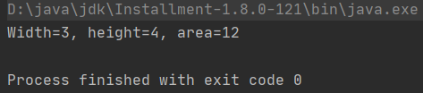

You can omit the property type if it can be inferred from the getter:

|  |
| --- |
| val area get() = this.width * this.height |

运行：

|  |
| --- |
| class Rectangle(val width: Int, val height: Int) {  //写法1  /*val area: Int // property type is optional since it can be inferred from the getter's return type  get() = this.width * this.height */  //写法2  val area get() = this.width * this.height } fun main() {  val rectangle = Rectangle(3, 4)  *println*("Width=${rectangle.width}, height=${rectangle.height}, area=${rectangle.area}") } |

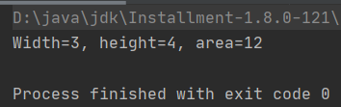

###### 2》 自定义setter

A） 作用

<https://kotlinlang.org/docs/properties.html#getters-and-setters>

If you define a custom setter, it will be called every time you assign a value to the property, except its initialization.

B） 代码演示

<https://kotlinlang.org/docs/properties.html#getters-and-setters>

A custom setter looks like this:

|  |
| --- |
| var stringRepresentation: String  get() = this.toString()  set(value) {  setDataFromString(value) // parses the string and assigns values to other properties  } |

C） setter参数名

<https://kotlinlang.org/docs/properties.html#getters-and-setters>

By convention, the name of the setter parameter is value, but you can choose a different name if you prefer.

D） 示例

<https://blog.csdn.net/arinasiyyj/article/details/113767299>

|  |
| --- |
| var *setStr*: String = ""  get() = **field** // 设置属性值时，先执行（field相关）  set(value) {  if (**field**.equals("")) {  **field** = "empty"  } else {  **field** = value  }  }  fun main() {  *setStr* = "";  *println*("str isEmpty $*setStr*") } |

这里的setStr和main（）都在顶层。

结果：

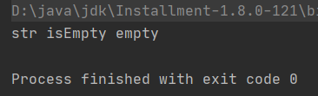

若value换成自定义名：

|  |
| --- |
| var *setStr*: String = ""  get() = **field** // 设置属性值时，先执行（field相关）  /*set(value) {  if (field.equals("")) {  field = "empty"  } else {  field = value  }  }*/  set(para) {  if (**field**.equals("")) {  **field** = "empty"  } else {  **field** = para  }  }  fun main() {  *setStr* = "";  *println*("str isEmpty $*setStr*") } |

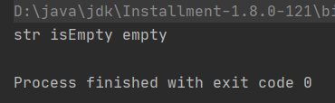

###### 3》 其他注意点

A） accessor的位置

<https://blog.csdn.net/wmd1732141816/article/details/113794437>

get(){xxx}和set(value){xxx}必须写在对应的属性下方,这样field字段获取的值才能与属性值相对应。

##### 4） 给accessor加注解或可见性修饰符

###### 1》 概述

<https://kotlinlang.org/docs/properties.html#getters-and-setters>

If you need to annotate an accessor or change its visibility, but you don't need to change the default implementation, you can define the accessor without defining its body:

|  |
| --- |
| **var** setterVisibility: String = **"abc"**  **private** **set** // the setter is private and has the default implementation  **var** setterWithAnnotation: Any? = **null**  **@Inject** **set** // annotate the setter with Inject |

###### 2》 给accessor加注解

###### 3》 给accessor加可见性修饰符

A） 当setter或属性用private修饰

参1：<https://blog.csdn.net/mjb00000/article/details/79174831>

参2：<https://blog.csdn.net/m0_37796683/article/details/107759662>

##### 5） accessor和数据类

###### 参1：<https://blog.csdn.net/m0_37796683/article/details/107759662>

在 Kotlin 中普通类中一般不提供 get() 和 set() 函数，因为普通的类中基本用不到，这点和 Java 相同，但是 Java 在定义纯粹的数据类时，会用到 get() 和 set() 函数，但是 Kotlin 这种情况定义了**数据类**，已经为我们实现了 get() 和 set() 函数。

###### 参2：<https://cloud.tencent.com/developer/article/1743378>

##### 6） Backing fields：幕后字段

###### 1》 是什么

参1：<https://kotlinlang.org/docs/properties.html#backing-fields>

In Kotlin, a **field** is only used as a part of a property to hold its value in memory. Fields cannot be declared directly. However, when a property needs a backing field, Kotlin provides it automatically. This backing field can be referenced in the accessors using the field identifier:

|  |
| --- |
| var counter = 0 // the initializer assigns the backing field directly  set(value) {  if (value >= 0)  field = value  // counter = value // ERROR StackOverflow: Using actual name 'counter' would make setter recursive：递归  } |

参2：<https://blog.csdn.net/m0_37796683/article/details/107759662>

后备字段相对 Java 来说是一种新的定义，不能在 Kotlin 类中直接声明字段，但是当属性需要后备字段时，Kotlin 有后端变量机制（Backing Fields）会自动提供，可以在访问器中使用后备字段标识符 field 来引用此字段，即 Kotlin 中的后备字段用 field 来表示。

###### 2》 为什么

<https://blog.csdn.net/m0_37796683/article/details/107759662>

###### 3》 限制

<https://kotlinlang.org/docs/properties.html#backing-fields>

The field identifier can only be used in the accessors of the property.

<https://blog.csdn.net/m0_37796683/article/details/107759662>

注意：后备字段 field 只能用于属性的访问器。

###### 4》 何时生成backing field

参1：<https://kotlinlang.org/docs/properties.html#backing-fields>

A backing **field** will be generated for a property if it uses the default implementation of at least one of the accessors, or if a custom accessor references it through the field identifier.

For example, there would be no backing field in the following case:

|  |
| --- |
| val isEmpty: Boolean  get() = this.size == 0 |

参2：<https://blog.csdn.net/m0_37796683/article/details/107759662>

如果属性至少使用一个访问器的默认实现，或者自定义访问器通过 field 标识符引用该属性，则将生成该属性支持的字段。也就是说只有使用了默认的 getter() 或 setter() 以及显示使用 field 字段的时候，后备字段 field 才会存在。下面这段代码就不存在后备字段：

|  |
| --- |
| val isEmpty: Boolean  get() = this.color == 0 |

这里定义了 get() 方法，但是没有通过后备字段 field 去引用。

##### 7） Backing properties：幕后属性

##### 实例

###### 例1：

Uikit库源码

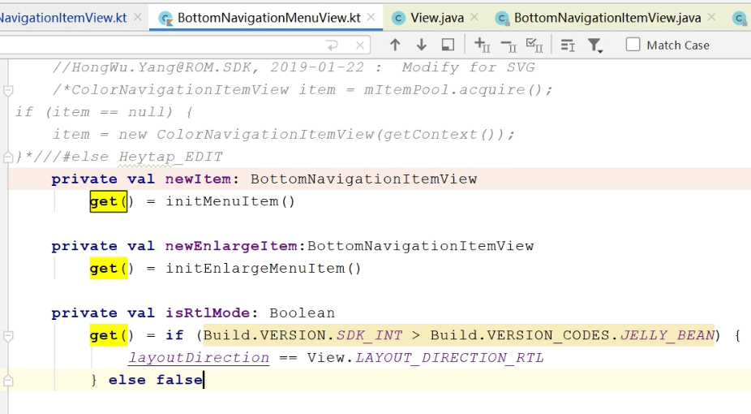

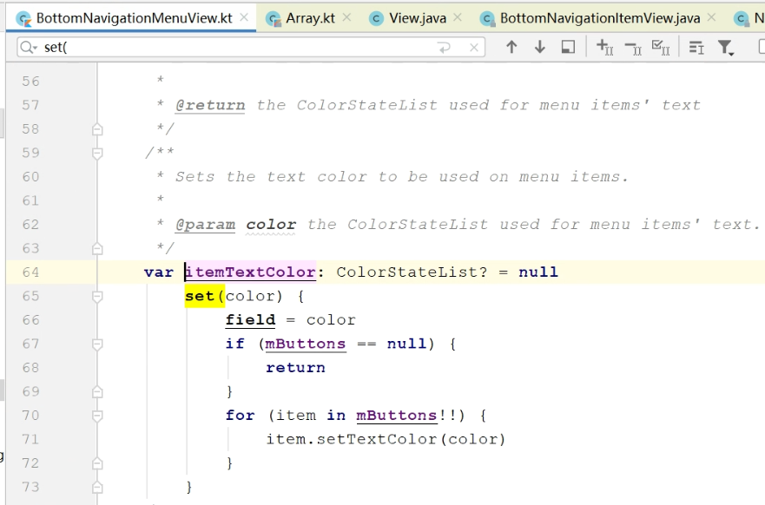

###### 例2：

Uikitdemo-motionkit-物理动画-列表

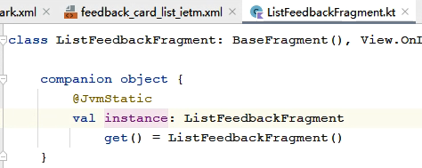

#### 《6》 常量：Compile-time constants

参考：<https://kotlinlang.org/docs/properties.html#compile-time-constants>

##### 1） 是什么

If the value of a read-only property is known at the compile time, mark it as a compile time constant using the **const** modifier.

##### 2） 限制

Such properties need to fulfil the following requirements（满足以下要求）:

* Top-level, or member of an [object declaration](https://kotlinlang.org/docs/object-declarations.html#object-declarations-overview) or [a companion object](https://kotlinlang.org/docs/object-declarations.html#companion-objects).
* Initialized with a value of type String or a primitive type
* No custom getter

##### 3） 在注解中使用

Such properties can be used in annotations:

|  |
| --- |
| **const** **val** SUBSYSTEM_DEPRECATED: String = **"This subsystem is deprecated"**  **@Deprecated**(SUBSYSTEM_DEPRECATED) **fun** foo() { ... } |

##### 4） 实例

1》 例1

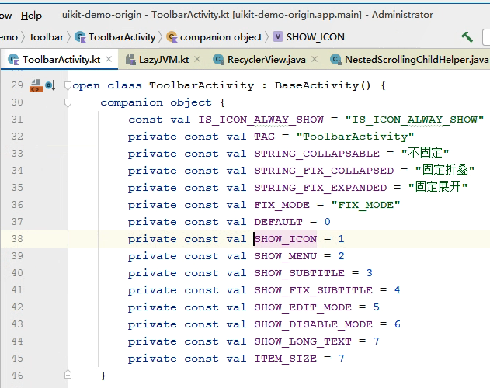

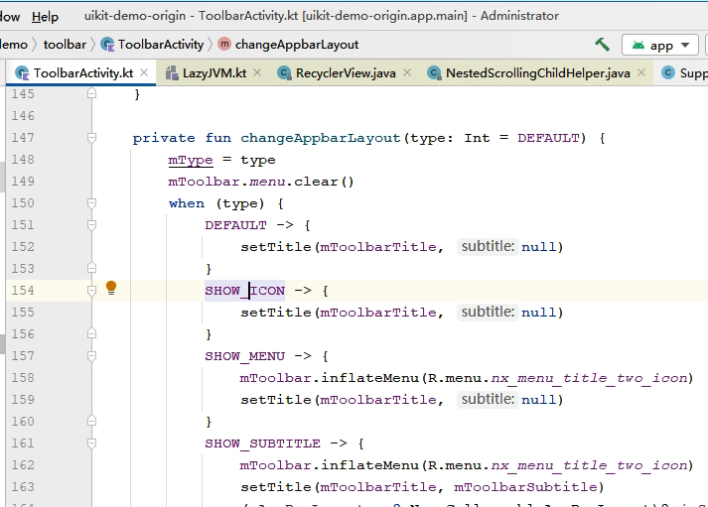

#### 《7》 注意点

《1》 在方法中的变量必须用var或val修饰；

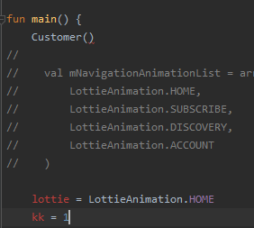

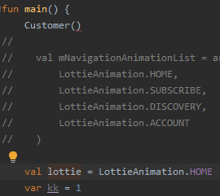

### 【4】 嵌套类与内部类：Nested and inner classes

<https://kotlinlang.org/docs/nested-classes.html>

<https://book.kotlincn.net/text/nested-classes.html>

#### 《x》 实例

##### 例1：

<https://kotlinlang.org/docs/this-expressions.html#qualified-this>

##### 例2：

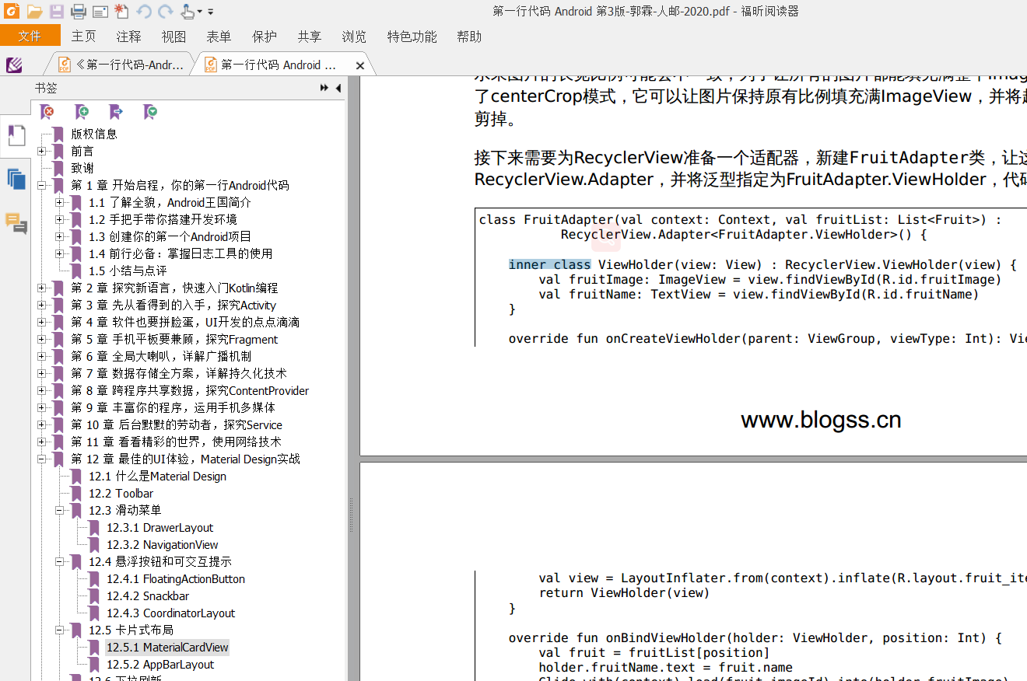

### 【5】 Object declarations

Object declaration：是单例类

## 继承： Inheritance

参考：<https://kotlinlang.org/docs/inheritance.html>

### 基础

#### 所有类的父类Any

##### 参1：<https://kotlinlang.org/docs/inheritance.html>

All classes in Kotlin have a common superclass:超类/父类, Any, which is the default superclass for a class with no supertypes:超类型/父型 declared:

|  |
| --- |
| **class** Example // Implicitly inherits from Any |

Any has three methods: equals(), hashCode(),

and toString(). Thus, these methods are defined for all Kotlin classes.

##### 参2：源码

|  |
| --- |
| */**  * The root of the Kotlin class hierarchy. Every Kotlin class has [Any] as a superclass.  */* public open class Any {  */**  * Indicates whether some other object is "equal to" this one. Implementations must fulfil the following  * requirements:  *  * * Reflexive: for any non-null value `x`, `x.equals(x)` should return true.  * * Symmetric: for any non-null values `x` and `y`, `x.equals(y)` should return true if and only if `y.equals(x)` returns true.  * * Transitive: for any non-null values `x`, `y`, and `z`, if `x.equals(y)` returns true and `y.equals(z)` returns true, then `x.equals(z)` should return true.  * * Consistent: for any non-null values `x` and `y`, multiple invocations of `x.equals(y)` consistently return true or consistently return false, provided no information used in `equals` comparisons on the objects is modified.  * * Never equal to null: for any non-null value `x`, `x.equals(null)` should return false.  *  * Read more about [equality](https://kotlinlang.org/docs/reference/equality.html) in Kotlin.  */* public open operator fun equals(other: Any?): Boolean   */**  * Returns a hash code value for the object. The general contract of `hashCode` is:  *  * * Whenever it is invoked on the same object more than once, the `hashCode` method must consistently return the same integer, provided no information used in `equals` comparisons on the object is modified.  * * If two objects are equal according to the `equals()` method, then calling the `hashCode` method on each of the two objects must produce the same integer result.  */* public open fun hashCode(): Int   */**  * Returns a string representation of the object.  */* public open fun toString(): String } |

#### 《2》 所有类默认是final

By default, Kotlin classes are final – they can’t be inherited. To make a class inheritable, mark it with the open keyword:

|  |
| --- |
| **open** **class** Base // Class is open for inheritance |

#### 《3》 显式地声明父类

To declare an explicit supertype, place the type after a colon in the class header:

|  |
| --- |
| open class Base(p: Int)  class Derived(p: Int) : Base(p) |

#### 《4》 基类的初始化

##### 参1：<https://kotlinlang.org/docs/inheritance.html>

###### 1） 派生类有primary constructor

If the derived class:派生类 has a primary constructor, the base class：基类 can (and must) be initialized in that primary constructor according to its parameters.

|  |
| --- |
| open class Base(p: Int)  class Derived(p: Int) : Base(p) |

###### 2） 派生类无primary constructor

If the derived class has no primary constructor, then each secondary constructor has to initialize the base type using the super keyword or it has to delegate to another constructor which does. Note that in this case different secondary constructors can call different constructors of the base type:

|  |
| --- |
| **class** MyView : View {  **constructor**(ctx: Context) : **super**(ctx)  **constructor**(ctx: Context, attrs: AttributeSet) : **super**(ctx, attrs)  } |

##### 参2：<https://www.jianshu.com/p/fc54d2241ba7>

#### 《5》 Kotlin是单继承

|  |
| --- |
| open class C1 {  open fun m1() {   } }  open class C2 {  open fun m2() {   } }  interface I1 {  }  class F1 : C1(), C2() { } |

报错

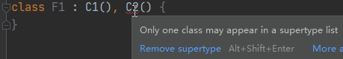

#### 《6》 继承和实现混写

|  |
| --- |
| open class C1 {  open fun m1() {   } }  open class C2 {  open fun m2() {   } }  interface I1 {  fun iM1() }  interface I2 {  fun iM2() {   } }  class F1 : C1(), I1, I2 {  override fun iM1() {  *TODO*("Not yet implemented")  } } |

即在冒号后用逗号列出类和接口即可

### Overriding methods

Kotlin requires explicit modifiers for overridable members and overrides:

|  |
| --- |
| open class Shape {  open fun draw() { /*...*/ }  fun fill() { /*...*/ }  }  class Circle() : Shape() {  override fun draw() { /*...*/ }  } |

运行：

|  |
| --- |
| open class Shape {  open fun draw() {  *println*("superclass draw()")  }  fun fill() { /*...*/ } }  class Circle() : Shape() {  override fun draw() {  *println*("subclass draw()")  } }  fun main() {  Circle().draw() } |

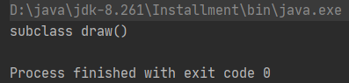

The override modifier is required for Circle.draw(). If it were missing, the compiler would complain.

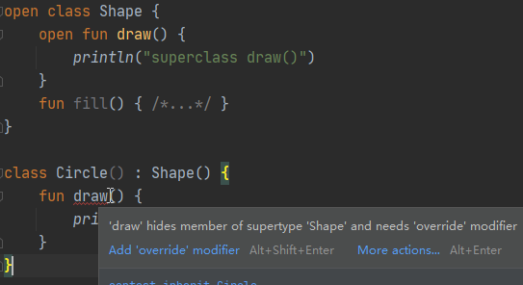

If there is no open modifier on a function, like Shape.fill(), declaring a method with the same signature in a subclass is not allowed, either with override or without it.

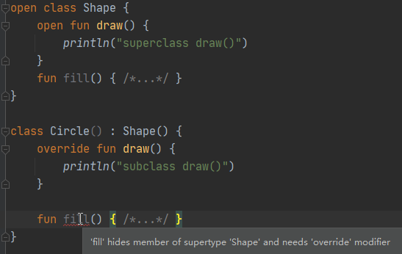

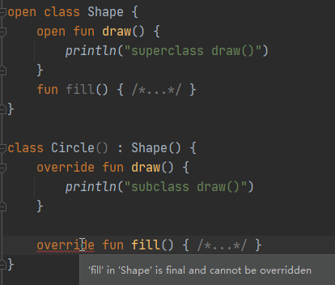

The open modifier has no effect when added to members of a final class – a class without an open modifier.

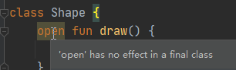

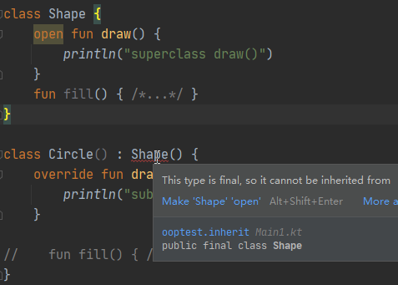

A member marked override is itself open, so it may be overridden in subclasses. If you want to prohibit re-overriding, use final:

|  |
| --- |
| open class Rectangle() : Shape() {  final override fun draw() { /*...*/ }  } |

运行：

* 不在override前加final：

|  |
| --- |
| open class Shape {  open fun draw() {  *println*("class Shape draw()")  }  fun fill() { /*...*/ } }  open class Circle() : Shape() {  override fun draw() {  *println*("class Circle draw()")  }  // fun fill() { /*...*/ } }  class SubCircle() : Circle() {  override fun draw() {  *println*("class SubCircle draw()")  }  // fun fill() { /*...*/ } }  fun main() {  val shape = SubCircle()  shape.draw() } |

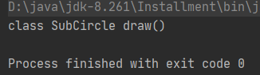

* 在override前加final：

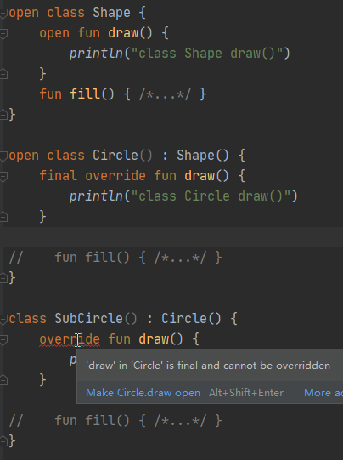

### Overriding properties

### Derived class initialization order

### Calling the superclass implementation

### Overriding rules

## 接口： Interfaces

参考：<https://kotlinlang.org/docs/interfaces.html>

### 组成

Interfaces in Kotlin can contain declarations of abstract methods, as well as method implementations.

What makes them different from abstract classes is that interfaces cannot store state. They can have properties but these need to be abstract or to provide accessor implementations.

### 定义接口

An interface is defined using the keyword interface

|  |
| --- |
| **interface** MyInterface {  **fun** bar()  **fun** foo() {  // optional body  }  } |

### Implementing interfaces

A class or object can implement one or more interfaces

|  |
| --- |
| **class** Child : MyInterface {  **override** **fun** bar() {  // body  }  } |

### Properties in interfaces

### Interfaces Inheritance

### Resolving overriding conflicts

## 数据类：Data classes

<https://kotlinlang.org/docs/data-classes.html>

<https://www.kotlincn.net/docs/reference/data-classes.html>

### 是什么

It is not unusual to create classes whose main purpose is to hold data. In such classes, some standard functionality and some utility functions are often mechanically derivable from the data.

In Kotlin, these are called data classes and are marked with data:

|  |
| --- |
| **data** **class** User(**val** name: String, **val** age: Int) |

### 【2】 从属性中派生成员

The compiler automatically derives the following members from all properties declared in the primary constructor:

* equals()/hashCode() pair
* toString() of the form "User(name=John, age=42)"
* [componentN() functions](https://kotlinlang.org/docs/destructuring-declarations.html) corresponding to the properties in their order of declaration.
* copy() function (see below).

### 【3】 语法规定

#### 整体

To ensure consistency and meaningful behavior of the generated code, data classes have to fulfill the following requirements:

* The primary constructor needs to have at least one parameter.
* All primary constructor parameters need to be marked as val or var.
* Data classes cannot be abstract, open, sealed, or inner.

#### 成员派生相关

Additionally, the generation of data class members follows these rules with regard to the members’ inheritance:

* If there are explicit implementations of equals(), hashCode(), or toString() in the data class body or final implementations in a superclass, then these functions are not generated, and the existing implementations are used.
* If a supertype has componentN() functions that are open and return compatible types, the corresponding functions are generated for the data class and override those of the supertype. If the functions of the supertype cannot be overridden due to incompatible signatures or due to their being final, an error is reported.
* Providing explicit implementations for the componentN() and copy() functions is not allowed.

#### 继承其他类

Data classes may extend other classes (see [Sealed classes](https://kotlinlang.org/docs/sealed-classes.html) for examples).

#### 无参构造器

On the JVM, if the generated class needs to have a parameterless constructor, default values for the properties have to be specified (see [Constructors](https://kotlinlang.org/docs/classes.html#constructors)).

|  |
| --- |
| data class User(val name: String = "", val age: Int = 0) |

### 【4】 Properties declared in the class body

### 【5】 Copy

### 【6】 Data classes and destructuring declarations

### 【7】 Standard data classes

## 枚举类： Enum classes

参考：<https://kotlinlang.org/docs/enum-classes.html>

### 基础使用

声明：

The most basic use case for enum classes is the implementation of type-safe enums:

|  |
| --- |
| **enum** **class** Direction {  NORTH, SOUTH, WEST, EAST  } |

Each enum constant is an object.

Enum constants are separated by commas.

初始化：

Since each enum is an instance of the enum class, it can be initialized as:

|  |
| --- |
| **enum** **class** Color(**val** rgb: Int) {  RED(0xFF0000),  GREEN(0x00FF00),  BLUE(0x0000FF)  } |

## （7） 扩展：Extensions

<https://kotlinlang.org/docs/extensions.html>

<https://book.kotlincn.net/text/extensions.html>

### 【1】 是什么

<https://kotlinlang.org/docs/extensions.html>

Kotlin provides the ability to extend a class with new functionality without having to inherit from the class or use design patterns such as *Decorator*. This is done via special declarations called *extensions*.

For example, you can write new functions for a class from a third-party library that you can't modify. Such functions can be called in the usual way, as if they were methods of the original class. This mechanism is called an *extension function*. There are also *extension properties* that let you define new properties for existing classes.

### 【2】 扩展函数

见上面“函数【x】不同类型函数《x》扩展函数”

# Kotlin集合：Collections

## Overview

参考：

1. <https://kotlinlang.org/docs/collections-overview.html>

### 【1】 概览

### 【2】 Collection types

#### 《1》 概述

#### 《2》 Collection

#### List

In Kotlin, the default implementation

of List is [ArrayList](https://kotlinlang.org/api/latest/jvm/stdlib/kotlin.collections/-array-list/index.html) which you can think of as a resizable array.

#### Set

#### Map

## 区间与数列：Ranges and progressions

参考：https://kotlinlang.org/docs/ranges.html#range

### 概述

#### until函数

To iterate a number range which does not include its end element, use the [until](https://kotlinlang.org/api/latest/jvm/stdlib/kotlin.ranges/until.html) function:

|  |
| --- |
| fun main() {  for (i in 1 *until* 10) { // i in [1, 10), 10 is excluded  *print*(i)  } } |

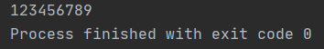

### Range

### Progression

## Collection通用

1. size

<https://kotlinlang.org/api/latest/jvm/stdlib/kotlin.collections/-list/size.html>

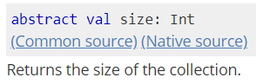

## List-specific operations

参考：<https://kotlinlang.org/docs/list-operations.html>

[List](https://kotlinlang.org/docs/collections-overview.html#list) is the most popular type of built-in collection in Kotlin. Index access to the elements of lists provides a powerful set of operations for lists.

### Retrieve elements by index

通用：

Lists support all common operations for element retrieval：检索: elementAt(), first(), last(), and others listed in [Retrieve single elements](https://kotlinlang.org/docs/collection-elements.html).

特定：

What is specific for lists is index access to the elements, so the simplest way to read an element is retrieving it by index. That is done with the [get()](https://kotlinlang.org/api/latest/jvm/stdlib/kotlin.collections/-list/get.html) function with the index passed in the argument or the shorthand [index] syntax.

|  |
| --- |
| fun main() {  val numbers = *listOf*(1, 2, 3, 4)  *println*(numbers.get(0))  *println*(numbers[0]) } |

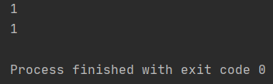

# Kotlin线程

## 用法

Kt中用线程是通过调thread方法

<https://kotlinlang.org/api/latest/jvm/stdlib/kotlin.concurrent/thread.html>

源码为：

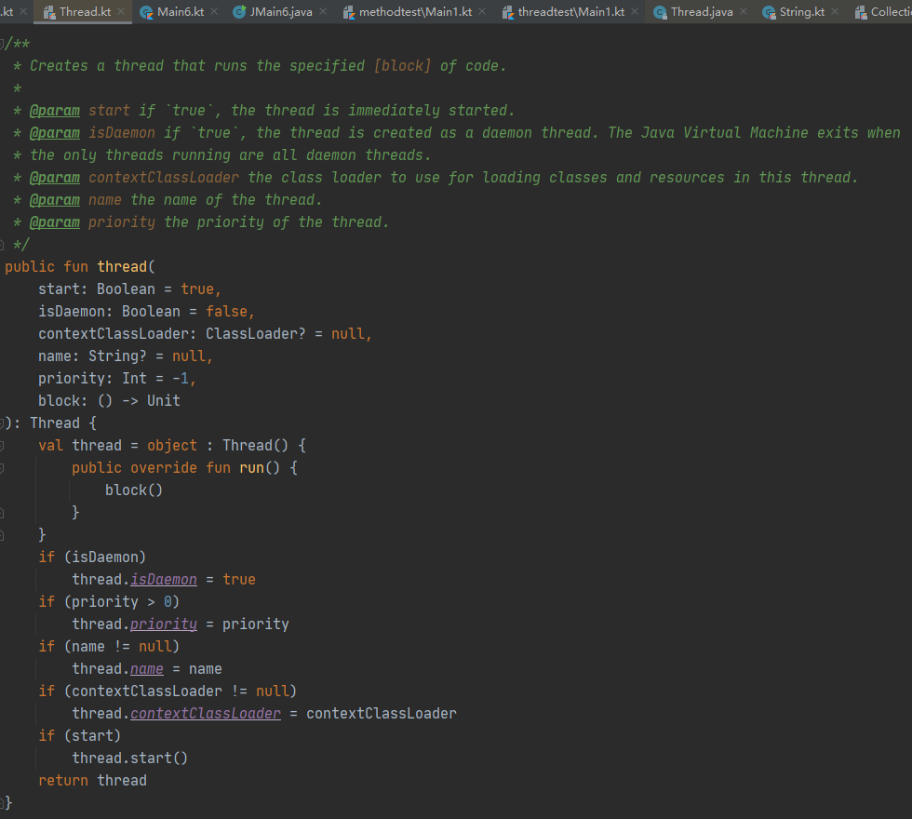

可见通过thread方法创建一个java的Thread对象，默认会启动线程调thread.start()。

## 示例

|  |
| --- |
| package threadtest  import kotlin.concurrent.thread  fun main() {  *thread* **{** for (x in 1..5) {  *println*("message：$x")  Thread.sleep(1000)  }  **}** } |

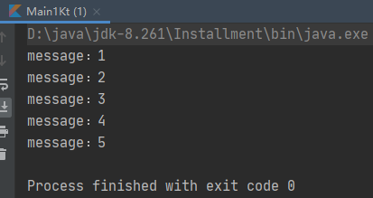

# Kotlin协程：Coroutines

## 是什么

参考：

1. <https://kotlinlang.org/docs/coroutines-overview.html>
2. 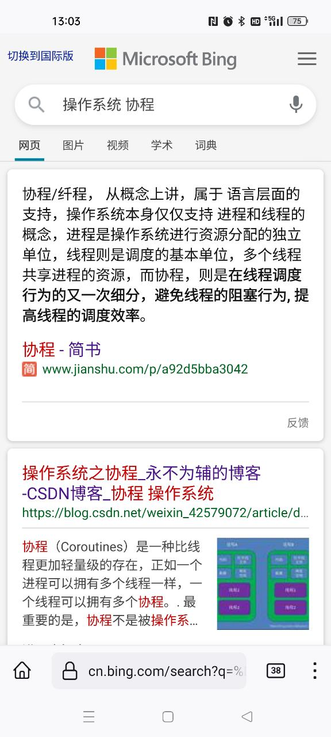

### 归纳：

* 1. 协程是轻量级线程，如同线程是轻量级进程；
  2. 协程是语言层面的，操作系统仅支持进程和线程；
  3. 协程的真正作用是“最大程度简化异步并发任务，用同步代码写出异步效果”；

# Kotlin泛型：Generics

<https://kotlinlang.org/docs/generics.html>

<https://book.kotlincn.net/text/generics.html>

## 泛型类

<https://kotlinlang.org/docs/generics.html>

### 【1】 声明

Classes in Kotlin can have type parameters：类型形参, just like in Java:

|  |
| --- |
| class Box<T>(t: T) {  var value = t  } |

### 【2】 使用

#### 《1》 不忽略类型实参

To create an instance of such a class, simply provide the type arguments:类型实参：

|  |
| --- |
| val box: Box<Int> = Box<Int>(1) |

运行：

|  |
| --- |
| class Box<T>(t: T) {  var value = t }  fun main() {  val box: Box<Int> = Box<Int>(1)  *println*(box.value) } |

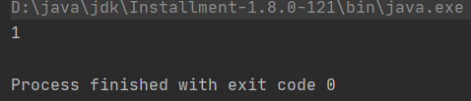

#### 《2》 忽略类型实参

But if the parameters can be inferred, for example, from the constructor arguments, you can omit the type arguments:

|  |
| --- |
| val box = Box(1) // 1 has type Int, so the compiler figures out that it is Box<Int> |

运行：

|  |
| --- |
| class Box<T>(t: T) {  var value = t }  fun main() { // val box: Box<Int> = Box<Int>(1) //写法1  val box = Box(1) // 写法2  *println*(box.value) } |

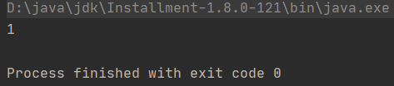

### 【3】 实例

#### 例1：<https://kotlinlang.org/docs/properties.html#backing-properties>

|  |
| --- |
| private var _table: Map<String, Int>? = null  public val table: Map<String, Int>  get() {  if (_table == null) {  _table = HashMap() // Type parameters are inferred  }  return _table ?: throw AssertionError("Set to null by another thread")  } |

## Variance：型变

## Type projections：类型投影

## Generic functions：泛型函数

### 【1】 语法

Classes aren’t the only declarations that can have type parameters. Functions can, too. Type parameters are placed before the name of the function:

|  |
| --- |
| **fun** <T> singletonList(item: T): List<T> {  // ...  }  **fun** <T> T.basicToString(): String { // extension function  // ...  } |

To call a generic function, specify the type arguments at the call site after the name of the function:

|  |
| --- |
| **val** l = singletonList<Int>(1) |

Type arguments can be omitted if they can be inferred from the context, so the following example works as well:

|  |
| --- |
| **val** l = singletonList(1) |

### 【2】 示例

|  |
| --- |
| fun <T> singletonList(item: T) {  *println*("item=$item") }  fun main() {  *singletonList*<Int>(1)  *singletonList*(10) } |

结果：

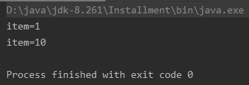

## Generic constraints：泛型约束

## Type erasure：类型擦除

# Kotlin反射：Reflection

<https://kotlinlang.org/docs/reflection.html>

<https://www.kotlincn.net/docs/reference/reflection.html>

## 概述

## JVM dependency

## Class references：类引用

### 获取已知类的引用

<https://kotlinlang.org/docs/reflection.html#class-references>

#### 《1》 概述

The most basic reflection feature is getting the runtime reference to a Kotlin class.

To obtain the reference to a statically known：静态已知的 Kotlin class, you can use the class literal syntax:

|  |
| --- |
| **val** c = MyClass::**class** |

The reference is a [KClass](https://kotlinlang.org/api/latest/jvm/stdlib/kotlin.reflect/-k-class/index.html) type value.

#### 《2》 Kt和Java的类引用关系

On JVM: a Kotlin class reference is not the same as a Java class reference. To obtain a Java class reference, use the .java property on a KClass instance.

#### 《3》 关于KClass

<https://kotlinlang.org/api/latest/jvm/stdlib/kotlin.reflect/-k-class/>

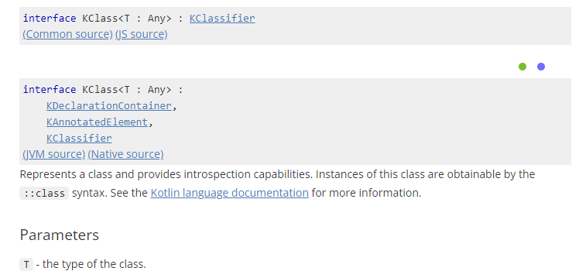

### 获取对象的类的引用：Bound class references

You can get the reference to the class of a specific object with the same ::class syntax by using the object as a receiver:

|  |
| --- |
| **val** widget: Widget = ...  assert(widget **is** GoodWidget) { **"Bad widget: ${widget::class.qualifiedName}"** } |

You will obtain the reference to the exact class of an object, for example, GoodWidget or BadWidget, regardless of the type of the receiver expression (Widget).

## Callable references：可调用引用

# Kotlin注解：Annotations

<https://kotlinlang.org/docs/annotations.html>

<https://book.kotlincn.net/text/annotations.html>

# Kotlin术语

## signature

<https://kotlinlang.org/docs/lambdas.html#function-types>

These types have a special notation that corresponds to the **signatures of the functions** - their parameters and return values.

## closure：闭包

<https://kotlinlang.org/docs/lambdas.html#closures>

A lambda expression or anonymous function (as well as a [local function](https://kotlinlang.org/docs/functions.html#local-functions) and an [object expression](https://kotlinlang.org/docs/object-declarations.html#object-expressions)) can access its closure, which includes the variables declared in the outer scope.

## （3） 接收者：receiver

主：<https://stackoverflow.com/questions/45875491/what-is-a-receiver-in-kotlin>

辅：

<https://discuss.kotlinlang.org/t/what-is-a-receiver/18588>

<https://dev.to/srdpatel/kotlin-extension-function-1dd7>

### 【1】 是什么

It is actually incredibly:难以置信地 easy to understand how blocks of code with receivers are handled:

**Imagine that, similar to extension functions, the block of code is evaluated inside the class of the receiver type.**[this](https://kotlinlang.org/docs/reference/this-expressions.html)**effectively becomes amended:修正 by the receiver type.**

### 【2】 出现位置

* 1. extension function

<https://kotlinlang.org/docs/extensions.html#extension-functions>

《2》 scope function

<https://kotlinlang.org/docs/scope-functions.html>

《3》 this expression

<https://kotlinlang.org/docs/this-expressions.html>

## （4） 作用域：scope

<https://kotlinlang.org/spec/scopes-and-identifiers.html#scopes-and-identifiers>

### 【1】 是什么

Kotlin program is logically divided into **scopes**.

A **scope** is a syntactically-delimited region of code which constitutes a **context** in which entities and their names can be introduced. Scopes can be nested, with entities introduced in outer scopes possibly available in the inner scopes if [linked](https://kotlinlang.org/spec/scopes-and-identifiers.html#linked-scopes).：**作用域**是一个由语法分隔的代码区域，它构成了一个**上下文**，在这个上下文中可以引入实体及其名称。作用域可以嵌套，外部作用域引入的实体如果被链接了，内部作用域可能可用该实体。

The top level of a Kotlin file is also a scope, containing all the scopes within a file.

### 【2】 分成2类

All the scopes are divided into two kinds: declaration scopes and statement scopes. These two kinds of scopes differ in how the identifiers may refer to the entities defined in the scopes.

Declaration scopes include:

* The project [modules](https://kotlinlang.org/spec/packages-and-imports.html#modules);
* The project [packages](https://kotlinlang.org/spec/packages-and-imports.html#packages-and-imports);
* The top level scopes of non-script Kotlin files;
* The bodies of [classifier declarations](https://kotlinlang.org/spec/declarations.html#classifier-declaration);
* The bodies of [object literals](https://kotlinlang.org/spec/expressions.html#object-literals);
* Function parameter scope containing the declared value parameters in a [function declaration](https://kotlinlang.org/spec/declarations.html#function-declaration) or a non-primary [constructor declaration](https://kotlinlang.org/spec/declarations.html#constructor-declaration);
* Primary constructor parameter scope containing the declared value parameters in a [primary constructor](https://kotlinlang.org/spec/declarations.html#constructor-declaration).

Statement scopes include:

* The top level scopes of script Kotlin files;
* Scopes produced by control structure bodies of different [expressions](https://kotlinlang.org/spec/control--and-data-flow-analysis.html#expressions-cdfa);
* The bodies of [function declarations](https://kotlinlang.org/spec/declarations.html#function-declaration);
* The bodies of [function literals](https://kotlinlang.org/spec/expressions.html#function-literals);
* The bodies of getters and setters of [properties](https://kotlinlang.org/spec/declarations.html#property-declaration);
* The bodies of [constructors](https://kotlinlang.org/spec/declarations.html#constructor-declaration);
* The bodies of instance initialization blocks in [classifier declarations](https://kotlinlang.org/spec/declarations.html#classifier-declaration);
* Special initialization scope for a body of a [classifier declaration](https://kotlinlang.org/spec/declarations.html#classifier-declaration).